Hierarchies of Light: A Taxonomy and Phenomenology of Meditation-Induced Phosphenes
Author: Jan M. Keppel Hesselink, MD, MSc, PhD Independent researcher, Meditation center Quinta Quixote, Algarve, Portugal

Abstract: This paper develops a taxonomic and phenomenological framework for meditation-induced phosphenes, internally generated luminous phenomena that occur with eyes closed during contemplative practice. Synthesizing decades of first-person practice reports with comparative sources from Buddhist, shamanic, and neuropsychological traditions, I propose a three-tier hierarchical taxonomy: (1) Basal Endogenous Visual Patterns (entoptic and early visual forms); (2) Complex Meditation-Induced Phosphenes (structured, geometric and symbol-like visions); and (3) Transpersonal Luminous Manifestations—intense, non-dual luminosities that often accompany insight and ego-dissolution. I distinguish these structured inner-light experiences from pathological hallucination and migraine aura by pointing to preserved reality testing, heightened clarity of awareness, and their characteristic affective correlates (awe, insight, surrender). At the uppermost level I introduce the concept of an Ultrasubjective Hyperspace (USH), a dimensionless, radiant field of experience in which symbolic forms dissolve into unified luminosity, and I suggest how encounters in this domain map onto reports of mystical illumination. Drawing on contemporary neurophenomenology, the paper outlines plausible mechanisms (sensory attenuation, homeostatic visual plasticity, recruitment of higher visual and mnemonic networks) and reports associations with electrophysiological markers such as gamma synchrony and default-mode network attenuation. By integrating contemplative descriptions with neurobiological accounts, this taxonomy reframes inner-light visions as a systematic, investigable class of conscious events and proposes empirical pathways for future research into their phenomenology, function, and neural correlates.
Keywords: phosphenes; meditation; phenomenology; inner light; hierarchical taxonomy; neurophenomenology; mystical experience; Ultrasubjective Hyperspace; entoptic phenomena; gamma synchrony; default mode network; transpersonal experiences; contemplative science

1. Introduction: Unveiling the Inner Light and the Ultrasubjective Hyperspace
For the past 40 years I suffer from migraine sans migraine. It is not a real suffering, because I see the lights and fortification patterns of the migraine aura without any headache. When I was 17 I started meditating and doing some yoga. In this century I started to see more and more lights behind the closed eyes, in sometimes fantastic patterns. Meanwhile I know these are meditation induced phosphenes, and you can find descriptions of comparable ‘visions’ in many Buddhist scriptures as well as in scriptures of saints such as Hildegard von Bingen, prophets, seers such as professor Carl Gustav Jung and mystics in all traditions. This experience provoked me to look deeper into these phenomena and discover the tantric path of the Yoga of the Inner Light (Keppel Hesselink, 2025-b; Keppel Hesselink, 2025-a). Phosphenes are the keys for unlocking this path; in this video I demonstrate what phosphenes are.
In this paper, we try to develop a phenomenology and taxonomy of those perceived inner light patterns, emerging behind closed eyes in meditation, entheogenic or shamanic traveling and will contrast this with the lights perceived during a migraine aura. The human visual system, even in the absence of external light, is capable of generating a rich array of endogenous visual phenomena, commonly referred to as phosphenes. These internal light perceptions, ranging from fleeting flashes to intricate patterns, have long been observed across diverse contexts, from simple eye pressure to neurological conditions. However, a comprehensive understanding and classification of these phenomena, particularly those arising from deliberate contemplative practices or altered states of consciousness, remains largely underdeveloped in mainstream scientific discourse. Often, such experiences are simplistically categorized as "entoptic hallucinations," a term that carries significant clinical connotations implying pathology and a loss of reality testing (Kaplan, 2006). This reductionist view fails to capture the profound complexity, structured progression, and often transformative nature of many inner light experiences. These inner light phenomena clearly belong to the transpersonal realm and deserve more attention from transpersonal psychologists. Indeed, the consistent reporting of similar experiences across mystical traditions, such as internal light, extinction of the self, and unity, suggests underlying biological dynamics are responsible, making them a primary focus for scientific study of mystical states from a neurophenomenological perspective (Winkelman, 2024).
This paper addresses this critical gap by presenting a detailed phenomenology and a novel hierarchical taxonomy of endogenous visual phenomena, with a particular focus on meditation induced phosphenes and their evolution into deeper luminous experiences. Drawing upon extensive first person phenomenological inquiry, we aim to provide an ultrafine phenomenological description of these inner light manifestations, mapping their progression from basic, reactive patterns to highly complex, symbolic, and ultimately transpersonal states, including their movements and transformations in the visual field. Crucially, we will delineate these experiences from other endogenous visual phenomena, such as the well documented migraine aura, highlighting key phenomenological and mechanistic distinctions. By integrating insights from traditional contemplative traditions, particularly Buddhism, with contemporary neurobiological perspectives on sensory attenuation and homeostatic plasticity, this taxonomy seeks to offer a more nuanced and accurate framework for understanding the origins, characteristics, and profound implications of the inner light phenomena. Ultimately, this work contributes to a broader reconceptualization of consciousness and its capacity to generate verifiable and meaningful internal realities, serving as a gateway to what we defined earlier as the Ultrasubjective Hyperspace. The Ultrasubjective Hyperspace (USH) we describe as a dimensionless, radiant field of consciousness that arises through sensory attenuation and deep contemplative states. It is experienced as a generative, non-local domain of inner vision and awareness, in which structured light forms, symbolic imagery, and transpersonal phenomena emerge. The USH is not a projection of fantasy or pathology but a veridical inner realm where the duality between observer and observed dissolves, revealing consciousness as fractal, luminous, and foundational. If we would create a coherent definition it would be:
Ultrasubjective Hyperspace (USH) is an internally accessed, dimensionless realm of radiant consciousness where structured luminous phenomena arise through meditative attenuation, culminating in non-dual realization. It represents the intrinsic capacity of the mind to generate meaningfully organized, transpersonal experiences that reveal the fractal and luminous essence of awareness itself.
Its core attributes thus are:
1. Dimensionless and Non-spatial: unlike ordinary visual perception, the USH transcends spatial coordinates. It contains movement, vortexes, and transformations, but these do not adhere to physical space-time as defined by Chronos.
2. Endogenously Generated Yet Structurally Coherent: though arising from within, the forms seen, like grids, yantras, angelic beings, and luminous buddhas, are not random. They exhibit internal logic, fractal organization, and symbolic content.
3. Beyond Pathology: USH phenomena occur with intact reality testing. They are not hallucinations but veridical inner experiences that often lead to insight, well-being, and ego dissolution.
4. Accessed through Attenuation and Neuroplasticity: entry into USH often follows reduction of external sensory input and occurs in deep meditation. It is likely supported by gamma synchrony, DMN attenuation, and advanced neuroplasticity.
5. A Portal to Transpersonal Realization: the ultimate state of USH, where the luminous geometry collapses into a unified field, corresponds to non-dual awareness, Bardo light, or Dharmakaya in Buddhist terms.
6. Emotionally and Ontologically Charged: experiences in the USH are marked by awe, timelessness (Kairos), clarity, and the dissolution of the egoic self. They often carry archetypal or sacred significance.
7. It is the very fabric from which illumination and enlightenment spring: the Ultrasubjective Hyperspace is not merely a domain of inner vision but the ontological source of all higher insight. It is the luminous ground that gives rise to states of gnosis, awakening, and realization in mystical traditions. Within this field, light is not metaphor but being itself, the radiant substratum of consciousness that reveals its own transcendence.

2. The Nature of Endogenous Visual Phenomena: Beyond "Hallucination"
Endogenous visual phenomena are percepts experienced by an individual in the absence of corresponding external light stimuli. They can however emerge after pressure on the eyeballs or induced by sound. While neuroscientific literature often classifies these as "hallucinations," it is crucial to establish a clear distinction for the purpose of this paper. Unlike pathological hallucinations (e.g., in psychosis), the phenomena discussed here occur with fully intact reality testing. The experiencer consistently distinguishes these internal perceptions from external reality and typically experiences no distress or pathological symptoms. Instead, they are often associated with states of heightened awareness, awe, deep meditation or contemplation, or profound insight.
The general mechanism underlying many endogenous visual phenomena is linked to sensory attenuation, a reduction in external sensory input. This can occur through various means, including sensory deprivation (e.g., darkness, silence, isolation, kinesthetic immobility during meditation), perceptual isolation (e.g., exposure to homogenous or invariant stimuli like a clear cloudless sky), or focused attentional practices that inhibit irrelevant sensory processing. When external inputs are attenuated, the brain's neuronal circuits engage homeostatic plasticity mechanisms to maintain stable activity. This often leads to a compensatory increase in neuronal excitability and spontaneous firing, which is then subjectively experienced as internal visual percepts (Winkelman, 2024). This enhanced internal consciousness, often described as a deafferentation of ordinary sensory input, allows the mind to focus on its own operations and internal information (Winkelman, 2024). It's also important to note that phenomena such as homogeneous and rectangular grid patterns, often evoked by viewing a uniform flickering field, and even those induced by deep pressure, appear to be cortical in origin rather than retinal, especially if they require binocular viewing (Young et al., 1975). While this mechanism can account for the basic generation of many phosphenes, the complexity and meaning of these experiences vary significantly, necessitating a hierarchical taxonomy as well as a transpersonal perspective on the structure and content of these phenomena.

3. The Phenomenology of Meditation Induced Phosphenes: A First Person Account
To provide a detailed understanding of the diverse spectrum of meditation induced phosphenes and their progression, this section presents a comprehensive first person account of experiences observed over many years of contemplative practice. These experiences typically unfold in a sequential manner, though the specific content, intensity and duration of each phase can vary with each session.
Phase 1: Initial Reactive Patterns Upon closing the eyes, the initial visual field is populated by simple, reactive phosphenes. These include afterimages, often centrally located, as well as flashing dots, stars, and random lights scattered across the entire visual field, tending to be more pronounced in the periphery. These early manifestations can also appear as yellowish-green "mists" or "clouds" that coalesce and drift aimlessly before evaporating, resembling the pyrotechnics of the Northern Lights (Nicholson, 2010).
Phase 2: Emergence of Organized Grids Following the initial reactive phase and mostly quite rapid (5 10 seconds), a more organized visual phenomenon consistently emerges. This is characterized by the emergence from the dark space of finely organized grid of lines, typically appearing in shades of blue, blue green, or dark green purple. These lines initially present as linear, then progress to intersecting patterns, eventually morphing into a complex, point centered line grid (figure 1). This coherent light vision can also manifest as a bright green ring that sweeps in from the peripheral rim of vision, shrinking steadily in diameter as if moving away from the viewer. This ring may continue to shrink for approximately 4 seconds, disappear, and then reappear in a clock like sequence after a 1 second refractory interval, with a set typically containing 3 to 6 such rings (Nicholson, 2010).

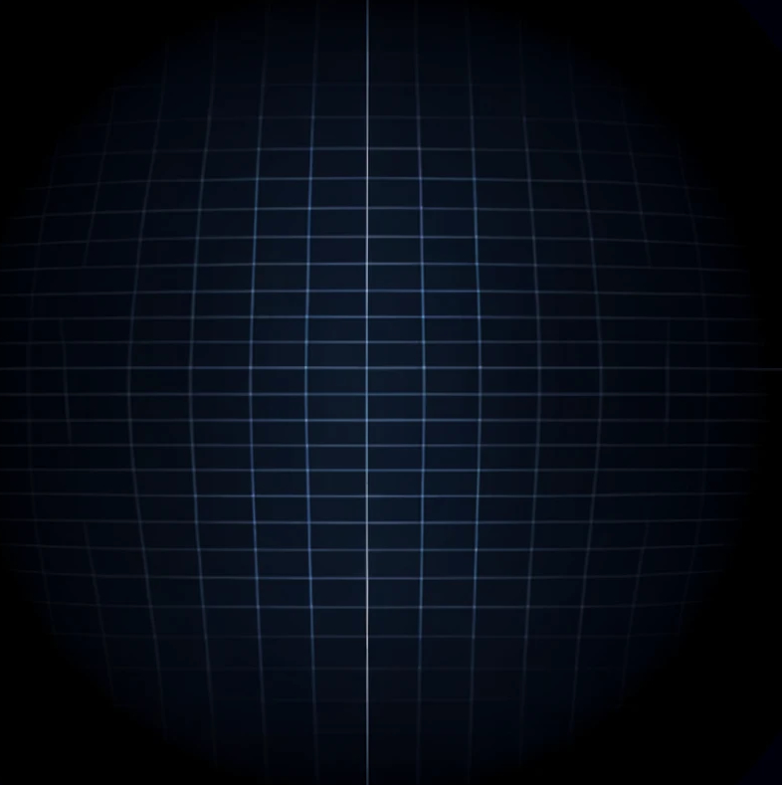 | 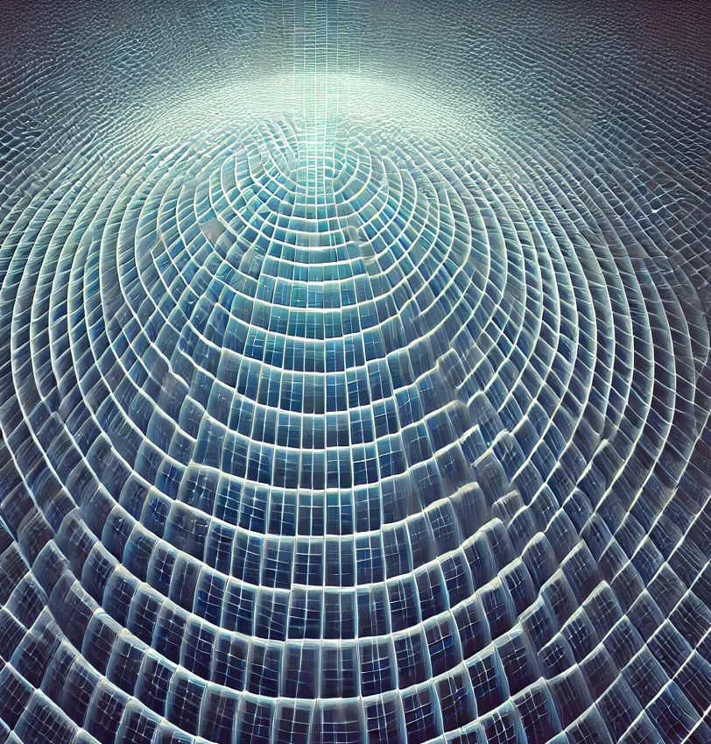

Figure 1 For me phophenes like a dark blue grid appears wthin 10-30 seconds after the initial habituation phase after you close the eyes; very soon these grids become moer complex, sometimes ;point-centered or multi-dimensional as in the second part of the picture above.

Phase 3: Central Light and Figural Transformations. After the grid phase, a central light might begin to appear. This light is not homogenous; instead, it is fractalized, resembling an ultrafine yantra, kaleidoscopic, and becomes increasingly radiant. From this radiant, fractalized light, figures begin to emerge and morph. A common and striking manifestation is a green or blue eye appearing centrally within the light field. This can then further transform into multiple faces, indicating a significant leap in the complexity and meaningfulness of the visual content. This "eye like" image is also described as a dark blue or purple mist or cloud of light that coalesces and hovers centrally, developing a brighter, opaque nodule at its center. This nodule can fluctuate between an "eye like" image with a dark pupil and an "iris like" ring of brightness, and the pupil quickly filling in with tiny promontories of light (Nicholson, 2010).
Phase 4: Fields of Jewels, Landscapes, and Narrative Content. This phase introduces a highly immersive and richly detailed visual experience. The light fields expand to encompass vibrant fields of jewels or flowers, often appearing in ruby red, emerald green, and sapphire blue, intricately mixed in what feels like a super dimensional pattern. These patterns can expand and morph into each other. From this point, whole landscapes may appear, or even cartoon like scenes, where patterns become quite realistic. Intermittently, crazy looking black signs may enter the scene, permeating the visual field in a seemingly random manner, adding an element of dynamic unpredictability. If there are clear ‘movies’ going on like changing landscapes, these may go on even when the eyes are temporarily opened and afterwards closed. There is no impact on the development of these ongoing ‘movies’.

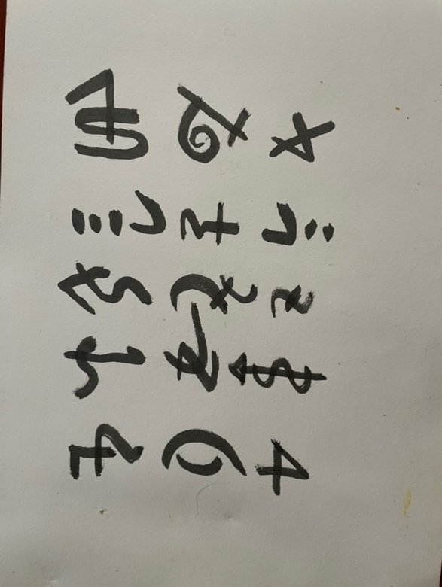
Figure 2. Crazy black symbols can race through the visual space, and morphe into different symbols, all quite quickly and rfelative small.

Phase 5: Vortex, Geometrical Worlds, and Luminous Beings. The experience may deepen into an increasingly bright light in the center, which can transform into a vortex or tunnel. There is a strong subjective sense of being able to move within this tunnel and even lose oneself in it. This tunnel opens into a sophisticated geometrical world of kaleidoscopic colors and shapes, suggesting the watcher is sucked into multi-dimensional visual spaces. Sometimes, these complex shapes morph further into angelic light beings. These angelic beings are characterized by wing like structures that move slowly and smoothly in the vertical plane, front to back. These movements induce a strong urge to move with them, sometimes leading to spontaneous Qigong like physical responses. Or the light fields morph into radiant sitting buddhas. Including seas of tantric flames around them, the deep red flames flickering as if real. Recently a phosphene became a radiant sitting being emerged and covered in rainbow-banners (Pfister, 2012; Foxhall, 2019) (Figure 3).

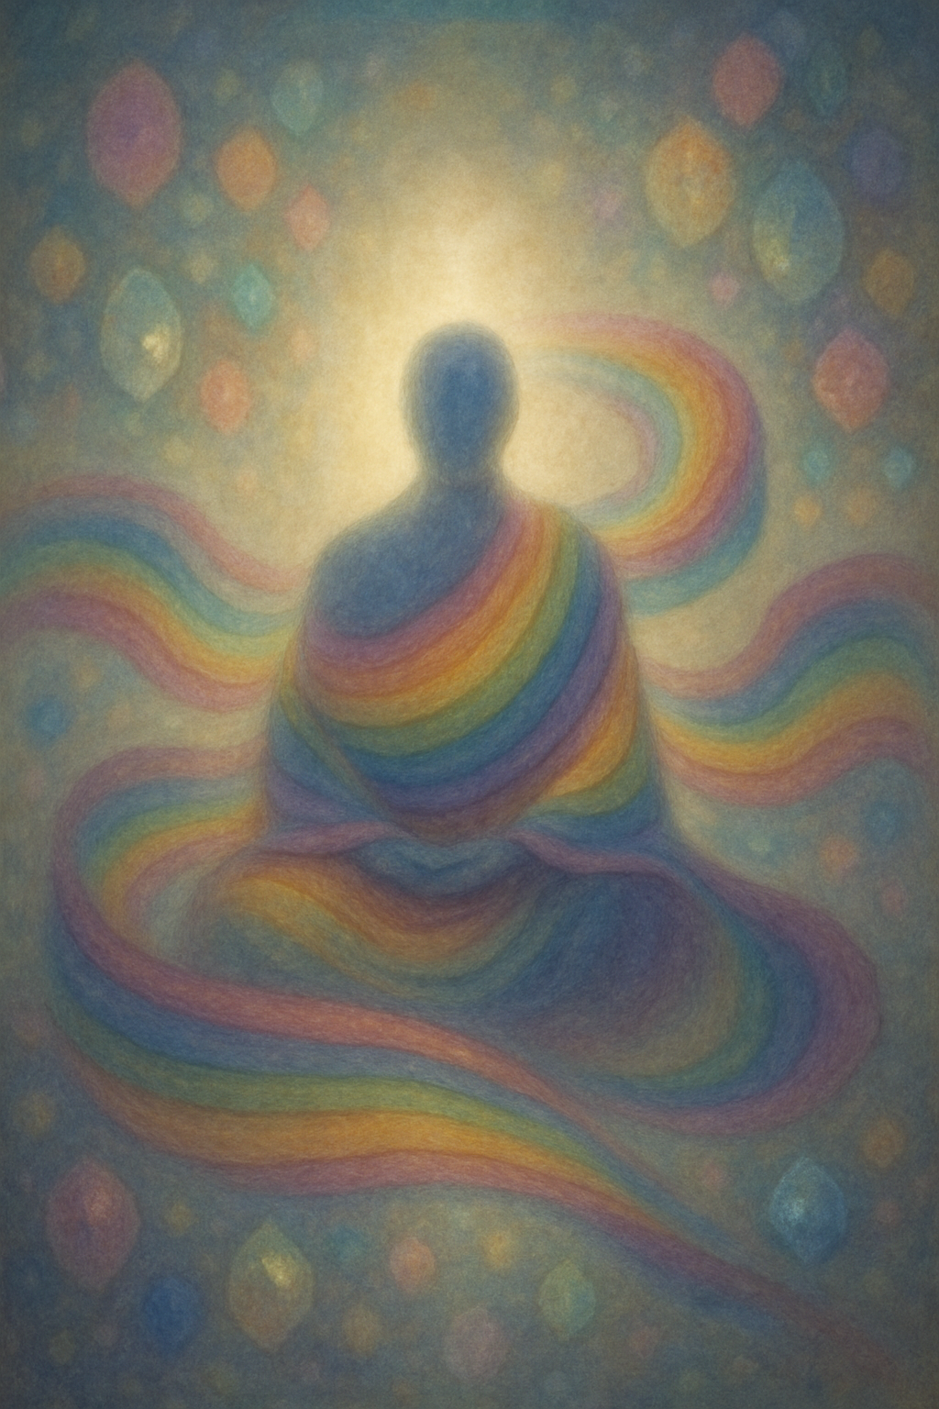
Figure 3. E radiant sitting figure with clothes like banners if rainbows.

Phase 6: Collapse to Unified Luminous Field and Non Dual Realization This is the most profound and rare phase, experienced only twice by the author. In this ultimate stage, all distinct light and form collapses. A new dimension unfolds where conventional spatial dimensions (up, down) disappear, along with any sense of self identification. The watcher and the watched become one and the same field of geometric light. This can be understood as the primary clear Bardo light, a direct experience of one's true nature as empty, radiant luminosity, inherently fractal as representing a divine geometry. The accompanying hearing of an inner voice and sense of illumination underscore the deeply transformative and existentially significant nature of this experience, representing a direct insight into the ground of being.
Each meditation session, however, is unique, and the progression through these phases is not strictly linear or guaranteed. Sometimes the phase of the multidimensional vortex directly sets in after the initial phase. The variability in content and intensity, such as a recent vision of a thick emerald green grid with ruby red jewels (Figure 4), underscores the dynamic and generative capacity of these endogenous visual phenomena.

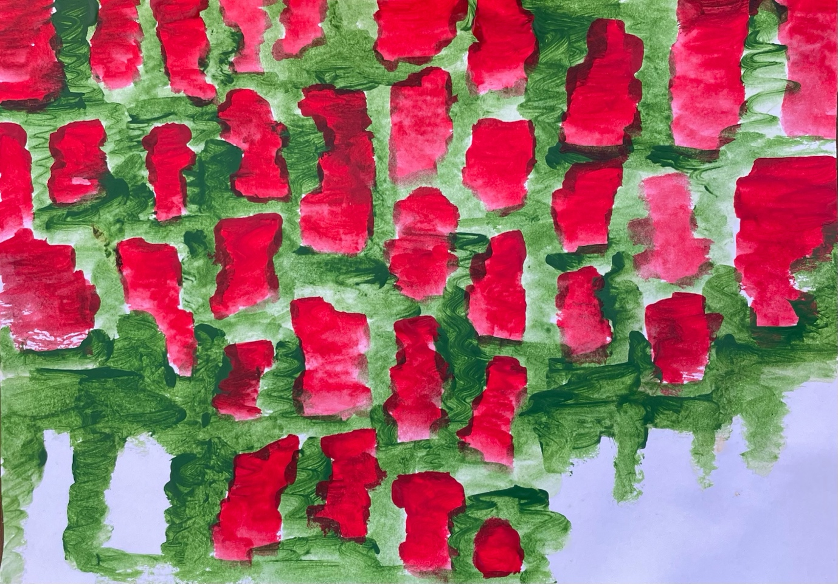
Figure 4. Ruby coloured hosphenes in an emerald green grid. This extreme ntens shimmering phosphene morphed afterwards in a bright field of glowing precious stones, including saphire-colourd ones and golden ones.

4. Interpretation of Meditation Induced Phosphenes: A Hierarchical Understanding
This section provides an interpretation of the phenomenological phases described in the preceding first person account, drawing connections to established neurobiological models of endogenous visual phenomena and traditional Buddhist contemplative typologies. This interpretation aims to contextualize these experiences within a hierarchical framework, illustrating their potential significance for understanding consciousness and the Ultra Subjective Hyperspace.
Phase 1: Initial Reactive Patterns - Basal Endogenous Visual Phenomena This initial phase, characterized by afterimages, flashing dots, stars, and random lights, including yellowish-green mists and clouds, aligns with what neuroscientific literature often describes as simple, circumscribed endogenous visual phenomena. Their appearance is largely reactive to basic sensory attenuation, such as eye closure or darkness. From a neurobiological perspective, these are likely the result of homeostatic plasticity mechanisms in the early visual system, including the retina and primary occipital cortex. Reduced external input leads to compensatory neuronal hyperexcitability and spontaneous firing, generating these basic light percepts. Traditional Buddhist texts, such as those describing the initial nimitta, often mention similar phenomena like "small radiant bursts" or "stars," which can be seen as early signs of concentration.
Phase 2: Emergence of Organized Grids - Patterned Endogenous Visuals The consistent emergence of finely organized grids of lines, with specific colors and evolving patterns, including the green ring phenomena, corresponds to what is scientifically termed patterned endogenous visual phenomena (e.g., tessellopsia). While still originating from homeostatic plasticity in the visual cortex due to sustained sensory attenuation, the appearance of organized patterns suggests a slightly more complex level of neural processing compared to random flashes. These patterns are distinct from the disruptive nature of a migraine aura, which also presents as patterned light but actively obliterates normal vision. In Buddhist traditions, descriptions of nimitta like "stretched out cobweb" or "wreath of flowers" resonate with these organized patterns, often signaling a deepening of concentration.
Phase 3: Central Light and Figural Transformations - Early Complex Manifestations The appearance of a fractalized, kaleidoscopic central light that morphs into recognizable figures, such as an eye or multiple faces, including the blue or purple "eye like" images, marks a significant transition to what neurobiology would classify as early complex visual manifestations. This level of complexity suggests that beyond basic occipital cortex activity, more prolonged sensory attenuation and heightened neuroplasticity are recruiting higher level visual processing areas. These include regions involved in object and face recognition (e.g., fusiform face area), indicating the brain's active construction of meaningful visual content from endogenous signals. The symbolic nature of the yantra and the eye points towards the inclusion of a deeper engagement with archetypal imagery, moving beyond mere abstract patterns.
Phase 4: Fields of Jewels, Landscapes, and Narrative Content - Immersive Complex Manifestations This phase represents a highly immersive and generative form of complex endogenous visual experience. The expansion into vibrant fields of jewels, flowers, and eventually detailed landscapes or cartoon like scenes, demonstrates extensive recruitment of brain areas associated with memory, imagination, and narrative construction. The "superdimensional" quality and the persistence of these "movies" even with temporary eye opening suggest a robust internal generation of reality that is largely independent of immediate external sensory input. This indicates widespread and extensive neuroplastic modifications, allowing for the creation of rich, internally consistent, and often personally meaningful visual worlds. The intermittent appearance of "crazy looking black signs" adds a dynamic element of spontaneous content generation within this immersive state.
Phase 5: Vortex, Geometrical Worlds, and Luminous Beings - Transpersonal Luminous Experiences The deepening of the experience into an increasingly bright light in the center, which can transform into a vortex or tunnel. There is a strong subjective sense of being able to move within this tunnel and even lose oneself in it. This tunnel opens into a sophisticated geometrical world of kaleidoscopic colors and shapes, suggesting the watcher is sucked into multi-dimensional visual spaces. Sometimes, these complex shapes morph further into angelic light beings. These angelic beings are characterized by wing like structures that move slowly and smoothly in the vertical plane, front to back. These movements induce a strong urge to move with them, sometimes leading to spontaneous Qigong like physical responses. Or the light fields morph into radiant sitting buddhas. Including seas of flames around them, the deep red flames flickering as if real. Also sitting figures totally dressed with rainbow ribbons can rise in the visual field.
Phase 6: Collapse to Unified Luminous Field and Non Dual Realization - The Ultrasubjective Hyperspace itself - this rare and most profound phase represents the ultimate realization within this hierarchy: a direct experience of the Ultrasubjective Hyperspace (USH) as a unified, non-dual luminous field. The collapse of all distinct forms, the dissolution of conventional spatial dimensions, and the loss of self-identification where "watcher and watched become one," aligns with the concept of the primary clear Bardo light in Buddhist traditions. As the great Tibetan yogi Milarepa describes, in this ultimate state, "My body merges with the body of Buddha, My words are like the true words of the Tathagata, My mind is absorbed in the Realm of Great Light" (Milarepa, 1962, p. 14). He further states, "When I look inwardly to the self-aware mind, I clearly see the light of the inner lamp; Of ignorant blindness, I have no fear" (Milarepa, 1962, p. 44). This "light of the inner lamp" is the Mind-Essence, the quintessential "light," where "There is no adulteration by distracting thoughts. In the real nature of beings, the realm of Mind, There is no subject-object defilement. In the natural state of the Mind-Essence There is no ground from which habitual thought may rise" (Milarepa, 1962, p. 273). Indeed, the nature of Mind is the Light and the Void, and by realizing the awareness of this Light-Void, one merges into "the original state of Non-effort" (Milarepa, 1962, p. 88). This is the "never-coming, never-going Realm of Great Light" (Milarepa, 1962, p. 487). All other lights are over-shadowed by this supreme light, akin to the sun shining in the sky (Milarepa, 1962, p. 226). In this state, thoughts are seen as insubstantial, like dreams or rainbows of illusion, disappearing without a trace when the light of Wisdom shines, "Like darkness in the sun" (Milarepa, 1962, p. 503).
Neurobiologically, this could correlate with widespread, highly integrated neural synchronization, particularly high frequency gamma oscillations, and profound DMN attenuation. This is not a "hallucination" in any pathological sense, but a direct apprehension of fundamental consciousness, empty, radiant, and inherently fractal as representing a divine geometry. The accompanying hearing of an inner voice and sense of illumination underscore the deeply transformative and existentially significant nature of this experience, representing a direct insight into the ground of being. This ultimate luminous state is also referred to as the Clear Light of the Dharmakaya, which, according to "The Tibetan Book of the Dead," shines at the time of death, offering a chance for liberation if recognized, despite the common ignorance and habitual clinging that prevent its recognition (Evans-Wentz, 1957). In the time of Marpa and Milarepa, this profound path was known as "the Road of Miraculous Light."

5. Contrasting Meditation Induced Phosphenes with Migraine Aura
While both meditation induced phosphenes and migraine aura are forms of endogenous visual phenomena, their phenomenology, underlying mechanisms, and subjective implications differ significantly. Understanding these distinctions is crucial for a precise hierarchical taxonomy and to avoid mischaracterizing profound contemplative experiences as pathological events.
The classic migraine aura, particularly the fortification spectrum (scintillating scotoma), presents as a zigzag semicircular line of bright, shiny, often iridescent lights that typically originates in a specific part of the visual field (e.g., lower right quadrant for the author). A defining characteristic of the migraine aura is its disruptive impact on normal vision. As the patterned light slowly expands and moves across the visual field over 5 15 minutes, it actively obliterates or impairs the perception of external reality. The visual field loses its structure, making it difficult to see clearly. This phenomenon is widely attributed to Cortical Spreading Depression (CSD), a wave of neuronal and glial depolarization that propagates across the cerebral cortex, transiently disrupting normal brain function.
In stark contrast, meditation induced phosphenes, especially those observed in the higher phases (Phases 3 6), do not obliterate or impair normal vision. Instead, they are typically experienced with closed eyes, or as an additional layer of inner perception that does not interfere with the fundamental ability to perceive external reality when the eyes are open. Their appearance is an addition to the visual field, not a replacement.
Furthermore, the spatial dynamics and generative complexity diverge significantly:
- Migraine Aura: Exhibits a predictable, migratory pattern, expanding from a localized origin point across the visual field. Its forms are largely restricted to repetitive geometric patterns (zigzags, shimmering).
- Meditation Induced Phosphenes: While initial phases may involve simple patterns, the progression in meditation leads to a vast and generative range of forms. These include intricate yantras, recognizable figures (faces, eyes, angelic beings), detailed landscapes, and even narrative content. Their movement feels more like an unfolding or morphing of an internal landscape, rather than a disruptive migration across a fixed external visual field. The "superdimensional" qualities and the sense of moving within the visual space (Phase 5) are entirely absent in migraine aura.
Beyond these phenomenological differences, a crucial distinction lies in the subjective experience of time. The migraine aura unfolds strictly within Chronos—quantitative, linear, and measurable time. Its progression is a fixed sequence of events over a defined duration, often perceived as an unwelcome intrusion on the ordinary flow of chronological time. In contrast, the higher phases of meditation induced phosphenes increasingly align with Kairos—a qualitative, opportune, and often non linear experience of time. Moments within these states, particularly the immersive worlds of Phase 5 and the non dual realization of Phase 6, can feel timeless, eternal, or profoundly significant, transcending the conventional chronological flow and offering a direct apprehension of a deeper, more meaningful temporal dimension.
The subjective experience and associated states also highlight a fundamental difference:
- Migraine Aura: Is an involuntary, often unwanted, and typically signals a transient neurological dysfunction, step by step progressing and fading away in time (Chronos). It is generally not associated with positive emotional states or profound insights.
- Meditation Induced Phosphenes: Are sometimes deliberately cultivated through practice and are associated with states of deep contemplation, awe, clarity, interconnectedness, and profound insight. They enfold in a time-fluid space (Kairos). They are frequently perceived as meaningful, transformative, and indicative of deeper states of consciousness, culminating in non dual realizations. The accompanying physiological modality shifts (e.g., Qigong like urge of movements) are integrated into a sense of well being and expanded awareness, rather than disruption.

6. A Hierarchical Taxonomy of Endogenous Visual Phenomena
Based on the detailed phenomenological accounts and their neurobiological and contemplative interpretations, we propose a hierarchical taxonomy that differentiates endogenous visual phenomena by their complexity, underlying mechanisms, and subjective significance. This three tiered model moves beyond simplistic classifications to acknowledge the rich spectrum of inner light experiences, from basic sensory artifacts to profound transpersonal manifestations.
Level 1: Basal Endogenous Visual Patterns (Reactive and Simple)
- Phenomenology: Characterized by simple, circumscribed light percepts. These include afterimages, flashing dots, stars, and random lights (Phase 1 of meditation induced phosphenes). Also includes patterned forms such as grids, lattices, and zigzags (Phase 2 of meditation induced phosphenes, and the classic migraine aura). Colors are often basic, shimmering, or iridescent.
- Origin and Mechanism: Primarily arise from sensory attenuation (e.g., eye closure, darkness, fixed gaze) inducing homeostatic plasticity in the early visual system (retina, primary occipital cortex). This leads to compensatory neuronal hyperexcitability and spontaneous firing. In the case of migraine aura, this is specifically linked to Cortical Spreading Depression (CSD), a propagating wave of neural depolarization that transiently disrupts cortical function. These phenomena are largely the result of basic release phenomena in the visual pathways and cortical fields.
- Characteristics: Generally involuntary. While some patterns may be organized, they typically lack complex symbolic meaning or narrative content. Migraine aura is disruptive to normal vision, whereas meditation induced phosphenes at this level are additive.
- Traditional Context: Corresponds to initial nimitta in Buddhist traditions or basic light experiences sometimes considered as "side effects" (makyo).
Level 2: Complex Meditation Induced Phosphenes (Generative and Symbolic)
- Phenomenology: Involves the emergence of highly vivid, structured, and often recognizable forms. This includes fractilized central lights, morphing figures (e.g., eyes, faces), intricate yantras (Phase 3). It progresses to immersive scenes such as vibrant fields of jewels and flowers, detailed landscapes, and even cartoon like or realistic narratives (Phase 4). These phenomena often possess "superdimensional" qualities and exhibit coherent movement and transformation.
- Origin and Mechanism: Result from more prolonged and extensive sensory attenuation, leading to widespread neuroplastic modifications beyond the primary visual cortex. This recruits higher level brain areas involved in memory, object recognition (e.g., fusiform face area), and imagination. The sustained and integrated activation of broader neural networks allows for the generation of complex, recognizable, and often personally meaningful content. This suggests an active, constructive process by the brain/mind, rather than mere release phenomena. Attention to details of internally generated images may also increase the capacity for visuospatial processing and working memory (Kozhevnikov et al., 2009).
- Characteristics: Highly immersive and perceptually vivid. While their initial appearance may be spontaneous, they can often be influenced or investigated through focused attention. They are frequently imbued with personal or archetypal meaning and are associated with states of deep absorption, insight, and emotional engagement. They do not obliterate normal vision.
- Traditional Context: Aligns with more developed nimitta descriptions in Buddhist texts and practices that encourage stabilizing and investigating these forms for insight into the mind's constructive nature.
Level 3: Transpersonal Luminous Manifestations (Ultrasubjective Hyperspace Access)
- Phenomenology: Represents a profound qualitative shift towards transpersonal and unifying experiences. This includes experiential traversal through visual phenomena (e.g., vortex, tunnel leading to kaleidoscopic worlds) (Phase 5). It culminates in the emergence of highly complex, often archetypal, sentient figures (e.g., angelic light beings, radiant sitting buddhas) that may appear to communicate or induce specific integrated somatic and motor responses (e.g., Qigong like urges of movements). The ultimate phase involves the collapse of all distinct forms into a unified, empty yet radiant field of geometric light, dissolution of conventional dimensions, and a non dual realization where "watcher and watched become one" (Phase 6, the primary clear Bardo light).
- Origin and Mechanism: This level signifies direct access to or manifestation from the Ultrasubjective Hyperspace. Neurobiologically, it is hypothesized to involve widespread, highly integrated neural synchronization (e.g., high frequency gamma oscillations), profound attenuation of the Default Mode Network (DMN), and enhanced connectivity across brain regions associated with self transcendence and fundamental awareness. This state is also conceptualized as resulting from the suspension of ordinary biologically based cognitive processes, such as the a priori forms of time and space (Kant, 1933; Winkelman, 2024), or a "mystical forgetting" of cognitive processes as described by Forman (Forman, 1990; Laughlin & Rock, 2020). This deconstruction through meditation induced alterations of consciousness may lead to increased awareness of normally unconscious mental processes, such as Ālaya awareness or ālaya vijñāna in Buddhist traditions (Waldron, 2011; Winkelman, 2024). While rooted in the homeostatic plasticity mechanisms of sensory attenuation, the expression at this level reflects a fundamental shift in the phenomenal content and experience of reality, moving beyond cortical generation to a direct apprehension of the ground of being.
- Characteristics: Profoundly transformative, often associated with peak experiences, mystical states, and ego dissolution. The experience is perceived as having an intrinsic, non local, and deeply significant reality. These states may be indicators of enhanced neuroplasticity and cortical malleability, facilitating deep and enduring psychological and existential shifts.
- Traditional Context: Corresponds to advanced stages of meditative absorption (jhana), the realization of the "pure bright mind," and the ultimate goal of recognizing the fundamental clarity and luminosity of mind in various Buddhist and mystical traditions. The ultimate luminous state is also referred to as the Clear Light of the Dharmakaya, which, according to "The Tibetan Book of the Dead," shines at the time of death, offering a chance for liberation if recognized, despite the common ignorance and habitual clinging that prevent its recognition (Evans-Wentz, 1957). In the time of Marpa and Milarepa, this profound path was known as "the Road of Miraculous Light."

7. Ancient Parallels: Endogenous Visual Experiences in Egyptian Mythology and Shamanic Traditions
Beyond individual phenomenological accounts and neurobiological explanations, historical and cultural records offer compelling parallels to meditation-induced inner light experiences, suggesting a universal human capacity for such phenomena. Ancient Egyptian myths, in particular, provide rich imagery that resonates with the structured progression of phosphenes.
In his exploration of ancient Egyptian myths, Philip Nicholson (2010) highlights striking color symbolism among the deities. The walls of Egyptian pyramids frequently depict gods residing in the Underworld (Dwat) with green skin or clothing, mirroring the color of fresh papyrus reeds. A notable exception is Amun, a sky-god often colored the dark blue of lapis lazuli, signifying his unknowable nature (Wilkinson, 2003). It's important to note that the ancient Egyptian word w3t, usually translated as "green," encompassed the green-to-blue spectrum (Nicholson, 2010).
While a common Egyptological theory posits that green symbolizes the vital forces of regeneration and immortality, exemplified by the Nile's annual new vegetation, Nicholson (2010) argues this explanation is incomplete. He suggests it overlooks or outright rejects the possibility that "mystical" experiences influenced the priests' choice of green and lapis lazuli for the gods (a view actively opposed by scholars like Assmann, 2001, 2005).
Nicholson (2010) proposes that at least some ancient Egyptian priests claimed to project their consciousness into the Dwat, where they experienced visions of light unlike any natural phenomenon, interpreting them as divine manifestations. To support this, he focuses on Horus, the falcon-god, and his manifestation as a disembodied, green-colored "Eye of Horus," capable of "flying into the dark of the Dwat." This description aligns remarkably with the green rings (Phase 2) and the blue or purple "eye-like" transformations (Phase 3) described in meditation-induced phosphenes, suggesting a shared endogenous visual origin.
Independent evidence further suggests the priests' capacity to induce such visions. Assem (2008) reports that certain Old Kingdom "High Priests" held the title "Chief of Seers" (wr m3), implying the ability to "see secrets." Additionally, Federn (1960) analyzed "transformations" in The Coffin Texts, finding that two-thirds of the spells included this word. Federn concluded these spells were likely used by the living for "identifying" with deities or "initiation" rites, suggesting they were tested for efficacy on Earth before being relied upon for the afterlife (Federn, 1960, p. 245). Building on Federn's work, Wente (1982) explored "Mysticism in Pharaonic Egypt?", discovering references in texts like The Book of the Underworld and The Book of Gates to priests who had visited the Underworld and returned with special knowledge, enabling them to mediate between human and divine realms.
Beyond Egyptian mythology, many anthropologists have embraced phosphenes as a naturalistic explanation for shamanic experiences (Giraldo Herrera, 2018). For instance, Reichel-Dolmatoff (1975) reported phosphenes among the effects of ayahuasca and observed a similarity between the designs drawn from shamanic experiences by the Tukano in the Colombian Vaupes River and the shapes of Knoll’s phosphenes, which were induced by electric currents resembling neuronal system magnitudes applied to the scalp. Similarly, Blackburn noted the resemblance of patterns observed by the shamans of the Chumash of California to phosphenes (as cited in Giraldo Herrera, 2018).
Later, in a series of highly influential articles, Lewis-Williams and Dowson (1988) explained the shamanic experience of the San in South Africa through the articulation of entoptic phenomena within the neuropsychology of trance. They proposed a diagnostic model for trance experiences comprising three stages, not necessarily consecutive:
- Entoptics, which they considered to encompass not only optic phenomena within the eye but also phenomena arising from neural processes on the retina, the optic nerve, and the visual cortex. However, the authors focused their exploration on neural visual processes, while optic phenomena occurring within the eye were left for future analysis.
- Geometrical patterns which, they argued, were generated in neural pathways.
- Iconics which, they assumed, to be cultural constructs articulating perception, generated in the frontal cortex.
After Lewis-Williams and Dowson, others have acknowledged the role of phosphenes or entoptics among different shamanic traditions, such as those of the Huichol in the Sierra Madre of Mexico or the Maki in Malakula, Melanesia (as cited in Giraldo Herrera, 2018). This association has generated substantial debate in the interpretation of rock and cave art iconography, as it was suggested that the similarity of motifs in different contexts could be derived from the observation of entoptic phenomena. This, in turn, was considered suggestive of the involvement of shamanism in various contexts such as Paleolithic European rock art and Iron Age European coins (as cited in Giraldo Herrera, 2018).
These historical accounts, as synthesized by Nicholson and Giraldo Herrera, provide a compelling argument that the consistent and specific iconography of ancient Egyptian deities and various shamanic traditions, particularly the green and blue hues, the "Eye of Horus," and geometric patterns, may be rooted in endogenous visual experiences similar to those reported in modern meditation, suggesting a transcultural and transhistorical continuity of these inner light phenomena.

Limitations and Future Directions
This paper adopts a phenomenological methodology, drawing primarily from the author's extensive first-person contemplative experiences gathered over several decades. This qualitative approach allows for an in-depth exploration of the subjective characteristics and developmental progression of inner light phenomena, which are then integrated with established neurobiological and cross-cultural frameworks.
Because of the inherent subjectivity of a first-person account there is a need for future studies involving multiple meditators across different traditions to validate the proposed taxonomy. Furthermore, the potential for neuroimaging studies (fMRI, EEG) should be explored to better define the neural correlates of the different phases of phosphene generation, particularly the higher transpersonal states. Further cross-cultural comparative studies to explore variations or universals in these experiences would solidify our understanding of this transpersonal realm of experiences. A realm which has been explored already for more than a millennium by the great yogi’s of the past such as Marpa and Milarepa. Thus, research the specific contemplative practices that most effectively induce and refine phosphenes, including new techniques would enrich this field.

8. Conclusion: Unveiling the Depths of Inner Luminosity
This paper presents a comprehensive phenomenological account and a novel hierarchical taxonomy of endogenous visual phenomena, specifically focusing on those experienced during contemplative practice. Through a detailed first person narrative, we've mapped the progression of meditation induced phosphenes from initial reactive patterns to increasingly complex, symbolic, and ultimately transpersonal luminous manifestations.
Our proposed three tiered taxonomy, comprising Basal Endogenous Visual Patterns, Complex Meditation Induced Phosphenes, and Transpersonal Luminous Manifestations, offers a nuanced framework that moves beyond simplistic categorizations. It clearly distinguishes these profound internal experiences from pathological neurological and the disruptive nature of phenomena like migraine aura. Crucially, meditation induced phosphenes occur with intact reality testing and are often associated with states of heightened awareness, deep insight, and a sense of well-being, rather than distress.
The progression through these phases, from elementary light percepts rooted in homeostatic plasticity of early visual pathways to immersive, generative visual worlds engaging higher cortical functions, and culminating in non-dual luminous fields, underscores the brain's extraordinary capacity for endogenous vision when external sensory input is attenuated. The most profound of these experiences, particularly the Transpersonal Luminous Manifestations, serve as direct portals to the Ultrasubjective Hyperspace, revealing an inherent, empty yet radiant luminosity that is fundamentally intertwined with the nature of consciousness itself.
This taxonomy has significant implications for consciousness studies, offering a structured approach to researching subjective visual experiences in altered states. It highlights the potential for neuroplasticity to facilitate profound shifts in perception and awareness through contemplative training. Furthermore, by placing these phenomena outside a purely pathological lens, we invite a more respectful and rigorous scientific engagement with inner light experiences described across diverse mystical and contemplative traditions.
Ultimately, understanding these inner lights can illuminate not just the mechanics of vision, but the very nature of consciousness and reality itself. The ancient path of the Yoga of the inner light is awakened once more. That it may lead the path for seekers towards illumination and enlightenment.

References
Assmann, J. (2001). The search for God in ancient Egypt. Cornell University Press.
Assmann, J. (2005). Death and salvation in ancient Egypt. Cornell University Press.
Assem, A. (2008). The Chief of Seers in the Old Kingdom. Kegan Paul.
Evans-Wentz, WY(1927) The Tibetan Book of the Dead; The After-Death Experiences on the Bardo Plane, according to Lama Kazi Dawa-Samdup's English Rendering. Oxford University Press.
Federn, W. (1960). The 'Transformations' in the Coffin Texts: A New Approach. Journal of Near Eastern Studies, 19(4), 241-257.
Forman, R. K. C. (1990). The problem of pure consciousness: Mysticism and philosophy. Oxford University Press.
Foxhall, K. (2019). Chapter Seven, “A Shower of Phosphenes”: Twentieth-Century Concepts of Scotoma and the Medical Uses of History. In Migraine: A History. Johns Hopkins University Press. Retrieved from https://www.ncbi.nlm.nih.gov/books/NBK544090/
Giraldo Herrera, C. E. (2018). Neuropsychological Naturalistic Explanations of Shamanic Visions. In Microbes and Other Shamanic Beings (pp. 129–146). Springer. https://doi.org/10.1007/978-3-319-71318-2_6
Kaplan, R. (2006). The neuropsychiatry of shamanism. Before Farming, 2006(4), 1-14.
Kant, I. (1933). Critique of pure reason (N. K. Smith, Trans.). Macmillan. (Original work published 1781)
Keppel Hesselink, J. M. (2025-a). Inner Light, Inner Seeing: A Phenomenological Inquiry into Phosphene Meditation and the Structure of Mystical Perception. PsyArXiv Preprints. Retrieved from https://osf.io/preprints/psyarxiv/s56h9_v1
Keppel Hesselink, J. M. (2025-b). The Ultrasubjective Hyperspace: A Unified Model of Consciousness and Reality. PsyArXiv Preprints.
Kozhevnikov, M., Louchakova, O., & Zappala, M. (2009). The effect of meditation on visuospatial processing and working memory. Consciousness and Cognition, 18(3), 733-747.
Laughlin, C. D., & Rock, J. (2020). The archetypal mind: A neurophenomenological approach to the self. Routledge.
Lewis-Williams, J. D., & Dowson, T. A. (1988). The signs of all times: Entoptic phenomena in upper palaeolithic art [and comments and reply]. Current Anthropology, 29(2), 201–245.
Milarepa. (1962). The hundred thousand songs of Milarepa. Shambhala Publications, Inc.
Nicholson, P. (2010). Meditation and Light Visions: A Neurological Analysis.
Pfister, R. (2012). Phosphenes and Inner Light Experiences in Medieval Chinese Psychophysical Techniques: An Exploration. In Concepts and Categories of Emotion in East Asia (pp. 38-70). Brill.
Reichel-Dolmatoff, G. (1975). The shaman and the jaguar. A study of narcotic drugs among the Indians of Colombia. Temple University Press.
Waldron, W. S. (2011). The Buddhist unconscious: The Alaya-vijñāna in the context of Indian Buddhist thought. Routledge.
Wente, E. F. (1982). Mysticism in Pharaonic Egypt? Journal of Near Eastern Studies, 41(3), 161-172.
Wilkinson, R. H. (2003). The complete gods and goddesses of ancient Egypt. Thames & Hudson.
Winkelman, M. (2024). Neurophenomenological Explanations of Contemplative Universals. Neurophenomenology and Neuroepistemology Approaches to Integrating Constructivist, Perennialist, and Universalist Perspectives on Mystical Experiences. Zygon: Journal of Religion and Science, 59(2), 382–409.
Young, R. S. L., Cole, R. E., Gamble, M., & Rayner, M. D. (1975). Subjective patterns elicited by light flicker. Vision Research, 15(12), 1289–1290.

