Pre-Generative AI perspectives: Risk and promise in Vietnam’s state media narratives on artificial intelligence (2016–2022)

Abstract
This study analyzes 324 online news articles published by five major Vietnamese state newspapers between 2016 and 2022. Besides rating the tone of each article as being positive, negative, or neutral, we also subject these articles to a rigorous thematic coding scheme; each article is read and coded nominally for whether it mentions AI-related topics such as AI ethics, risks, development, investment, AI public events, policies, etc. The analyses show the majority of news reports on AI are event-related, with 194 articles (59.8%) published about 151 unique AI-related events. Concurring with the literature on AI-related narratives, we conclude that industry actors are the main drivers of media narratives about AI. Hence, it is not surprising that the three major narratives are first, the prevailing optimism regarding AI development and application; second, the emphasis on AI development as one of the key contributors to the national stature; and third, the shallow discussion of AI ethics. We find the number of negative news items was dismissed at 4, equivalent to merely 1.23%, whereas that of neutral news items was 47, or 14.5%. Problematically, there is a stark shortage of editorial, op-ed, and in-depth feature articles explaining various ethical and social issues related to AI deployment. The AI-related ethical issues, such as privacy violations, gendered bias, etc., are merely listed as talking points and are being overshadowed by the narrative of ‘efficiency,’ ‘cybersecurity,’ ideological security,’ and ‘strategic advantage.’ Moreover, we also provide an explanation for the limited attention that AI-related ethical issues receive from government newspapers in Vietnam, attributing it to the lack of a philosophical foundation for the discussion on AI ethics and the optimistic view on AI of the Vietnamese state's journals is tied to the way the Vietnamese government is gaining legitimacy, that is, through economic developments.

Key words: Artificial Intelligence; AI communication; media framing
That seems to put an end to the birds’ free ride on fresh vegetables and fruits… Running out of ideas, they seek consultation with Kingfisher. Experienced and quite updated on the new technologies, Kingfisher says: – You guys have met rivals of the 4.0 age. You would for sure fail if you didn’t study them carefully. You must do thorough research on their behaviors to find a solution.
- In Bogeyman, Wild Wise Weird (Vuong, 2025)-

1. Introduction
Artificial intelligence (AI), a term coined by Stanford Professor John McCarthy in 1955 to mean “the science and engineering of making intelligent machines,” is about programming systems, computers or machines to perform tasks, solve problems, learn, think, and make smart predictions (Manning, 2020). The growth in computational power has propelled demand for building AI systems across the world, with the AI arms race already underway (Fatima et al., 2022; Meserole, 2018; Savage, 2020). For instance, China and the United States have fielded AI systems designed for strategic and multi-domain awareness, capable of conducting civilian and military operations in maritime, land, air, cyberspace and space domains (Price et al., 2018). The competition for strategic advantage is pronounced even in smaller powers such as Vietnam (Pham, 2019). As a developing country with a single ruling party, Vietnam is driven to embrace cutting-edge technology that would advance its strategic interests at both the domestic and international levels.
There are three reasons for studying the case of AI development and adoption in Vietnam. First, there is an insufficient number of studies on the pursuit of AI applications in developing countries. Even the Global AI Vibrancy Tool, an interactive visualization on the global AI race developed by the Stanford Institute for Human-Centered Artificial Intelligence, contains data of only 29 countries, with the majority being developed, high-income ones (Stanford University, 2021). Another report by the Brookings Institute looks at strategic AI plans in 34 countries, which include mostly expected players such as China, the U.S., India, South Korea, Germany, and the United Kingdom (Fatima et al., 2021, 2022). However, it is reported that the adoption of AI capabilities has increased the most, from 45% in 2020 to 57% in 2021, at corporate organizations headquartered in emerging economies, which include China, the Middle East and North Africa (McKinsey & Company, 2021). As this adoption rate continues to rise in the next few years, emerging markets including Vietnam warrant a higher degree of attention.
Second, in the global discourse on AI, the strategic rivalry between the United States and China often takes center stage, leaving smaller powers such as Vietnam in the struggle for political balance (Nguyen & Hekman, 2022a; Savage, 2020). The two superpowers are Vietnam’s biggest economic partners: China is Vietnam’s top import market while the U.S. is its leading export destination. Understanding Vietnam’s position in the global AI discourse presents insights for other emerging economies as well as developed economies in terms of outreach to a potential market.
Third, in 2021, Vietnam published its first AI Masterplan in which it aspires to be “among the top four countries in the ASEAN and in the group of 60 world’s leading countries in research, development and application of AI” by 2030 (Vietnamese Prime Minister, 2021). Such ambitious targets raise questions as to whether they are practical or rhetorical given the many challenges concerning financing and human resources that Vietnam would need to overcome. Emerging economies such as Vietnam are missing from existing analyses on national AI strategies as well as the literature on AI communication.
With that said, the present research examines the case of AI communication and development in Vietnam. It has two primary questions:
RQ1: Who drives the communication of AI in Vietnam and by what means?
RQ2: What are the AI narratives and their discrepancies in Vietnam?
There are two reasons for studying the developments of AI in conjunction with its communication to the public. The first reason pertains to how AI representation and perception in the public domain can have a considerable impact on AI research, regulation, and reception (Cave et al., 2019; Cave et al., 2018; Johnson & Verdicchio, 2017). Governments and industry actors, working separately and together, actively influence the adoption of AI by businesses and society. Scholars highlight the issuance of legal frameworks, policy guidance and national strategic documents among the major tools shaping the public debates on AI as well as its imaginaries (Bareis & Katzenbach, 2022; Guenduez & Mettler, 2022). In these documents, AI is frequently portrayed as a disruptive technology that is changing the fabric of human society. Such representation might inspire and enable debates, but it might also create false expectations and perceptions. In worse case, and one that is already happening, through collaboration with technology leaders and insiders, the government gains control of the narrative by surveillance, censorship, elevation of search rankings, stealth editing, retroactive revision of textual reports, deletion of unfavorable information, and so on (Duberry, 2022; Elkin-Koren & Perel, 2020; Feldstein, 2019, 2021; King et al., 2013; Wright, 2018). As AI enables governments to gain a higher degree of control at a reasonable cost, it is important to be aware of how AI is communicated to the public.
The second reason concerns the intersection of AI as a formal academic discipline and a host of other fields like sociology, anthropology, computer science, economics, and so on. A study on AI communication has the potential to reveal the interests in and understanding of AI in social, political, ethical, and legal realms. It is worth noting that, although more than 60 years have passed since the founding of AI as an academic discipline, the scholarship on AI communication remains lacking in scope and depth (Nah et al., 2020). Existing studies on media coverage of AI tend to be drawn from either Western or Chinese media content, with the focus being the economic potential and impact of AI and its ethical and governance challenges (Cave et al., 2019; Mao & Shi-Kupfer, 2021; Nah et al., 2020; Vergeer, 2020; Zeng et al., 2022; Zhai et al., 2020). Studying the integration of AI into society requires making sense of the information about AI that is being fed to us.
The research, therefore, fills a much-needed gap in the literature on AI communication in a developing setting such as Vietnam. It makes three primary contributions. First, through a mixed-method analysis of over three hundreds of online Vietnamese news articles on the concerned topic in the past five years, the research contributes empirical evidence to existing analyses on global AI reporting. Second, as the framing of AI in Vietnam is studied through the lens of national security and defense, it puts the study of AI at the nexus of politics, communication, and technology. Here, we investigate how the state’s perceived security threats and priorities contribute to shaping Vietnam’s AI communication and governance. Third, the findings highlight (i) the excessive optimistic and one-dimensional nature of the mainstream media about AI, and (ii) the marginal discussion of AI ethics. These points raise important questions about the national AI communication strategy as well as present lessons for other developing countries in a similar position.

2. Literature review
This section examines existing studies on global non-fiction AI discourse and media representations on AI development and utilization.

2.1. Global reporting trends
Existing longitudinal studies on media reporting on AI have looked at major English-language media outlets in the past 30 years to extract the growth trends and major topics. For instance, in an analysis of views and expressions about AI in articles published by the New York Times between January 1986 and June 2016, Fast and Horvitz (2017) find that AI coverage has increased sharply since 2009. Similarly, Nguyen and Hekman (2022b) track a steady growth of AI media interest in the past decade, noting the article volume nearly quadrupled from 2010 to 2015. By comparison, two other studies have observed that news reporting on AI surged after 2014 and became more fragmented in content (Vergeer, 2020; Zhai et al., 2020).
In terms of topics, studies find a set of words gaining salience across time, such as automation, autonomous driving, robotics, smart assistant, healthcare, machine learning, deep learning, algorithm, big data, speech recognition, Turing Test, computer vision, quantum computing, etc. (Fast & Horvitz, 2017; Vergeer, 2020; Zhai et al., 2020). An investigation into more than 11,000 AI-related articles published by USA Today, CNN, The Washington Post, The New York Times and The Guardian between 1980 and 2018 unveiled the correspondence of AI news to three development stages of AI history since the late 1970s (Zhai et al., 2020). The focus of news reports shifted away from the development of expert systems during the 1970s to the integration of cognitive science and psychology in AI applications in the 1980s-1990s; then, the third and current stage from the 2000s witnessed the gradual inclusion of agricultural science, materials science and immunology in AI-related reports (Zhai et al., 2020). This finding implies a clear engagement of media reporting with scientific discoveries in the U.S. Such an active dialogue between the media and academia can help better inform public understanding of AI.
The diversification of AI news reporting and framing is similarly observed by Nguyen and Hekman (2022b) in a study of 3,089 English-language news items published in mainstream outlets from January 2010 to May 2021. Here, the authors note the transformation of AI as a research subject and topic of science fiction to one that carries practical socioeconomic, cultural and political impacts in just a few years. Meanwhile, the topic of AI ethics remains fairly new as not much was found on relevant media outlets before 2013 (Ouchchy et al., 2020).
In terms of sentiment, although studies note that AI-related discourse tends to be characterized by discussions about the benefits and potential of the technology, there lacks a consensus on the media sentiment over the long run. Some have found articles appear to be positive or optimistic (Chuan et al., 2019; Fast & Horvitz, 2017; Zeng et al., 2022) while others reported sentiment to be balanced out across time as discourse became more sensitive to risk (Nguyen & Hekman, 2022b; Ouchchy et al., 2020; Vergeer, 2020). Meanwhile, concerns about AI in the press converge toward a set of specific issues, such as the fear of humanity losing control of AI (Fast & Horvitz, 2017), the ethical challenges of AI (Ouchchy et al., 2020; Zhai et al., 2020), the risks of data bias (Nguyen & Hekman, 2022b), the prospect of mass unemployment, the third revolution warfare or a new arms race (Altmann & Sauer, 2017; Nguyen & Hekman, 2022a; Zhai et al., 2020).

2.2. Media framing of AI
Newspapers run by different organizations in different countries vary in the reporting style. It is not surprising that AI representations differ across countries because they reflect the cultural, societal and political setting in which the AI systems are grounded (Suerdem & Akkilic, 2021). Studies on media framing of AI are limited in number as well as scope. Most have been published in the past two years and rely on a single-country focus, rather than cross-cultural comparisons, with the primary method being content analysis.
When looking at only domestic newspapers in the Netherlands, Vergeer (2020) finds that certain newspapers did not report on AI-related topics which would appear to be of interest to their audiences, and that popular newspapers were more negative about AI. The reason for the negativity was attributed to the heightened attention these newspapers paid to the topics of tech giants, fake news, AI singularity, Asia as an emerging economic and technological powerhouse, rather than topics relating to the science of AI, such as deep learning algorithms, quantum computing, and autonomous vehicles (Vergeer, 2020). By comparison, examining Chinese media content, Zeng et al. (2022) highlight a lack of critical debate on AI evaluations, with industry and political actors dominating the discussions, whereas van Noort (2022) draws attention to the construction of pride, hope and fear as three primary emotions in Chinese discourse and media strategy about AI. China’s emotional appeal to its AI narratives is a strategic move geared toward reinforcing the identity of China as a global AI power (van Noort, 2022).
The prominence of industry actors and politicization of AI as a public issue is not unique to China. The framing of a future vision on AI in German media is also shown to adhere to the government’s agenda, instead of being challenged by alternative narratives within the public debate (Köstler & Ossewaarde, 2022). The finding suggests a close unity between political and industry actors in Germany. By comparison, tech corporates in the United Kingdom are found to be driving the discussion with industry concerns, and that right-leaning outlets focus on economics and geopolitics whereas left-leaning outlets highlight ethics and discrimination issues (Brennen et al., 2018).
News framing of AI, according to an analysis on news dataset dated between 2010 and 2021 by Nguyen and Hekman (2022b), may include as many as 14 distinct frames that represent diverse aspects of AI’s impact on society. Yet, in general, no matter the geographical differences, the details of AI-related technology, including the technical aspects and ethical issues, are often presented in a superficial manner in media coverage (Nguyen & Hekman, 2022b; Ouchchy et al., 2020; Zeng et al., 2022). AI systems are increasingly positioned as a widely relevant and competent solutions to a host of public problems in contemporary society (Bareis & Katzenbach, 2021; Brennen et al., 2018; Guenduez & Mettler, 2022; van Noort, 2022). Popular among these narratives are the framing of AI systems as advanced and capable of “outperforming” or “surpassing” human expertise (Bunz & Braghieri, 2022; Curran et al., 2020).

2.3. Vietnam’s AI Masterplan
In this picture of global AI discourse, where does Vietnam stand? Similar to the development in China and the UK, AI discourse in Vietnam is politicized by nature. All media agendas are controlled by the single-ruling communist party, and thus, all discussions of AI as a technology and in relation to society need to be contextualized in the political setting. This section summarizes the actions taken by Vietnam on this AI journey.
On 26 January 2021, two weeks after the United States launched its first National AI Initiative Office (Trump White House, 2021), Vietnam issued for the first time a masterplan for developing and applying AI by the year 2030. Under the plan, Vietnam, currently a lower middle-income country, aspires to be “among the top four countries in the ASEAN and in the group of 60 world’s leading countries in research, development and application of AI” (Vietnamese Prime Minister, 2021). While the implementation details remain unclear, what is widely recognized is Vietnam’s pursuit of AI technologies is not new, and in fact, is a continuation of its on-going commitments to national digital transformation. On 27 September 2019, Vietnam’s highest leadership body, the Politburo, passed a resolution on seizing the opportunities of the fourth Industrial Revolution, known as Industry 4.0 (Communist Party of Vietnam, 2019). The resolution was codified into a national strategy on 31 December 2020, in which Vietnam targets to have the digital economy contribute to 20% of the GDP and have 80% of its nearly 100-million people population connected to the Internet by 2025 (Vietnamese Prime Minister, 2020).
To achieve these goals, the AI masterplan plan lays out the core tasks in five areas including law, technical development, AI ecosystem construction, practical applications, and international collaboration. The development and application of AI in cybersecurity are delegated primarily to two governmental bodies, namely the Ministry of Defense (MOD) and the Ministry of Public Security (MPS).
In line with the masterplan, both the MOD and MPS are asked to develop a national center for big data storage, cloud and fog computing. The MOD, however, should focus more on the application of AI in military-defense, particularly (i) the modernization of army equipment and weapons, (ii) the development of operational plans in national defense systems, (iii) the adoption of AI-powered preventive and rapid response to counter cyber warfare, bio-chemical warfare, as well as to (iv) rescue operations in case of natural disasters, accidents, or epidemics (Section IV.3).
Meanwhile, the MPS should work on (i) completing the legal framework for privacy protection, human rights protection, and cybersecurity and order related to the development and use of AI, along with (ii) applying AI technologies in national security systems, such as the customs and immigration management system, the high-tech crime prevention and control system, and (iii) proposing technical solutions to prevent crimes utilizing AI technologies (Section IV.4).
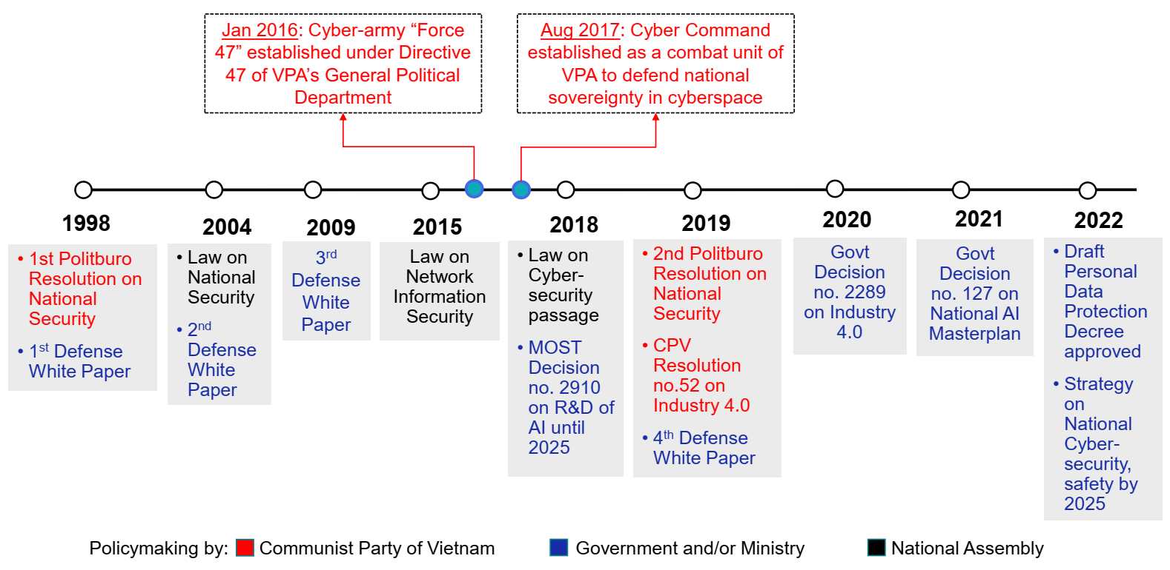
Figure 1: A timeline of major policies and decisions regarding national security and AI development in Vietnam
The next section describes the methodology and main findings.

3. Materials and method

3.1. Data collection
Data collection was conducted through news crawling of specified search terms, namely “trí tuệ nhân tạo” (artificial intelligence), “AI,” “công nghệ AI” (AI technology), “thành phố thông minh” (smart city), and “an ninh mạng” (cybersecurity) on five online news portals. The dataset was created by querying the search keywords on the public API for metadata (e.g., article headline, date, article blurb, and URL) associated with the articles published on selected online news outlets.
Vietnam has 807 press agencies, including both print newspapers and online news portals, all of which are controlled by the state (Quynh Duong, 2022). Given that media content is likely to be recycled across many news portals as well as be directed to deliver messages on behalf of the state (Marr, 1998), the study only collected samples from five web sites. The news outlets were chosen on two bases: (i) they must represent some official state or government organizations, and/or (ii) they must have a large enough number of visits every month. Table 1 summarizes the major characteristics of the five selected news portals for this study and the number of news items collected and coded for each outlet. In the outcome, after reading through 628 items collected based on the search key words, the authors extracted 324 items (51.5%) relevant to the topic at hand.
Of the five outlets selected, only VnExpress was owned by a private enterprise—FPT Corporation, the largest information technology service company in Vietnam. The other four news portals were either under the direct management of the government or the party.
Table 1. Summary of five selected news portals in the study (Source: https://www.similarweb.com/)
 | Báo điện tử Đảng Cộng Sản Việt Nam | Báo Chính Phủ | VnExpress | Dân Trí | Thanh Niên
English name | The electronic news portal of the Vietnam Communist Party | Government News Portal | VnExpress International | Dan Tri International | Young People
Head organization | Vietnam Communist Party | Government of Vietnam | FPT Corporation | Ministry of Labor, Invalids, and Social Affairs | Vietnam Youth Federation
Web site | dangcongsan.vn | baochinhphu.vn | vnexpress.net | dantri.com.vn | thanhnien.vn
Date | 01/31/2000 | 01/10/2006 | 02/26/2001 | 07/2005 | 12/01/2003
Traffic rank | #830 | #720 | #7 | #20 | #26
Category rank | #66 | #55 | #1 | #4 | #5
Average 3-month visits (June-August 2022) | 1.6 million | 3.1 million | 168 million | 72.9 million | 72 million
Total items collected | 51 | 96 | 436 | 13 | 32
Total relevant items | 44 | 63 | 193 | 7 | 17

Figure 1 details the number of articles published by each outlet by year. The reason for the unbalanced data collection is due to the limits imposed on data crawling by the news services. Certain news websites, in this case those of Dan Tri and Thanh Nien, likely limit the number of stories that the search can pull from their databases. According to Figure 1, media reporting on the topic of AI surged dramatically between 2018 and 2021. The uptrend might slow down in the next few years given that the search was closed in June 2022.
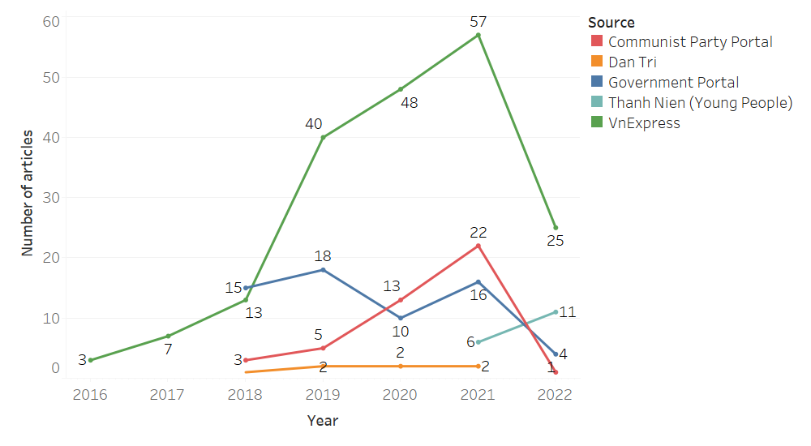
Figure 2. Number of news articles by each online news portal by year

3.2. Data categorization
The mixed-method study carries out a qualitative analysis of news reports on AI in Vietnam. As part of this, the two authors categorized data at a nominal level (e.g., the presence or absence of a variable), and not at ordinal level (e.g., the intensity of a variable) (O’Connor & Joffe, 2020).
First, similar to Vuong et al. (2018), all articles were manually read by the two authors and coded qualitatively as binary (yes/no) for seven subjects: (i) mention of AI challenges, risks, and obstacles, (ii) mention of AI ethics, (iii) mention of AI in development phase, (iv) mention of spending for AI, (v) mention of public events, (vi) mention of policymaking, (vii) mention of international collaboration.
The variable for spending is tracked along three sub-categories, such as (i) whether any scholarship or financing was made for educational purposes relating to AI, (ii) whether any financial awards were made during technology competitions relating to AI, and (iii) whether any financial commitments were made to an AI-related projects, e.g., investment in an AI startup.
Second, collected items were also coded as categorical for two subjects: namely (i) AI development/application section, and (ii) technology mentioned.
To supplement the binary variables, we coded three sub-variables that are (i) the spending amount if mentioned, (ii) the name of the event in case of a public event, and (iii) the names of foreign countries mentioned.
Third, following previous studies on this topic (Nguyen & Hekman, 2022b; Ouchchy et al., 2020; Vergeer, 2020), all articles were coded as having a tone that was either “positive,” “neutral,” or “negative.” Positive articles discuss only the benefits of AI without discussing the drawbacks, and/or mention the challenges only in passing. Negative articles discuss only the drawbacks without discussing the benefits, and/or mention the opportunities without delving into them. Neutral articles, meanwhile, present both the positive and negative aspects of the use of AI in an almost equal manner. The purpose is to see whether reporting and discussion of AI in the media is one-sided or balanced.
To ensure intercoder reliability, we assigned the raw data equally in a random manner and coded separately based on the explanation above.

4. Findings and discussion
This section details the findings, compares them with the extant literature, and discusses their implications. It lays out the main drivers and tones of Vietnamese media discourse on AI and examines the prominent narratives in media reports.

4.1. Drivers of media framing on AI in Vietnam
The finding confirms that the framing of AI in Vietnamese media is shaped by the government as much as industry actors. While the government sets the AI strategy and vision, much of its on-the-ground implementation relies on key science-technology actors, such as Viettel, FPT Corporation, VinAI, and local universities. Figure 3 illustrates the prevalence of sectors mentioned in news reports, in which the business and science-technology sectors stand out the most, followed by news reports involving actors in governance, education, and healthcare sectors. This result could be attributed to the fact that news articles crawled from VnExpress, which is owned by the tech giant FPT Corporation, take up the majority of the sample. The tech company uses the media platform to promote its interest in AI as well as to guide public attention toward the topic.
Meanwhile, the number of articles on AI in the security sector is smaller, and reports on actors in the media-communications and tourism sectors are noticeably absent in Figure 3. Only six articles were found to report on AI developments or applications in media-communications, and just one reported on AI adoption in tourism.
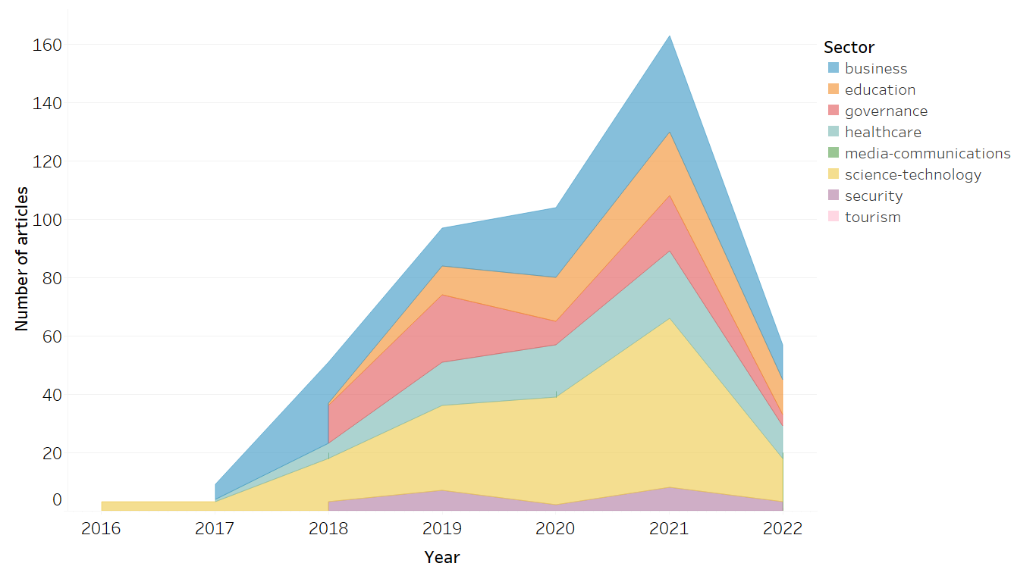
Figure 3. Categorization of news items
The dominant presence of industry actors is not surprising given that previous studies in China, Germany, and the United Kingdom have also found a similar trend (Brennen et al., 2018; Köstler & Ossewaarde, 2022; Zeng et al., 2022). In the case of Vietnam, the industry actors are driving the media discourse on AI by taking the lead in organizing public events about AI on a frequent basis. This is reflected in a high volume of reports on AI-related events in Vietnam: 194 articles (59.8%) were published about 151 unique AI-related events. Of the events, 67 were seminars, forums, and conferences, 14 were tech competitions, and 10 were tech exhibitions, with the notable annual organization of AI4VN, AI Day, AI Hackathon, to name a few. Figure 4 brings attention to the detailed numbers. Here, an increase in the number of media reports on AI from 2019 onwards corresponds to increases in the number of public events on AI as well as the reports on these events.
The prevalence of event-centric reporting implies a relative lack of editorial, op-ed, and in-depth feature articles on AI. Clearly, there is not enough writing in the mainstream Vietnamese media about the science of AI.
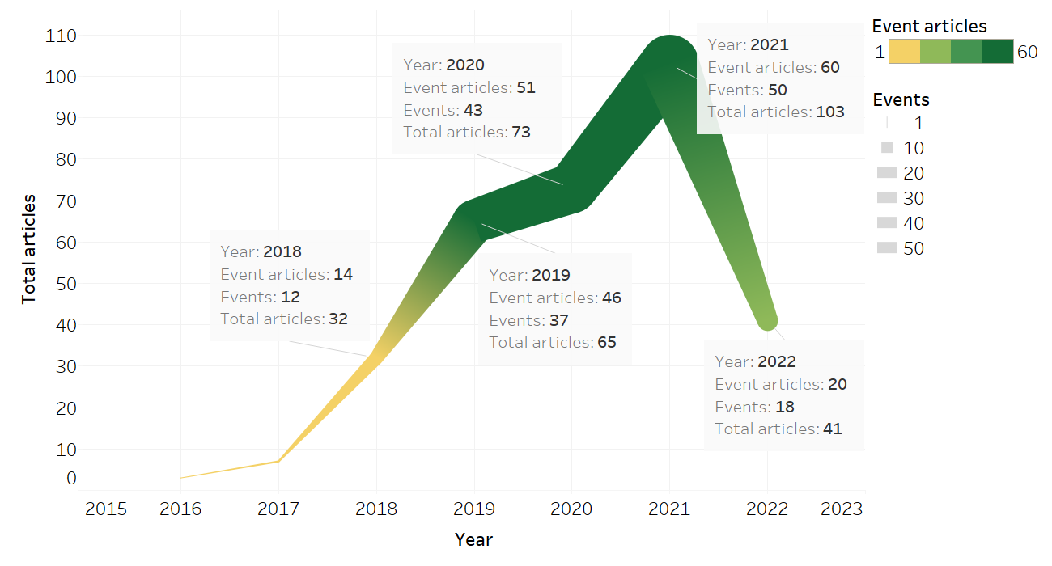
Figure 4. Media reports on AI-related public events with count of events over total reports
The drivers of public discourse about AI in Vietnam can thus be summed up in three groups: (i) the government setting the national strategy and future vision (Figure 1), (ii) the industry actors actively investing and promoting public engagement in AI through public events, and (iii) the media generating public awareness of AI, as shown in Figure 4.

4.2. Vietnamese narratives about AI
This section discusses three prominent narrative strands. The constant acknowledgement of AI benefits across sectors is identified as a common building block of narrative construction (Figure 5). A widespread use of AI technologies is expected to improve the quality of life: from the mundane such as traffic conditions or stopping cheating in exams, to emergency problems such as identifying lost children or natural disaster alert systems, or to even spotting inconsistencies in the law-making processes (See Table 3 below). AI technologies are captured in the discourse of social utilities, and their usages are associated with words such as ‘efficiency,’ ‘security,’ and ‘productivity’. The pursuit of AI, despite all its difficulties, is justified because of its utility. What follows is the framing of AI as inevitable – because all socioeconomic sectors are expected to utilize the new technology, and as necessary – because developing advanced technology solidifies national strength. Such representations of AI, through frequent reporting and public campaigns, contribute to normalizing its presence and gradual applications in society.
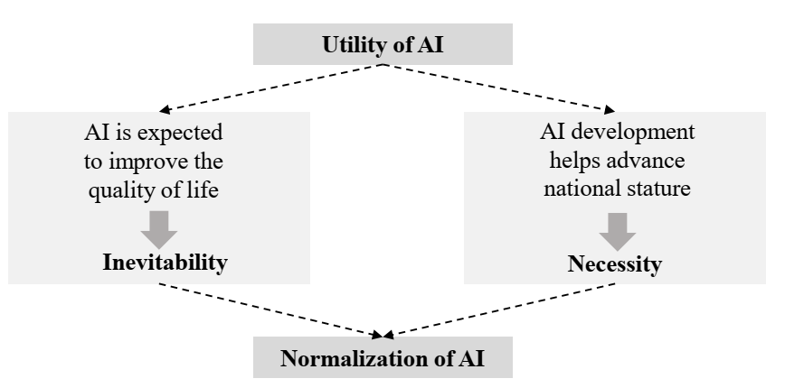
Figure 5. The narratives of AI development and adoption in Vietnamese media

Narrative 1: AI is inevitable
Here, because AI is presented as immensely useful and beneficial to all sectors, the development and use of AI in Vietnam is inevitable. Table 2 summarizes the major utility points for four sectors.
Table 2. Summary of major themes for certain sectors as analyzed in the media reports
 | Utility narrative | Points of caution | Example source(s)
Education | - Revolutionize teaching methods  - Enrich learning-teaching opportunities  - Improve labor force quality | - Change nature of teacher-student relationship  - Unable to handle emotional aspect | (Anh, 2021; Van, 2021)
Healthcare | - Revolutionize disease diagnosis and prognosis  - Improve patient-doctor relationship | - Need upgraded data infrastructure  - Need better protection of personal health information  - AI impossible to fully replace doctors | (Minh, 2019; VA, 2021)
Law-making | - Smart auto detection of inconsistencies in legal documents  - Assist legislative and judiciary processes to ensure impartiality  - Speed up handling of outstanding cases | - Need human oversight | (Hang, 2019)
Security-defense and governance | - Better track, detect, and control irregularities and/or those violating the laws (e.g., traffic accidents, power grid management, urban management, and criminal activities, etc.)  - Improve cybersecurity  - Develop smart city | - Exposed to more cyber-attacks  - Quick spread of misinformation, fake news  - Need upgraded data infrastructure  - Need more skilled tech workforce | (Xuan, 2019, 2021)

Narrative 2: AI is necessary
The necessity of AI also follows in the framing of AI development as critical to the construction of national identity and enhancement of national stature in the global race for AI.
Given that media outlets in Vietnam are controlled and monitored by the state, it is not surprising that the reporting is politically driven. Here, AI technologies are captured in the discourse of national standing, and their development by local companies is used to promote a sense of pride, a yardstick of national capabilities in matching the big nations’ advanced technological development.
Examining the news articles reveals two priorities in Vietnam’s plan to develop AI by 2025. First, to build “make-in-Vietnam” AI products that not only meet the domestic demand but can also be exported to niche markets (My, 2021). Public writings on this aspect evaluate it as “practical” as Vietnamese AI products cannot immediately compete against those from more developed markets (Ngoc, 2018). Second, to create competitive products, the government is intent on boosting domestic capacity through investment in technological infrastructure, human resource education and training, and international networking. It is quite apparent how the role of the public and private sectors is well-defined regarding AI research and development. As discussed above, the government sets the agenda and leads key projects, including the “Digital Vietnamese knowledge system” (launched in 2018). The private sector, comprising tech companies and startups, is actively training the domestic market through frequent public events and competitions so that AI applications can be normalized in everyday life.
The normalization is carried out by industry insiders as much as by those in the education sector. Education in the field of AI still relies on local universities and colleges, even though the National Foundation for Science and Technology Development (NAFOSTED), the country’s pioneering science funder, is committed to support basic AI research projects. The NAFOSTED Conference on Information and Computer Science, organized annually since 2014, has been built as an academic community for researchers in the fields of AI, computer science, software engineering and related areas. The conference is one of many scientific seminars held every year in Vietnam and contributes to the government’s attempt to cultivate a network of 100 overseas Vietnamese scientists. Tapping into the communities of approximately 400,000 Vietnamese scientists overseas is one of the goals to bridge the technological gaps between Vietnam and developed countries (Minh, 2018).
Here emerges a strong narrative of Vietnam looking inward to build its domestic capacity, that Vietnam is capable and attractive as a destination for AI development. This becomes more evident when examining how, even though international expertise is acknowledged as important, cooperation with international partners has been uneven. Only twelve states were mentioned in the 324 articles tracked here, with the United States, Australia, Japan, and South Korea being the most mentioned. Specifically, there are many Vietnamese scientists affiliated with U.S. higher education institutes, with many having returned and spearheaded big AI projects in Vietnam. Meanwhile, South Korea’s Naver Corporation joined hands with Hanoi University of Science and Technology to open the Vietnam AI Center in March 2021 (BT, 2021). Australia is running the Aus4Innovation, an AUD14.5 million development program, to connect Australian and Vietnamese researchers and boost collaboration in scientific innovation (CSIRO, 2022). Overall, there is a sense of pride in news reports about Vietnamese software developers and AI scientists being successful overseas and giving back to the homeland.

4.3. Narrative discrepancies

Discrepancy 1: Optimism prevails amid a lack of media-science communications
While extant studies have found sentiments in media reports about AI to be mixed between being positive and balanced, this research finds an overwhelming sense of optimism and positivity with regards to the development and usage of AI technologies in Vietnam. Figure 6 brings attention to the detailed composition of sentiments (negative, neutral, and positive) in all collected news articles over the recent years.
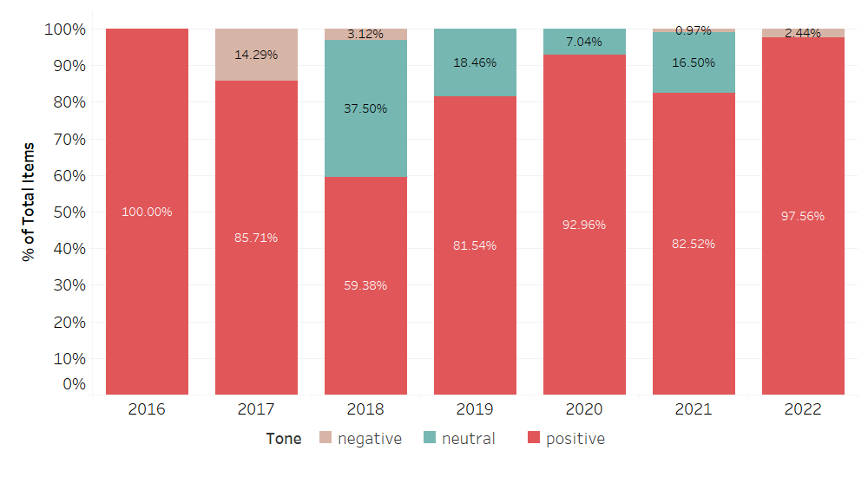
Figure 6. Sentiment analysis
Except for the year 2018 when the proportion of positive news items was 59.38% over the total items, every other year being tracked shows that proportion to be at least above 80%. Remarkably, there appears to be no items marked as negative in 2019 and 2020. In total, the number of negative news items was negligible at 4, equivalent to merely 1.23%, whereas that of neutral news items was 47, or 14.5%.
Of the small number of articles that discuss the downsides of AI development in Vietnam, one published in 2017 outlines a number of limitations in the domestic tech market, such as low demand, an unwillingness to pay a high price for AI products, and a lack of creativity driven by the tech industry’s long-standing position as a source of labor skillful in assembly work rather than creative software engineering work (Nguyen, 2017). These limitations, however, appear to have been sidelined as they are no longer visible in the media reports after 2018.
The negative aspects covered in more recent news articles include ethical and security issues along with challenges for the government in the age of the fourth Industrial Revolution, or Industry 4.0 as it is known in Vietnam. For instance, while there is acknowledgement in the press of the anticipated utility of AI, there is heightened urgency in improving governance capability in adopting the new technologies to improve state monitoring of media-communications and the state sector overall (Hang, 2018; Lam, 2021). Another article warns users of the threats of personal data thief and cyber attacking (Xuan, 2021). Such concerns fall in line with the current literature (Nguyen & Hekman, 2022b; Ouchchy et al., 2020; Vergeer, 2020).
The modest number of neutral reports on AI in Vietnam shows a limited attempt at informing the public on both sides of AI. One potential explanation for the optimistic reporting is, because many reports are event-centric, reporters are more likely to capture the buzz and optimism of the events even if event participants might have talked about both sides of the AI issues. This finding contrasts with that of Zhai et al. (2020), which shows the American media as actively reporting and reflecting on the actual scientific developments of AI and related fields. The implication is clear: academics should look to expand science communications on AI in Vietnam as a way to complement existing media reports.

Discrepancy 2: Absence of operational investments undermines acknowledgement of AI’s importance
There lies a considerable discrepancy between Vietnam’s AI strategy and the execution of this plan. How to operationalize AI beyond its talking points remains a question. This finding is similar to what Fatima et al. (2020) discovered upon a study of 34 AI strategic plans. Governments have been shown to lack plans for operational investments and frequently fail to consider the realities of funding.
In the case of Vietnam, collected news reports provide little to no concrete numbers on the long-term investment on AI. A survey recently reveals that investment in AI solutions companies in Vietnam amounted to just USD0.03 per capita between 2015 and 2019, compared to USD21 per capita in China and USD68 per capita in Singapore (Loh, 2020). The low spending figure on AI-powered solutions is understandable in the sense that AI applicability depends on fundamentals such as data network and digital platforms, both of which are not yet strong in Vietnam.
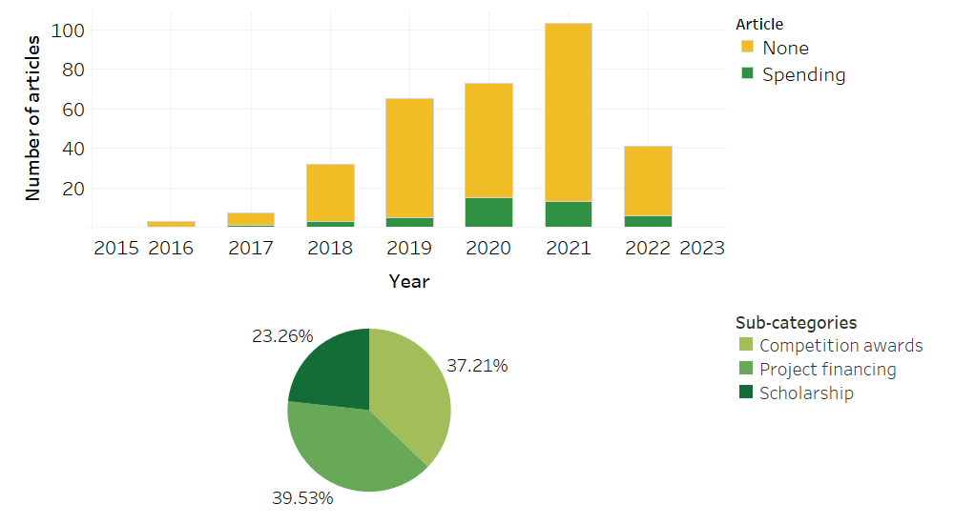
Figure 7. (above) Count of news reports on AI-related spending and (below) sub-categories of spending
Figure 7 illustrates the low number of Vietnamese news articles on investment in AI in the past seven years. Articles reporting on any kind of spending related to AI account for just 13.3% of the total sampled reports. Of these articles, 39.53% were on the financial commitments to AI-related projects, such as Australia funding USD650,000 to support Vietnam’s applications of AI solutions (CSIRO, 2022; Giang, 2020), or the Vietnamese supply chain management startup Abivin mobilizing USD1 million investment (Lien, 2019); while 37.21% were on the awards given to participants at tech competitions, and the remaining 23.26% were on scholarship or financial aid to students pursuing the field of AI. Awards and scholarships are driven by tech giants such as FPT Corporation, which is understandable given that the company uses VnExpress to promote its standing in the field. A scholarship ranges from USD800 to USD16,000 while a competition award goes from USD1,000 to USD8,000. Nonetheless, the money largely comes from private tech companies and foreign government, and not enough was reported on the government’s investment plans for AI in the short and long terms.

Discrepancy 3: Discussion on the ethics of AI is marginal despite robust talks on AI potential.
Despite all the talks about the inevitability and necessity of AI, the study finds a lack of discussion on the ethics of AI. The number of articles mentioning AI ethics was limited to five, of which only one was wholly negative and four neutral. None of the articles present a standalone discussion of ethical issues in developing and using AI; all were reports following up an event. Four of the five events involved foreign participants, who all contributed to expanding the talking points on AI ethics.
Concerns about AI ethics in Vietnam spread across economic and legal spectrum (Table 4). In economic terms, the reports touch on the risk of a fractured labor market as the wage gap widens between the highly skilled tech workers and those less skilled. There is a shared concern about growing inequality and unfairness as AI technologies become more ubiquitous in our daily life. The inequality issue is addressed in both the domestic economy and the global economy. In legal terms, there is a balanced discussion on the importance of establishing data ethics and data protection protocols. The emphasis is on risk assessment and a clear outline of responsibilities in human-machine systems.
Table 4. Summary of five articles mentioning ethics in the pursuit of AI
Article | Tone | Sector | Occasion | Concerns
Lien (2021) in Communist Party Portal | Neutral | Science-technology | An international seminar | - Fracturing labor market  - Wage gap, inequality;  - Privacy;  - Data ethics;  - Legal framework on AI;
Tuan (2019) in  Government Portal | Neutral | Governance; science-technology | A digital economic forum | - Human-centric technology;  - Moral and humanity values;
Hien (2022) in  Thanh Nien (Young People) | Negative | Governance; science-technology | An international seminar | - Inequality;  - Responsibility in decision-making involving AI;  - Human-machine balance;
Chi (2019) in VnExpress | Neutral | Business; security; science-technology | A digital economic forum | - Abuse of AI systems;  - Inequality;
Xuan (2020) in VnExpress | Neutral | Healthcare | A healthcare seminar | - Infrastructure (smart technology, big data);  - Privacy;  - Legal frameworks on AI;  - Responsibility in decision-making involving AI;

Many of the talking points are merely listed, and solutions to issues such as widening inequality, human-machine balance, abuse of AI systems, and data privacy remain a puzzle. For instance, one articles quotes then Prime Minister Nguyen Xuan Phuc, as saying that “Technological innovation must first and foremost be for humans, and about keeping good moral and humanity values” (Tuan, 2019), but offers no plan for execution. Overall, media coverage on AI ethics in Vietnam is superficial. We will discuss some of the reasons for this phenomenon. First, the most plausible explanation is the issue of political legitimacy through development, which is deeply rooted in East Asian philosophies and political cultures about the roles of the rulers (Ho & Luong, 2025; Nguyen & Ho, 2019). Since the Doi Moi reforms of 1986, Vietnam’s Communist government has derived legitimacy from economic growth and political stability (Thayer, 2010, p. 427). Rooted in Marxist views of transforming the world through practice (Nguyen, 2019), the Vietnamese state has long emphasized science and technology as engines of progress. Recently, this focus has expanded to high-tech development, with Minister Chu Ngoc Anh (2020) affirming that science and technology are key drivers of socio-economic advancement and Vietnam’s global standing (Chu, 2020). AI is thus portrayed optimistically in Vietnamese state media as a strategic asset for national development and global competitiveness. Recently, Party General Secretary Tô Lâm called AI a “spearhead and breakthrough,” linking this optimism to the government’s drive to showcase competence and harness AI for Vietnam’s development (Nguyen, 2025).
The second plausible reason concerns the foundational nature of Marxism-Leninism as a guiding philosophy for AI integration in Vietnamese society. While discussions of ethical issues related to AI are increasingly widespread and well-known, these discussions are largely Anglo-Eurocentric and stem from several Anglo-European philosophical discourses. More specifically, Jobin et al. (2019) found that most ethical frameworks originate in the U.S., U.K., and EU, reflecting Kantian and utilitarian ideals such as autonomy, dignity, and beneficence. Marxism, by contrast, conceives freedom as collective self-realization and liberation from material and social constraints (Walicki, 1988). In Vietnam, however, Marxism–Leninism is interpreted mainly through developmental and political lenses. As Dinh Thi Phuong (2019) notes, it directs the socialist path and comprehensive renovation, while Nguyen Van Quang et al. (2024) show its continued role in shaping scientific and technological policy. Consequently, official discussions of AI ethics emphasize modernization and governance over normative or rights-based concerns. Although scholars have proposed Confucian or Buddhist alternatives (Song, 2020; Hongladarom, 2020; Lin, 2023; Seok, 2024), these remain marginal in Vietnamese media discourses, where Marxism–Leninism and Ho Chi Minh’s thoughts remain central to state ideology. Together, these factors contribute to the narrow scope of AI ethics discourse in Vietnam’s official narratives.

5. Conclusion
This study identifies the two major narratives that help normalize AI in Vietnam’s public discourse and analyzes the discrepancies laden in narratives. Here, although AI is presented as inevitable and necessary based on its utility value, Vietnamese media reporting on AI falls short of critical analyses, the science and technology of AI, and the ethics of AI. We also propose that the lack of attention for AI-related ethics comes from the lack of a philosophical foundation for the discussion on AI ethics. And the optimistic view on AI of the Vietnamese state's journals is because of the way the Vietnamese government is gaining legitimacy through economic developments.
There are some common points with previous studies, such as the overall optimism about the potentials of AI, the prominent role of the government and industry insiders in shaping the public discourse on AI, and the lack of specific details on operational investments in both the short and long runs. Yet, the communication of AI in Vietnam also reveals two different trends, namely the event-centric nature of media reporting on AI and the low engagement between AI researchers and mainstream media. Science communications on AI should be promoted to diversify perspectives on the topic.
The optimism and national pride toward the development and application of AI could be interpreted as a way of training the public to think about promising technology in a positive way. Commentaries critical of the government using AI, such as to control, increase surveillance, punish, or persecute citizens, are not allowed. However, critical writings on AI need not be attacks of the government but could start with asking questions that are missing in the current discourse—e.g., how much investment is needed, what kind of governance is expected, what kind of ethical oversight can be implemented and by whom?
News portals owned by private tech companies such as VnExpress could increase the number of editorials, op-eds, and long-form articles explaining AI technical features and their various social and ethical implications. AI communications should also engage a diverse pool of stakeholders including scientists, legal experts, ethicists, etc., moving away from the current industry-led media reports. Better science communications can inform the public and policymakers, shaping a more balanced understanding of AI and its impacts on society in the long run (Vuong, 2018).

Conflicts of Interest
The authors declare no conflict of interests.
Data availability
The data can be made available upon reasonable request.

References
Altmann, J., & Sauer, F. (2017). Autonomous weapon systems and strategic stability. Survival, 59(5), 117-142.
Anh, M. (2021). Thúc đẩy đào tạo nhân lực trí tuệ nhân tạo chất lượng cao [Promoting training of high-quality AI workforce]. Vietnam Communist Party Portal. Retrieved August 24 from https://dangcongsan.vn/khoa-hoc/thuc-day-dao-tao-nhan-luc-tri-tue-nhan-tao-chat-luong-cao-595026.html
Bareis, J., & Katzenbach, C. (2021). Talking AI into Being: The Narratives and Imaginaries of National AI Strategies and Their Performative Politics. Science, Technology, & Human Values, 47(5), 855-881. https://doi.org/10.1177/01622439211030007
Bareis, J., & Katzenbach, C. (2022). Talking AI into Being: The Narratives and Imaginaries of National AI Strategies and Their Performative Politics. Science, Technology, & Human Values, 47(5), 855-881. https://doi.org/10.1177/01622439211030007
Brennen, S., Howard, P. N., & Nielsen, R. K. (2018). An Industry-Led Debate: How UK Media Cover Artificial Intelligence (Oxford Martin Programme on Misinformation, Science and Media, Issue. https://reutersinstitute.politics.ox.ac.uk/our-research/industry-led-debate-how-uk-media-cover-artificial-intelligence
BT. (2021). Việt Nam có trung tâm nghiên cứu về trí tuệ nhân tạo đầu tiên [Vietnam has first center on AI research]. Government Portal. Retrieved August 26 from https://baochinhphu.vn/viet-nam-co-trung-tam-nghien-cuu-ve-tri-tue-nhan-tao-dau-tien-102290024.htm
Bunz, M., & Braghieri, M. (2022). The AI doctor will see you now: assessing the framing of AI in news coverage. AI & Society, 37(1), 9-22. https://doi.org/10.1007/s00146-021-01145-9
Cave, S., Coughlan, K., & Dihal, K. (2019). "Scary Robots": Examining Public Responses to AI.AIES '19 Proceedings of the 2019 AAAI/ACM Conference on AI, Ethics, and Society, Honolulu, HI, USA.
Cave, S., Craig, C., Dihal, K. S., Dillon, S., Montgomery, J., Singler, B., & Taylor, L. (2018). Portrayals and perceptions of AI and why they matter (Technical Report, Issue. http://lcfi.ac.uk/media/uploads/files/AI_Narratives_Report.pdf
Chi, M. (2019). Trầm Hương Khánh Hoà ATC dự diễn đàn các cựu lãnh đạo quốc gia [Tram Huong Khanh Hoa ATC partakes in Club de Madrid]. VnExpress. Retrieved August 24 from https://vnexpress.net/tram-huong-khanh-hoa-atc-du-dien-dan-cac-cuu-lanh-dao-quoc-gia-4001688.html
Chuan, C.-H., Tsai, W.-H. S., & Cho, S. Y. (2019). Framing artificial intelligence in American newspapers. Proceedings of the 2019 AAAI/ACM Conference on AI, Ethics, and Society,
Communist Party of Vietnam. (2019). NGHỊ QUYẾT Số: 52-NQ/TW VỀ MỘT SỐ CHỦ TRƯƠNG, CHÍNH SÁCH CHỦ ĐỘNG THAM GIA CUỘC CÁCH MẠNG CÔNG NGHIỆP LẦN THỨ TƯ [Resolution No.52-NQ/TW on some directions, policies for proactively engaging in the fourth Industrial Revolution]. Thu Vien Phap Luat. Retrieved April 22 from https://thuvienphapluat.vn/van-ban/Dau-tu/Nghi-quyet-52-NQ-TW-2019-chinh-sach-chu-dong-tham-gia-cuoc-Cach-mang-cong-nghiep-lan-thu-tu-425113.aspx
CSIRO. (2022). Aus4Innovation. CSIRO. Retrieved August 26 from https://research.csiro.au/aus4innovation/
Curran, N. M., Sun, J., & Joo-Wha, H. (2020). Anthropomorphizing AlphaGo: a content analysis of the framing of Google DeepMind’s AlphaGo in the Chinese and American press. AI & Society, 35(3), 727-735. https://doi.org/https://doi.org/10.1007/s00146-019-00908-9
Duberry, J. (2022). AI in public and private forms of surveillance: Challenging trust in the citizen-government relations. In Artificial Intelligence and Democracy (pp. 93-125). Edward Elgar Publishing.
Elkin-Koren, N., & Perel, M. (2020). Separation of functions for AI: Restraining speech regulation by online platforms. Lewis & Clark L. Rev., 24, 857.
Fast, E., & Horvitz, E. (2017). Long-term trends in the public perception of artificial intelligence. Proceedings of the AAAI conference on artificial intelligence,
Fatima, S., Dawson, G. S., Desouza, K. C., & Denford, J. S. (2021). Winners and losers in the fulfillment of national artificial intelligence aspirations. (Techtank). https://www.brookings.edu/blog/techtank/2021/10/21/winners-and-losers-in-the-fulfilment-of-national-artificial-intelligence-aspirations/
Fatima, S., Dawson, G. S., Desouza, K. C., & Denford, J. S. (2022). How countries are leveraging computing power to achieve their national artificial intelligence strategies. Brookings Institute. Retrieved August 4 from https://www.brookings.edu/blog/techtank/2022/01/12/how-countries-are-leveraging-computing-power-to-achieve-their-national-artificial-intelligence-strategies/
Fatima, S., Desouza, K. C., & Dawson, G. S. (2020). How different countries view artificial intelligence. https://www.brookings.edu/research/how-different-countries-view-artificial-intelligence/
Feldstein, S. (2019). The road to digital unfreedom: How artificial intelligence is reshaping repression. Journal of Democracy, 30(1), 40-52.
Feldstein, S. (2021). The Rise of Digital Repression: How Technology is Reshaping Power, Politics, and Resistance. Oxford University Press.
Giang, K. (2020). Australia hỗ trợ Việt Nam ứng dụng trí tuệ nhân tạo trong phục hồi kinh tế hậu COVID-19 [Australia supports Vietnam apply AI in post-COVID19 economic recovery]. Nhan Dan. Retrieved October 17 from https://dangcongsan.vn/kinh-te/australia-ho-tro-viet-nam-ung-dung-tri-tue-nhan-tao-trong-phuc-hoi-kinh-te-hau-covid-19-560790.html
Guenduez, A. A., & Mettler, T. (2022). Strategically constructed narratives on artificial intelligence: What stories are told in governmental artificial intelligence policies? Government Information Quarterly, 101719. https://doi.org/https://doi.org/10.1016/j.giq.2022.101719
Hang, D. T. T. (2018). Vấn đề và giải pháp quản lý truyền thông ở Việt Nam trong thời đại Cách mạng công nghiệp 4.0 [Issues and solutions in media monitoring management in Vietnam in the age of Industry 4.0]. Dan Tri. Retrieved August 24 from https://dantri.com.vn/giao-duc-huong-nghiep/van-de-va-giai-phap-quan-ly-truyen-thong-o-viet-nam-trong-thoi-dai-cach-mang-cong-nghiep-40-20180723162133011.htm
Hang, T. (2019). Áp dụng trí tuệ nhân tạo trong xây dựng pháp luật [Applying AI in law-making process]. Vietnam Communist Party Portal. Retrieved August 24 from https://dangcongsan.vn/thoi-su/ap-dung-tri-tue-nhan-tao-trong-xay-dung-phap-luat-523976.html
Hien, Q. (2022). Chuyên gia cảnh báo nguy cơ về 'đạo đức trí tuệ nhân tạo' khi ‘máy học người’ [Expert warns about risks of 'AI ethics' when 'machine learning humans']. Thanh Nien. Retrieved August 24 from https://thanhnien.vn/chuyen-gia-canh-bao-nguy-co-ve-dao-duc-tri-tue-nhan-tao-khi-may-hoc-nguoi-post1422710.html
Ho, M.-T., & Luong, M.-V. (2025). Unraveling the concepts of Democracy (民主) and People as the Roots of the state (民本) facing AI-mediated politics. AI & SOCIETY. https://doi.org/Forthcoming
Jobin, A., Ienca, M., & Vayena, E. (2019). The global landscape of AI ethics guidelines. Nature Machine Intelligence, 1(9), 389-399. https://doi.org/10.1038/s42256-019-0088-2
Johnson, D. G., & Verdicchio, M. (2017). Reframing AI Discourse. Minds and Machines, 27(4), 575-590. https://doi.org/10.1007/s11023-017-9417-6
King, G., Pan, J., & Roberts, M. E. (2013). How censorship in China allows government criticism but silences collective expression. American political science Review, 107(2), 326-343.
Köstler, L., & Ossewaarde, R. (2022). The making of AI society: AI futures frames in German political and media discourses. AI & Society, 37(1), 249-263. https://doi.org/https://doi.org/10.1007/s00146-021-01161-9
Lam, N. B. (2021). Vượt qua áp lực 4.0: Chính sách, pháp luật đã có, vấn đề là tổ chức thực hiện. Government News Portal. Retrieved August 24 from https://baochinhphu.vn/vuot-qua-ap-luc-40-chinh-sach-phap-luat-da-co-van-de-la-to-chuc-thuc-hien-102294300.htm
Lien, B. (2019). Ngày hội trí tuệ nhân tạo Việt Nam 2019 sẽ thu hút nhiều chuyên gia hàng đầu thế giới [AI4VN 2019 expected to attract many leading world experts]. Nhan Dan. Retrieved October 17 from https://dangcongsan.vn/y-te/ngay-hoi-tri-tue-nhan-tao-viet-nam-2019-se-thu-hut-nhieu-chuyen-gia-hang-dau-the-gioi-528875.html
Lien, B. (2021). Xây dựng đạo đức trí tuệ nhân tạo gắn với chuyển đổi số, môi trường số [Building AI ethics in line with digital transformation, digital environment]. Vietnam Communist Party Portal. Retrieved August 24 from https://dangcongsan.vn/khoa-hoc/xay-dung-dao-duc-tri-tue-nhan-tao-gan-voi-chuyen-doi-so-moi-truong-so-595763.html
Loh, D. (2020). Asean faces wide AI gap as Vietnam and Philippines lag behind. Financial Times. https://www.ft.com/content/e99fcb64-2a26-4fa8-9911-03942fbf4493
Manning, C. (2020). Artificial Intelligence Definitions. https://hai.stanford.edu/sites/default/files/2020-09/AI-Definitions-HAI.pdf
Mao, Y., & Shi-Kupfer, K. (2021). Online public discourse on artificial intelligence and ethics in China: context, content, and implications. AI & Society, 1-17. https://doi.org/10.1007/s00146-021-01309-7
Marr, D. (Ed.). (1998). The mass media in Vietnam. Dept. of Political and Social Change, Research School of Pacific and Asian Studies, The Australian National University. https://openresearch-repository.anu.edu.au/handle/1885/132913.
McKinsey & Company. (2021). The state of AI in 2021. McKinsey & Company. Retrieved August 4 from https://www.mckinsey.com/business-functions/quantumblack/our-insights/global-survey-the-state-of-ai-in-2021
Meserole, C. (2018). ORDER FROM CHAOS: Artificial intelligence and the security dilemma. The Brookings Institution. Retrieved April 22 from https://www.brookings.edu/blog/order-from-chaos/2018/11/06/artificial-intelligence-and-the-security-dilemma/
Minh, A. (2018). Việt Nam mời 100 nhà khoa học giúp phát triển công nghiệp 4.0. VnExpress. Retrieved October 18 from https://vnexpress.net/viet-nam-moi-100-nha-khoa-hoc-giup-phat-trien-cong-nghiep-4-0-3790492.html
Minh, H. (2019). Việt Nam sử dụng trí tuệ nhân tạo để chọn phác đồ chữa ung thư [Vietnam deploys AI tool in cancer prognosis]. Government Portal. Retrieved August 24 from https://baochinhphu.vn/viet-nam-su-dung-tri-tue-nhan-tao-de-chon-phac-do-chua-ung-thu-102250374.htm
My, L. (2021). Nền tảng Trí tuệ nhân tạo toàn diện “Make in Vietnam” giúp doanh nghiệp Việt bứt phá [Comprehensive AI platform "Make in Vietnam" helps Vietnamese businesses make breakthrough]. ICT News VietnamNet. https://ictnews.vietnamnet.vn/nen-tang-tri-tue-nhan-tao-toan-dien-make-in-vietnam-giup-doanh-nghiep-viet-but-pha-400046.html
Nah, S., McNealy, J., Kim, J. H., & Joo, J. (2020). Communicating Artificial Intelligence (AI): Theory, Research, and Practice. Communication Studies, 71(3), 369-372. https://doi.org/10.1080/10510974.2020.1788909
Ngoc, B. (2018). Kế hoạch phát triển trí tuệ nhân tạo của Việt Nam đến 2025 [Artificial Intelligence development plan of Vietnam by 2025]. VnExpress. Retrieved August 24 from https://vnexpress.net/ke-hoach-phat-trien-tri-tue-nhan-tao-cua-viet-nam-den-2025-3836227.html
Nguyen, D., & Hekman, E. (2022a). A ‘New Arms Race’? Framing China and the U.S.A. in A.I. News Reporting: A Comparative Analysis of the Washington Post and South China Morning Post. Global Media and China, 7(1), 58-77. https://doi.org/https://doi.org/10.1177/20594364221078626
Nguyen, D., & Hekman, E. (2022b). The news framing of artificial intelligence: a critical exploration of how media discourses make sense of automation. AI & Society. https://doi.org/10.1007/s00146-022-01511-1
Nguyen, P. (2017). Startup Việt gặp khó trong ứng dụng trí tuệ nhân tạo [Vietnamese startups face difficulties in AI applications]. VnExpress. Retrieved August 24 from https://startup.vnexpress.net/tin-tuc/xu-huong/startup-viet-gap-kho-trong-ung-dung-tri-tue-nhan-tao-3609576.html
Nguyen, T.-D., & Ho, M.-T. (2019). People as the Roots (of the State): Democratic Elements in the Politics of Traditional Vietnamese Confucianism. Journal of Nationalism, Memory & Language Politics, 13(1), 90-110. https://doi.org/doi:10.2478/jnmlp-2019-0001
O’Connor, C., & Joffe, H. (2020). Intercoder Reliability in Qualitative Research: Debates and Practical Guidelines. International Journal of Qualitative Methods, 19, 1609406919899220. https://doi.org/10.1177/1609406919899220
Ouchchy, L., Coin, A., & Dubljević, V. (2020). AI in the headlines: the portrayal of the ethical issues of artificial intelligence in the media. AI & SOCIETY, 35(4), 927-936. https://doi.org/10.1007/s00146-020-00965-5
Pham, T. T. H. (2019). Phát triển trí tuệ nhân tạo (AI) tại Việt Nam: Thực trạng, kinh nghiệm quốc tế và xu hướng phát triển [Developing AI in Vietnam: Current situation, international experience, and development trends]. People's Policy Academy Portal. Retrieved April 22 from http://hvcsnd.edu.vn/nghien-cuu-trao-doi/dai-hoc-40/phat-trien-tri-tue-nhan-tao-ai-tai-viet-nam-thuc-trang-kinh-nghiem-quoc-te-va-xu-huong-phat-trien-5675
Price, M., Walker, S., & Wiley, W. (2018). The Machine Beneath: Implications of Artificial Intelligence in Strategic Decision making. PRISM, 7(4), 92-105. https://www.jstor.org/stable/26542709
Quynh Duong. (2022). Thúc đẩy chuyển đổi số tại các cơ quan báo chí Việt Nam [Accelerating digitization at Vietnamese press agencies]. Financial and Monetary Market Review. Retrieved October 18 from https://thitruongtaichinhtiente.vn/thuc-day-chuyen-doi-so-tai-cac-co-quan-bao-chi-viet-nam-42413.html
Savage, N. (2020). The race to the top among the world’s leaders in artificial intelligence. Nature Index(588), S102-S104. https://www.nature.com/articles/d41586-020-03409-8
Stanford University. (2021). GLOBAL AI VIBRANCY TOOL: Who's leading the global AI race? Stanford Institute for Human-Centered Artificial Intelligence. Retrieved August 3 from https://aiindex.stanford.edu/vibrancy/
Suerdem, A., & Akkilic, S. (2021). Cultural Differences in Media Framing of AI. In B. Schiele, X. Liu, & M. W. Bauer (Eds.), Science Cultures in a Diverse World: Knowing, Sharing, Caring (pp. 185-207). Springer Singapore. https://doi.org/10.1007/978-981-16-5379-7_10
Trump White House. (2021). The White House Launches the National Artificial Intelligence Initiative Office. Office of Science and Technology Policy, Trump White House. Retrieved April 22 from https://trumpwhitehouse.archives.gov/briefings-statements/white-house-launches-national-artificial-intelligence-initiative-office/
Tuan, D. (2019). Thủ tướng: Sáng tạo công nghệ mới trước hết phải vì con người [PM: Technological innovation must be for humans first and foremost]. Government Portal. Retrieved August 24 from https://baochinhphu.vn/thu-tuong-sang-tao-cong-nghe-moi-truoc-het-phai-vi-con-nguoi-102258019.htm
VA. (2021). Ứng dụng trí tuệ nhân tạo hỗ trợ sàng lọc và tiên lượng điều trị COVID-19. Vietnam Communist Party Portal. Retrieved August 24 from https://dangcongsan.vn/khoa-hoc-va-cong-nghe-voi-su-nghiep-cong-nghiep-hoa-hien-dai-hoa-dat-nuoc/tin-tuc-su-kien/ung-dung-tri-tue-nhan-tao-ho-tro-sang-loc-va-tien-luong-dieu-tri-covid-19-591677.html
van Noort, C. (2022). On the use of pride, hope and fear in China’s international artificial intelligence narratives on CGTN. AI & Society. https://doi.org/10.1007/s00146-022-01393-3
Van, P. (2021). Ứng dụng dạy học sử dụng trí tuệ nhân tạo [Study app uses AI]. VnExpress. Retrieved August 24 from https://startup.vnexpress.net/tin-tuc/xu-huong/ung-dung-day-hoc-su-dung-tri-tue-nhan-tao-4305020.html
Vergeer, M. (2020). Artificial Intelligence in the Dutch Press: An Analysis of Topics and Trends. Communication Studies, 71(3), 373-392. https://doi.org/10.1080/10510974.2020.1733038
Vietnamese Prime Minister. (2020). QUYẾT ĐỊNH Số: 2289/QĐ-TTg BAN HÀNH CHIẾN LƯỢC QUỐC GIA VỀ CÁCH MẠNG CÔNG NGHIỆP LẦN THỨ TƯ ĐẾN NĂM 2030 [Decision No.2289/QD-TTg: Issuance of National Strategy on the Fourth Industrial Revolution by 2030]. Thu Vien Phap Luat. Retrieved April 22 from https://thuvienphapluat.vn/van-ban/Cong-nghe-thong-tin/Quyet-dinh-2289-QD-TTg-2020-Chien-luoc-quoc-gia-ve-Cach-mang-cong-nghiep-lan-thu-tu-den-2030-461337.aspx
Vietnamese Prime Minister. (2021). QUYẾT ĐỊNH Số: 127/QĐ-TTg: BAN HÀNH CHIẾN LƯỢC QUỐC GIA VỀ NGHIÊN CỨU, PHÁT TRIỂN VÀ ỨNG DỤNG TRÍ TUỆ NHÂN TẠO ĐẾN NĂM 2030 [Decision No. 127/QD-TTg: Issuance of National Masterplan on the Research, Development, and Application of AI until 2030]. Thu Vien Phap Luat. Retrieved April 19 from
Vuong, Q.-H. (2018). The (ir)rational consideration of the cost of science in transition economies. Nature Human Behaviour, 2(1), 5-5. https://doi.org/10.1038/s41562-017-0281-4
Vuong, Q.-H., Bui, Q.-K., La, V.-P., Vuong, T.-T., Nguyen, V.-H. T., Ho, M.-T., Nguyen, H.-K. T., & Ho, M.-T. (2018). Cultural additivity: behavioural insights from the interaction of Confucianism, Buddhism and Taoism in folktales. Palgrave Communications, 4(1), 143. https://doi.org/10.1057/s41599-018-0189-2
Vuong, Q. H. (2025). Wild Wise Weird. https://www.amazon.com/dp/B0BG2NNHY6 (5th ed.).
World Economic Forum. (2016). The Fourth Industrial Revolution, by Klaus Schwab. World Economic Forum. https://www.weforum.org/about/the-fourth-industrial-revolution-by-klaus-schwab
Wright, N. (2018). How artificial intelligence will reshape the global order. Foreign Affairs, 10.
Xuan, N. (2019). Công nghệ AI sẽ giải quyết lỗ hổng an ninh mạng tại Việt Nam [AI technology will help Vietnam address cybersecurity loopholes]. VnExpress. Retrieved August 25 from https://vnexpress.net/cong-nghe-ai-se-giai-quyet-lo-hong-an-ninh-mang-tai-viet-nam-3967753.html
Xuan, N. (2020). Quy định rõ trách nhiệm khi ứng dụng AI trong y tế [Clear stipulation needed on responsibilities for AI applications in healthcare]. VnExpress. Retrieved August 24 from https://vnexpress.net/quy-dinh-ro-trach-nhiem-khi-ung-dung-ai-trong-y-te-4166599.html
Xuan, N. (2021). Hiếu PC: 'AI có thể bị lợi dụng tạo công cụ hack tự động' [Hieu PC: AI can be abused as an auto hacking tool]. VnExpress. Retrieved August 24 from https://vnexpress.net/hieu-pc-ai-co-the-bi-loi-dung-tao-cong-cu-hack-tu-dong-4285253.html
Zeng, J., Chan, C.-h., & Schäfer, M. S. (2022). Contested Chinese Dreams of AI? Public discourse about Artificial intelligence on WeChat and People’s Daily Online. Information, Communication & Society, 25(3), 319-340. https://doi.org/10.1080/1369118X.2020.1776372
Zhai, Y., Yan, J., Zhang, H., & Lu, W. (2020). Tracing the evolution of AI: conceptualization of artificial intelligence in mass media discourse. Information Discovery and Delivery, 48(3), 137-149. https://doi.org/10.1108/IDD-01-2020-0007

The fourth Industrial Revolution was first brought up by the German economist Klaus Martin Schwab. See World Economic Forum. (2016). The Fourth Industrial Revolution, by Klaus Schwab. World Economic Forum. https://www.weforum.org/about/the-fourth-industrial-revolution-by-klaus-schwab
Abbreviation notes: VPA stands for Vietnam People’s Army; MOST for Ministry of Science and Technology; Govt for Government; and MPS for Ministry of Public Security. Additionally, the colors of the text indicate the type of organization issuing the document: red means the document was issued by a Party or Party-affiliated organization, black means it was issued by the legislative body of the National Assembly, and blue means it was issued by the government or government-affiliated organization.

