Enhancing the Teaching of Applied Ethics with Virtual-Reality-Presented Thought Experiments

Jinglin Zhou
Fudan University
Yiran Cao
Fudan University
Jiacheng Ji
Fudan University
Guoyu Wang*
Fudan University

Abstract: In this paper, we propose incorporating virtual-reality-presented thought experiments (VRTEs) to enhance the quality of undergraduate courses on classic works in applied ethics. Thought experiments are a key method in applied ethics for eliciting intuitions as evidence for or against theories. However, our interviews and surveys show that undergraduates often struggle with imagination deficiencies, add undescribed details, apply pre-endorsed theories, lack seriousness, and show disinterest when reading written thought experiments, hindering their engagement and critical thinking. We argue that VRTEs may mitigate these challenges by providing concrete visualisations, immersive experiences, embodiment, interactivity, and controlled reaction times. Feedback from our pilot practice indicates that VRTEs have the potential to mitigate these challenges. To enhance the benefits, we recommend allowing sufficient time for the development of VRTEs and alternating between traditional paper-based teaching and VRTE sessions. We also address potential objections to our teaching approach.
Keywords: Applied Ethics; Course Structure; Thought Experiments; Trolley Scenarios; Virtual Reality

In contemporary philosophy, the method of cases is frequently employed. Philosophers using this approach create hypothetical scenarios, known as thought experiments, to draw out readers’ intuitions. If a theory or generalisation conflicts with the intuition elicited by a thought experiment, it is considered defeasible evidence against the theory. Conversely, if the theory aligns with the intuition, it serves as prima facie support (Pust 2019). This method is widely used across philosophical branches, including the Gettier Case in epistemology (Gettier 1963), the Flagpole Case in the philosophy of science (Bromberger 1966), and the Experience Machine Cases in normative ethics (Nozick 1990).
The method of cases is also prominent in applied ethics (Walsh 2011). Applied ethics is ‘about the application of ethics or morality … to practical issues’ (Singer 2011, 1), such as abortion, euthanasia, and animal rights. Many classic works in this field use thought experiments, such as the Trolley Cases (Foot 1967; Thomson 1976), the Violinist Case (Thomson 1971), the Drowning Child Case (Singer 1972), and the Young Girl’s Child Case (Parfit 1986), to derive intuitions as evidence in support of their arguments.
Undergraduate applied ethics courses, as discussed in this paper, aim to familiarise students with classic works in the field. Many instructors have higher expectations: they want students to critically evaluate the works they read, fostering a mindset of critical thinking that will benefit their future studies. Most importantly, instructors hope students will develop a lasting interest in applied ethics after the courses, as genuine interest is the best teacher. To achieve these goals, students should be able to mentally simulate the thought experiments they read and form corresponding intuitions. This allows them to evaluate whether the intuitions philosophers aim to evoke are merely the philosophers’ idiosyncratic preconceptions. Besides, students need to develop a long-term interest in thought experiments.
However, undergraduate students in applied ethics classes often encounter difficulties with thought experiments. For instance, while teaching Philippa Foot’s famous paper ‘The Problem of Abortion and the Doctrine of the Double Effect’ (Foot 1967 below), one student mentioned finding it hard to imagine the Gas Room Scenario, in which five patients could be saved by manufacturing a certain gas but this would inevitably release lethal fumes into the room of another patient who could not be moved. Another student reflected that while reading Foot’s paper, they unwittingly applied the very principle Foot defends – that negative duties are stricter than positive duties – back into the scenarios she depicts, leading to circular reasoning. More seriously, many students complained that the thought experiments are so abstract and bizarre that they become boring. This lack of interest leads them to skim or abandon the paper after just a few pages.
These difficulties can significantly frustrate teachers’ goals of cultivating critical thinking and long-term interest in applied ethics, compromising the quality of instruction. Fortunately, the emerging technology of virtual reality (VR) seems to offer a promising solution. Applied ethics teachers could develop VR-based games that model the thought experiments depicted in classic works. These games can engage students, spark their interest, and control their response times to evoke pre-theoretic intuitions. Given these advantages, we propose and defend the use of VR-presented thought experiments (VRTEs) to enhance the quality of teaching applied ethics, based on feedback from our previous teaching practice.
Admittedly, the method of cases faces several significant critiques, independent of how thought experiments are presented. Firstly, some argue that drawing moral conclusions from thought experiments to real-life cases by analogy is unreliable, since thought experiments inevitably provide limited information compared to real cases (Dancy 1985; Wilson 2016). Secondly, some thought experiments incorporate biologically or technologically impossible elements, such as human fission. Critics worry that our capacity for intuitive judgment is unreliable in such scenarios, as it has not been shaped by evolution or social practice to handle them (Kitcher 2012). Thirdly, many thought experiments are accused of being misleading by posing dubious questions, artificially limiting the range of admissible actions, or introducing problematic assumptions through implicature or presupposition (Wood 2011). Fourthly, experimental philosophy has shown that moral intuitions vary across demographics (e.g., Buckwalter and Stich 2010), are influenced by both rational deliberation and emotional reactions (Haidt 2001), and are prone to moral dumbfounding (Haidt and Hersh 2001).
This paper refrains from addressing these challenges, as its focus is on enhancing the teaching of classic works in applied ethics, rather than improving the method of cases itself. Given the ubiquity of this method in these works, instructors must still present students with various thought experiments, whether in written form or through other media. The key question, then, is whether VRTEs, as a mode of presentation, can better serve pedagogical purposes compared to other methods, despite the well-grounded critiques that no mode can fully escape. Nonetheless, we believe a well-rounded course should also expose students to both the objections to and defences of the method of cases.
The structure of our paper is as follows. In the first section, we outline the various difficulties students may encounter with thought experiments in applied ethics. Next, we theoretically explore the functions of VRTEs in mitigating these difficulties. In the third section, we introduce our previous teaching practice where VRTEs were employed and present the feedback provided by students. While the feedback provides limited supports for the potential of VRTEs, it also suggests specific ways to structure an applied ethics course to make the best of VRTEs. Therefore, in the fourth section, we propose a specific structure for an applied ethics course. Finally, we consider and respond to potential objections to our proposal.

1. The Challenges Thought Experiments Bring to Students
In many universities, courses that teach undergraduates classic works in applied ethics aim to enable students to critically evaluate these works and cultivate a long-term interest in the field. However, our past teaching experience suggests that written thought experiments pose many challenges to undergraduates, hindering their development of a critical perspective and lasting interest. To address this, we incorporated feedback sessions in our applied ethics course for the spring semester of 2024 to identify the kinds of difficulties undergraduates, as philosophical novices, may encounter.
The course consisted of 43 undergraduates, from freshmen to seniors. Initially, we dedicated a 90-minute lecture to instructing students on the method of cases. A week later, we used another pre-read lecture to teach Foot 1967 and Judith Jarvis Thomson’s rebuttal in ‘Killing, Letting Die, and the Trolley Problem’ (Thomson 1976 below, 206-7). We chose the two works because they are both classics and contain a rich array of thought experiments. After this lecture, we administered Questionnaire Ⅰ to each student present, with responses from 40 out of 43 registered students (36 valid responses). The questionnaire assessed students’ reactions to thought experiments presented in written format (see Appendix). Furthermore, we conducted in-depth interviews with 13 students (referred to as students A-M) to further explore their difficulties with thought experiments after a VRTE session (see Interview Outline in the Appendix).
The feedback from students indicates they encountered many interconnected difficulties with thought experiments. However, these difficulties can be classified into five main types. The first kind of difficulty is that some students find it challenging to imagine the thought experiments depicted by Foot and Thomson. Here, imagination refers to the production of mental images while reading (Esrock 1994). In Questionnaire I, we surveyed how easily students could imagine each thought experiment provided by Foot 1967 and Thomson 1976. Specifically, from questions 1 to 10, we presented students with ten different thought experiments in turn. In each sub-question x.1, we asked, ‘How easy do you find it to imagine this fictional scenario in your mind?’ Students could respond with ‘very easy,’ ‘easy,’ ‘average,’ ‘difficult,’ or ‘very difficult.’ The results show that 30% of students found it not easy to imagine the thought experiments, with 8.61% finding it at least hard to imagine (see Table 1 below). Interestingly, sometimes the difficulty in imagining is due to unwillingness rather than inability. For example, student E mentioned that they could not vividly imagine the trolley scenarios because doing so would evoke unpleasant feelings. However, there is nothing inherently unimaginable about the trolley scenarios. These scenarios are not modally remote, as they involve no biologically or technologically impossible elements, but are simply unusual combinations of everyday items. The failure to imagine, therefore, stems from some students’ diminished ability or reluctance to visualise written scenarios. Just as science fiction films help audiences visualise fantastical worlds, directly presenting students with immersive experiences can remedy their limited imaginative capacities.

Table 1. Descriptive statistics for each sub-question x.1 in Questionnaire I
How easy do you find it to imagine this fictional scenario in your mind?
Sub-questions | 1.1 | 2.1 | 3.1 | 4.1 | 5.1 | 6.1 | 7.1 | 8.1 | 9.1 | 10.1 | Average | Comparison
Very easy | 41.7% | 36.1% | 30.4% | 27.8% | 30.6% | 27.8% | 30.6% | 25.0% | 36.1% | 33.3% | 31.9% | Easy to imagine  70.0%
Easy | 38.9% | 25.0% | 36.1% | 36.1% | 38.9% | 50.0% | 41.7% | 38.9% | 38.9% | 36.1% | 38.1% | Easy to imagine  70.0%
Average | 16.7% | 22.2% | 22.2% | 25.0% | 22.2% | 16.7% | 25.0% | 25.0% | 13.9% | 16.7% | 20.6% | Not easy to imagine  30.0%
Difficult | 2.8% | 13.9% | 11.1% | 11.1% | 8.3% | 2.8% | 2.8% | 11.1% | 11.1% | 11.1% | 8.6% | Not easy to imagine  30.0%
Very difficult | 0.0% | 2.8% | 0.0% | 0.0% | 0.0% | 2.8% | 0.0% | 0.0% | 0.0% | 2.8% | 0.8% | Not easy to imagine  30.0%

This issue of imagination has significant consequences. Firstly, depending on the extent of a student’s deficiency in imagination, a thought experiment may increasingly resemble a mere sequence of words. This can result in the failure to trigger strong moral intuitions, similar to how readers with aphantasia (inability to visualise) have a dampened emotional response to stories (Wicken, Keogh, and Pearson 2021). However, elicited moral intuitions are essential for evaluating works of applied ethics. Secondly, and closely related, the lack of strong moral intuitions may lead students to apply the moral principles they already endorse, or those that the philosophers are defending, back to the thought experiments to draw moral verdicts. For instance, student M had difficulty imagining Thomson’s trolley scenario, in which a passenger must decide whether to let the trolley run over five people or divert it to one person. They reported that they simply endorsed the moral verdict Thomson expects them to adopt. Finally, students who struggle with imagination may find philosophical works with thought experiments boring.
The second difficulty is that some students introduce details not described by the authors into the thought experiments, which substantially influence their verdicts. Students B, C, H, I, and K all reported adding details not mentioned by Foot 1967 and Thomson 1976 into the trolley scenarios. Notably, student H imagined the person on the side track as someone intimate, while student I imagined an elderly person on the side track versus five children on the main track. Most students who introduced additional details reported that these details affected their verdicts about the trolley cases, at least undermining their confidence in their intuitions. Details not specified by a philosopher’s description may introduce more morally relevant features than those the philosopher intends to account for with a moral principle or theory. For example, Foot’s distinction between negative and positive duties is meant to address moral situations involving possible victims with no distinguishing characteristics, rather than cases like an intimate versus five strangers or an elder versus five children. As a result, a verdict about a thought experiment with such smuggled-in details can no longer serve as a basis for critically evaluating the philosopher’s argument.
The third difficulty is that some students apply their pre-endorsed moral principles or theories back into the thought experiments. During our interviews, most students mentioned that their verdicts on the written trolley scenarios were not pre-theoretic intuitions. For instance, student A applied a utilitarian principle to justify turning the trolley to the side track, killing one person. More notably, student J applied Foot’s thesis – that negative duties are weightier than positive duties – back to the trolley scenarios. Student C simply endorsed Foot’s own intuitions regarding each thought experiment. However, it is widely assumed in philosophy that the method of cases is used to elicit our pre-theoretic intuitions to evaluate a theory (e.g., Weatherson 2003, 8). Drawing theory-laden verdicts from thought experiments leads to testing one theory against another or even circular reasoning, such as testing Foot’s principle against her own intuitions.
The fourth difficulty is that some students do not take thought experiments seriously. In question 11 of Questionnaire I, we asked students, ‘Regarding the thought experiments above, how serious are you when making your choices?’ They could reply with ‘very serious,’ ‘serious,’ ‘average,’ ‘casual,’ or ‘very casual.’ More than 13% of students indicated that they did not make their choices in a serious manner (see Figure 1 below).
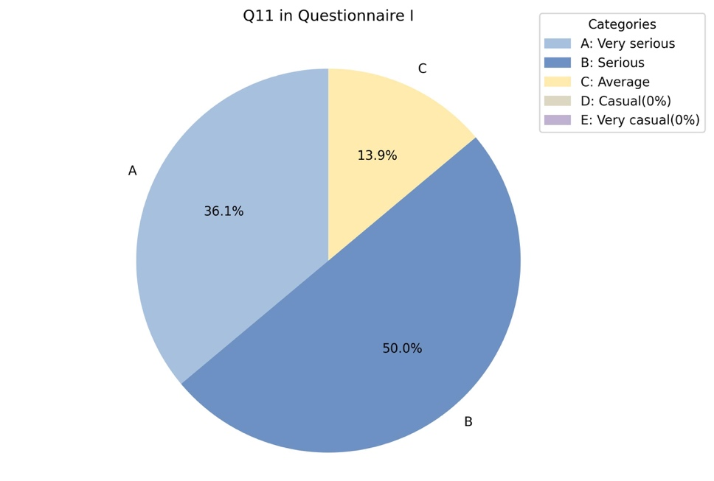
Figure 1. Question: Regarding the thought experiments above, how serious are you when making your choices?

This may be because written thought experiments seem unrealistic and inanimate, failing to evoke the seriousness that people have when facing real-life moral dilemmas. This lack of seriousness can weaken the perceived strength of their moral intuitions, which is often seen as an indicator of trustworthiness (e.g., Davis 2007, 430). Even worse, a lack of seriousness to the extent of an ‘anything goes’ attitude can result in arbitrary verdicts that cannot serve as evidence in theory selection at all.
The final difficulty is that many students lack interest in thought experiments. In question 12 of Questionnaire I, we asked students, ‘Do you find the thought experiments above interesting?’ They could reply with ‘very interesting,’ ‘interesting,’ ‘average,’ ‘boring,’ or ‘very boring.’ More than 35% of students did not find the thought experiments interesting (see Figure 2).
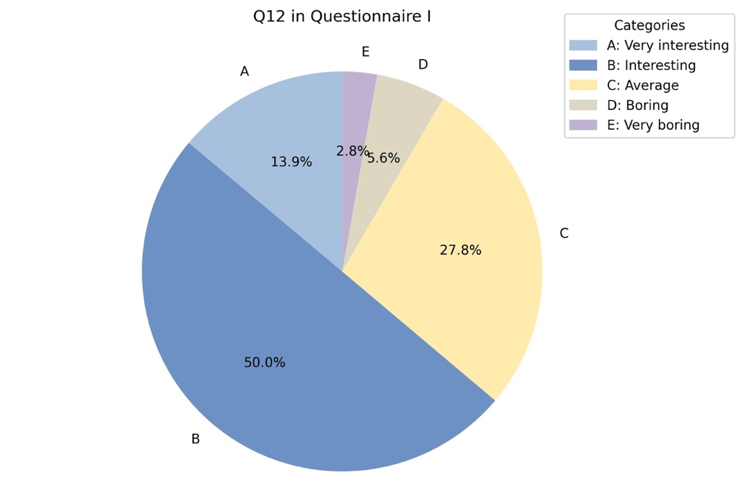
Figure 2. Question: Do you find the thought experiments above interesting?

Likewise, in question 13 of Questionnaire I, we asked students, ‘Would you be willing to experience more thought experiments?’ More than 20% of students showed a lack of interest in exploring other thought experiments (see Figure 3).
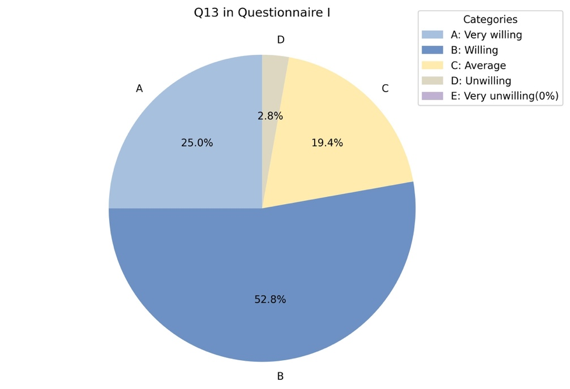
Figure 3. Question: Would you be willing to experience more philosophical thought experiments?

Similar to the lack of seriousness, this disinterest may stem from the unrealistic and inanimate nature of thought experiments. Students do not feel that the scenarios are ones they could encounter in real life, nor can they engage with the perspectives of the protagonists, as written scenarios lack embodiment and interaction (Aoudjit 2012, 49). Unlike the previous difficulties that mainly affect students’ ability to critically evaluate Foot’s and Thomson’s arguments, the lack of interest is more detrimental: disinterested students may even lack the motivation to finish reading Foot 1967 and Thomson 1976. This is evidenced by the invalid responses to Questionnaire Ⅰ from four students who answered randomly, following patterns like ‘ABA’. Disinterest in thought experiments can also discourage students from reading other classic works involving them, severely compromising the teaching of applied ethics.
In sum, undergraduates mainly face five types of difficulties with thought experiments: imagination deficiency, adding undescribed details, drawing theory-laden verdicts, lack of seriousness, and disinterest. These obstacles significantly hinder the ability of applied ethics courses to cultivate students’ critical perspectives on classic works and their genuine interest in the field.

2. The Functions of Virtual-Reality-Presented Thought Experiments
In this section, we explore the functions of VRTEs that may mitigate the difficulties undergraduates encounter with written thought experiments. VR is a technology that uses computer-generated simulations to create an immersive environment for users. It often involves three-dimensional visualisations, sounds, and sometimes tactile feedback, enabling users to interact with and experience a virtual world as if it were real (Mujber, Szecsi, and Hashmi 2004). VRTEs are VR-based games that faithfully present various thought experiments depicted by applied ethicists. In a VRTE, a user experiences the entire setting of a thought experiment and is required to make an action choice. For example, in a Foot trolley VRTE, the user plays the role of the trolley driver who must decide whether to let the trolley hit five people or turn it onto one person.
The first potential function of VRTEs is to visualise written thought experiments in a standardised way. Visualisation can help students overcome imagination deficiencies by addressing the abstract nature of thought experiments (e.g., Campos, Hidrogo, and Zavala 2022; Johnson et al. 2002). Experimental philosophy has demonstrated the phenomenon of framing effects – namely, that different linguistic phrasing can influence participants’ responses to a thought experiment (Tversky and Kahneman 1981). By using non-linguistic visualisation, VRTEs can reduce framing effects. Besides, a VRTE can be designed to include, to the greatest extent possible, only the details originally contained in a thought experiment. For example, a Foot trolley VRTE can depict five versus one person with no distinguishing characteristics. While a VRTE necessarily involves some extraneous details, they can be maximally constrained to those that have no bearing on the moral status of action options – morally irrelevant features – such as the colour of the trolley and sky. By standardising each student’s vision of a thought experiment, the addition of undescribed but morally relevant details can be effectively curbed. This standardisation ensures that students are exposed to nearly identical contextual information, the variation of which, as experimental philosophers have shown, can shift responses (Nichols and Knobe 2007).
The second function is to provide a sense of immersion in virtual thought experiments. Immersion refers to VR’s technological capability to render virtual environments and objects realistically (Slater 2018, 432). Being immersed in a VRTE, students’ attention is focused on an unfolding event (Zahiu et al. 2023, 50), such as a runaway trolley, until a moral choice must be made. This immersion can temporarily eliminate the cognitive space to imagine extra details or apply pre-endorsed moral theories. However, one reason many philosophers keep their life-or-death thought experiments unrealistic is likely to avoid triggering negative emotions that could distort moral intuitions (Rawls 2005, 42). Moreover, presenting students with graphic, bloody scenarios in the classroom may cross ethical boundaries in education. Therefore, when designing immersive VRTEs, it makes sense to avoid depicting gruesome scenes, such as deaths.
The third function is to control students’ response times to thought experiments. Unlike reading a paper, where students have ample time to draw a verdict, VRTEs can be designed to limit reaction times. For instance, a Foot trolley VRTE might set a fixed time, such as 20 seconds, from the moment the trolley starts moving to when it reaches the victims. Constrained response times may reduce the likelihood of adding extraneous details or relying on pre-endorsed moral theories. However, it could be argued that the moral intuitions philosophers aim to elicit through thought experiments are those formed after reflection. Restricting response times in VRTEs may hinder this expectation. In this sense, VRTEs should be seen as a supplement rather than a substitute for traditional paper-based reading, where students are given sufficient time to reflect and form their moral intuitions. Thus, as we propose later, teachers should alternate between VRTE sessions and traditional paper-based teaching.
The fourth function is embodiment. An avatar is the digital representation of a user in the virtual world, and the subjective experience of the avatar’s body as one’s own is called embodiment (Slater et al. 2010). In a VRTE, a student’s avatar becomes the protagonist of the thought experiment. With a sense of body ownership and situatedness granted by embodiment (Kokkinara et al. 2016), students can effectively put themselves in the protagonist’s shoes (Rueda and Lara 2020), thus experiencing moral dilemmas in an immediate and personal way. This immediate experience may significantly enhance the seriousness with which students approach the scenario.
The fifth function is interaction with the virtual environment. VRTEs allow users to make virtual action choices with perceptible consequences within an immersive environment (Sastry and Boyd 1998; Irshad, Perkis, and Azam 2021). For example, a Foot trolley VRTE can depict the trolley running over one person or five people based on the user’s decision. Unlike written thought experiments that follow a predetermined script and stop at a decision point, the inherent interactivity of VRTEs provides students with a sense of participation, cultivating their interest in thought experiments (Zhang, Bowman, and Jones 2019). Realising that their choices are causally responsible for realistic consequences may also lead students to take their moral decisions more seriously (Dechering and Bakkes 2018).
To sum up, there are strong theoretical reasons supporting VRTEs’ value in mitigating the difficulties student face with thought experiments. Nonetheless, their practical efficacy still needs to be examined. Therefore, we incorporated a VRTE session into our applied ethics course for the spring semester of 2024 to assess the potential of VRTEs to enhance teaching quality in practice. In the next section, we introduce this pilot teaching practice, using student feedback to evaluate how well VRTEs help overcome difficulties and to discuss the limitations of our pioneering approach. Our investigation is humanistic in nature, relying primarily on interview results. Based on reflections on our initial practice, the fourth section proposes a structure for an applied ethics course that deeply engages with VRTEs.
However, there are several potential objections to incorporating VRTEs into applied ethics classrooms. Firstly, some may be concerned that VRTEs could take up too much of students’ time, potentially encroaching on the limited time available for traditional, paper-based teaching. This concern could largely be mitigated by making VRTE sessions voluntary and extra-curricular – students would have the opportunity to experience VRTEs, but participation would be based on their own voluntary consent.
Secondly, many institutions currently lack the technological infrastructure (equipment, lab space, etc.) needed to support VRTEs at a meaningful level. Since most institutions would either be unable to incorporate VRTEs into their teaching or could only do so to a limited extent, offering VRTEs at only a select few institutions raises concerns about educational equity and equal access to technology. In response to this objection, we believe that any programme with high-quality educational resources faces similar equity challenges – some institutions will inevitably offer better multimedia, library resources, instructors, or simply greater renown than others. Nonetheless, educational equity remains a key value to uphold. Therefore, in the fourth section, after outlining a course structure, we explore ways to mitigate unequal access to VRTEs across institutions with different levels of resources.
Thirdly, there are some risks associated with the use of VR, such as cybersickness, visual fatigue, muscle strain, acute stress, and mental overload (Souchet et al. 2023). Students who are neurodivergent may be particularly vulnerable to these issues. Furthermore, teachers trained in ethics, rather than clinical psychiatry or psychology, may lack the expertise to manage such risks effectively. Avoiding harm to students is one of the foremost moral priorities in education, especially in the teaching of applied ethics. Therefore, in the fourth section, we also offer strategies to mitigate these potential risks.

3. A Pilot Practice and Its Feedback
Two weeks after the aforementioned lecture on Foot 1967 and Thomson 1976, we organised a VRTE session for students to experience two VR trolley scenarios. The 36 students who submitted valid responses to Questionnaires I participated. In each round, four to six students could experience the VRTEs together. They sat in chairs, wearing VR headsets and holding controllers. The left controller allowed them to move the avatar’s body, while the right controller enabled them to adjust their perspectives and interact with the environment. A large display screen in front of them showed their VR experiences in 2D, allowing others to observe (see Image 1).
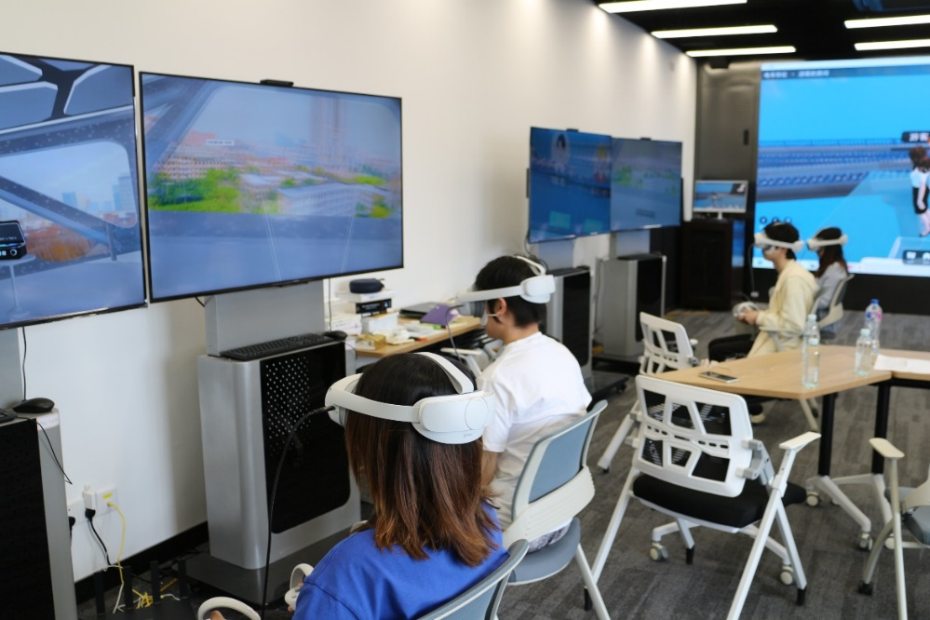
Image 1. Illustration of the setup for a VRTE session

The first VRTE was a VR presentation of the trolley case described by Foot (Foot 1967, 8), where a student played the role of the trolley driver. In front of the trolley, there were two tracks (see Image 2). Five people were on the main track, while one person was on the side track. Tall wire fences on both sides barred anyone from leaving the tracks. The trolley’s brakes had failed, so the student, as the driver, could not stop it. If the student did nothing, the trolley would continue on the main track and hit the five people. The student could choose to divert the trolley onto the side track, hitting one person. At the moment when the trolley reached the victim or victims, the students’ vision was redirected to a beautiful beach scene. We did not depict deaths to avoid causing negative emotions for the students. The VRTE strictly controlled the student’s response time to 20 seconds – if they exceeded this time, the trolley would proceed straight and hit the five people.

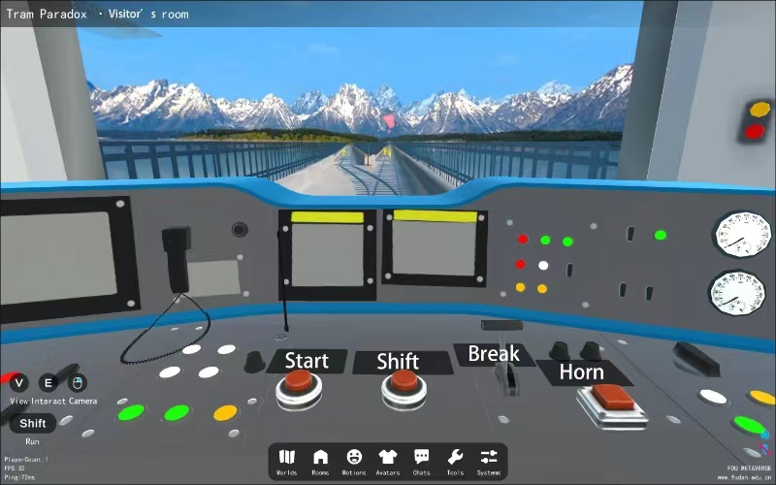
Image 2. A 2D screenshot of Foot’s VRTE

The second VRTE was a variation of the trolley case depicted by Thomson 1976 (Thomson 1976, 207). In the original thought experiment, Thomson describes a passenger on a trolley with failed brakes, whose driver has just died from shock. In our VRTE, a student played the role of a passerby who stumbled upon a control button that could redirect the runaway trolley to a side track. The rest was the same as in the first VRTE: the student had 20 seconds to decide whether to redirect the trolley. Our VRTE did not completely mirror Thomson’s original scenario because depicting the driver’s death could trigger unwanted negative emotions. However, the passerby encountering the control button, like the passenger, is unexpectedly drawn into a moral dilemma. The morally relevant features in both scenarios are identical. It can be expected that whether the player is the passenger or the passerby, the choices made would be similar.
After each round of the VRTEs, we administered two questionnaires to each student. Questionnaire Ⅱ was similar to Questionnaire I, aiming to assess students’ reactions to the various written thought experiments from Foot 1967 and Thomson 1976, while Questionnaire III inquired about their perceptions of the VRTEs (see Appendix). One week after the VRTE session, we conducted in-depth interviews with 13 participants to gather feedback for evaluating and improving our VRTEs for future applied ethics teaching (see Appendix).
The feedback from students, to a certain extent, suggests that VRTEs can improve the teaching of applied ethics by mitigating the difficulties students encounter with thought experiments. Firstly, it is clear that our VRTEs can remedy imagination deficiency. In question 8 of Questionnaire III (‘Regarding the VR trolley scenarios, which of the following statements do you think are accurate?’), 86% of students reported that the VRTEs transformed abstract descriptions into immersive, concrete scenarios. The visualisation capacity of VRTEs even has a lasting effect: in Questionnaire Ⅱ, which students completed after the VRTE session, 8% more students reported finding it easy to imagine Foot’s trolley scenario compared to Questionnaire I (see Figure 4 below). A plausible explanation for this lasting effect is that, while answering Questionnaire Ⅱ, students still retained the vivid visualisation of the trolley scenario that our VRTEs had impressed upon them. Although 11.1% fewer students found it very easy to imagine the scenario, there are two good reasons to explain this reduction. Firstly, before the VRTE session, many students likely imagined a simplified, sketch-like version of Foot’s trolley scenario. After the session, however, some might have tried to visualise a more fine-grained scene, similar to the one presented in the VRTE, which is a more challenging task. Secondly, the distinction between ‘very easy’ and ‘easy’ is naturally blurrier than that between ‘easy’ and ‘not easy’. Some students might have used slightly different criteria when answering the two surveys.
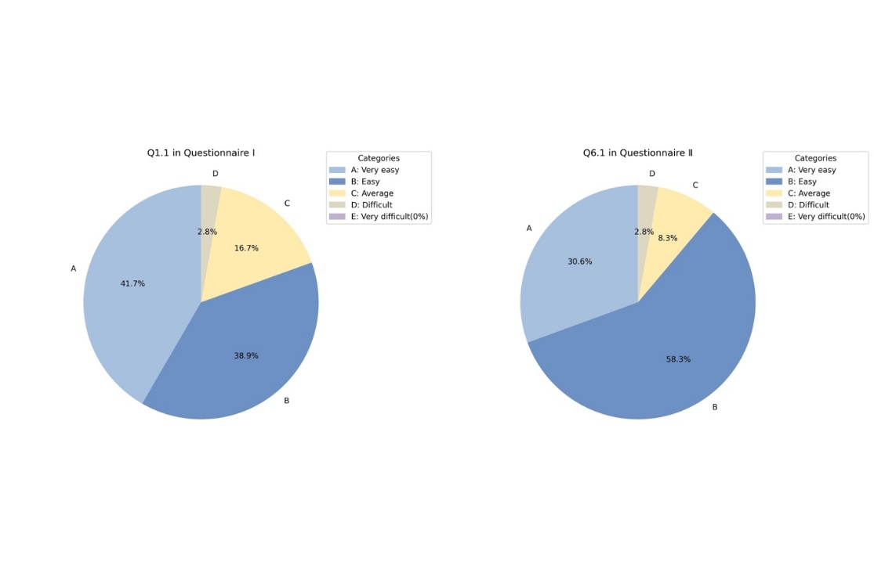
Figure 4. Comparison between students’ responses to an identical question before and after a VRTE session: Regarding the Trolley Driver experiment, how easy do you find it to imagine this fictional scenario in your mind?

Secondly, our VRTEs can, to some extent, deter the addition of extraneous details. In our VRTEs, we strictly minimised details not described by Foot and Thomson, including only those unlikely to distort moral verdicts. In the interviews, students C and I mentioned that they had no time to consider the extraneous details they previously added to written thought experiments. Student H stated that they responded directly to their perception of the VRTEs instead of thinking about ‘the difference between a driver and a passerby’. Similarly, student K reported that their responses to the VRTEs were less influenced by smuggled-in details, preconceptions, and personality. Many students insisted that in the future they would align their responses to trolley scenarios with the choices they made in the VRTEs. For example, student H mentioned that if their reaction to the written version of Foot’s trolley scenario had differed from what they had chosen in the VRTE, they would have stuck to their choice in the VRTE. This suggests that the VRTEs’ ability to deter extraneous details has a lasting effect.
However, student B reported that their choices in the VRTEs were still influenced by the extraneous details they added to the written trolley cases when reading Foot’s and Thomson’s works. This suggests that in future teaching, we should have students experience VRTEs before reading the papers where their written counterparts appear.
Thirdly, we find that our VRTEs can partially deter the application of pre-endorsed moral theories. Most participants reported that their choices in the VRTEs were based on intuition rather than pre-endorsed moral theories. Students B, C, and J mentioned that the VRTEs compressed their response time so much that they did not have time to consider moral principles. Since many students expected to align their responses to written trolley scenarios with their VRTE choices, introducing VRTEs seems capable of preventing students from applying pre-endorsed moral theories when reading applied ethics works.
However, this potential was underutilised due to a shortcoming in our course structure. Specifically, students D, E, F, and I reported that they had a strong impression of what Foot and Thomson expected them to choose in the trolley scenarios, so they followed these expectations in the VRTEs. Students C and J found it hard not to think about what the philosophers said while experiencing the VRTEs. This further highlights the need to let students experience VRTEs before reading related papers, ensuring their responses are based on pre-theoretic intuition rather than preconceived ideas.
Fourthly, regarding whether our VRTEs made students treat thought experiments more seriously, the feedback is mixed. Some interviewees, such as students B, E, and M, reported that they became more serious when responding to the VRTEs. Such testimonies seem somewhat supported by the comparison between data collected from Questionnaire I and Questionnaire Ⅱ, showing a slight increase in the seriousness with which students approached thought experiments (see Figure 5). Notably, those treating thought experiments very seriously increased by more than 5%.
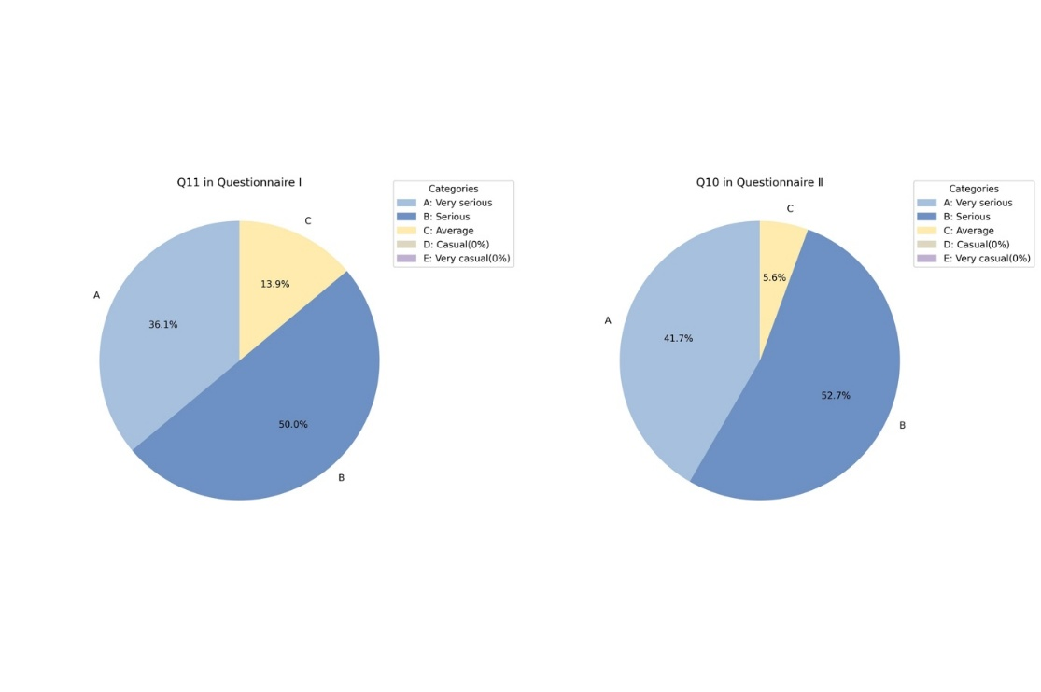
Figure 5. Comparison between students’ responses to an identical question before and after a VRTE session: Regarding the thought experiments above, how serious are you when
making your choices?

However, certain interviewees reported feeling less serious during the VRTEs. One reason for such self-claimed lack of seriousness, according to our interviews, is that some equated seriousness with the time invested in making a choice, whereas our VRTEs strictly controlled their reaction time. It is hard to define what it means to treat thought experiments seriously, but as mentioned earlier, seriousness is mostly a counter-attitude to an ‘anything goes’ mindset. In this vein, these students’ self-reported haste in making a choice in the VRTEs does not indicate they adopted an ‘anything goes’ attitude. Rather, it likely suggests they took the VRTEs seriously enough to feel they needed more time to make a choice.
Some self-reported lack of seriousness resulted from our VRTEs not being realistic enough. Student D claimed that the lack of realism kept them from becoming fully immersed in the VRTE, leading them to adopt a game-like attitude towards the choices. Student K also complained about the lack of realism. Their feedback indicates that we should optimise our VRTEs to enhance users’ sense of immersion. Student C suggested that to increase seriousness, the scenes where the trolley hits people should be bloodier. However, this advice conflicts with our deliberate effort to avoid triggering any potential negative emotion in our students. Balancing realism with the avoidance of negative emotions is a challenging task when it comes to enhancing immersion – we return to this point in the next section. One might argue, however, that the lack of realism is inherent to many philosophical thought experiments, and thus cannot be resolved by VRTEs. Admittedly, many thought experiments involve bizarre scenarios that could never occur in reality. Yet, just as television and cinema make science fiction stories feel more realistic than reading them, VR – if VRTEs are well-designed – can enhance the realism of thought experiments through immersive, embodied, and interactive experiences.
Finally, students’ feedback suggests that VRTEs have some value in enhancing students’ interests in thought experiments. The interviews with VRTE participants indicate that most found the use of VR made thought experiments more interesting. For instance, student B mentioned that VR added interaction with the trolley scenarios, making them more intriguing. Students K and L noted that the first-person perspective provided by our VRTEs increased their engagement and interest. Furthermore, almost all interviewees expressed a desire for more VRTEs in future teaching, clearly indicating strong interest.
Comparison between students’ responses to Questionnaire I and Questionnaire Ⅱ also, to a certain degree, supports this finding. In both questionnaires, after inquiring their reactions to the thought experiments provided by Foot and Thomson, we asked the same sample of students the same question: ‘Do you find the above thought experiments interesting?’ 80.6% of the students in Questionnaire Ⅱ claimed that they found the thought experiments interesting or very interesting, while only 63.9% of the students in Questionnaire I made such claims (see Figure 6 below).
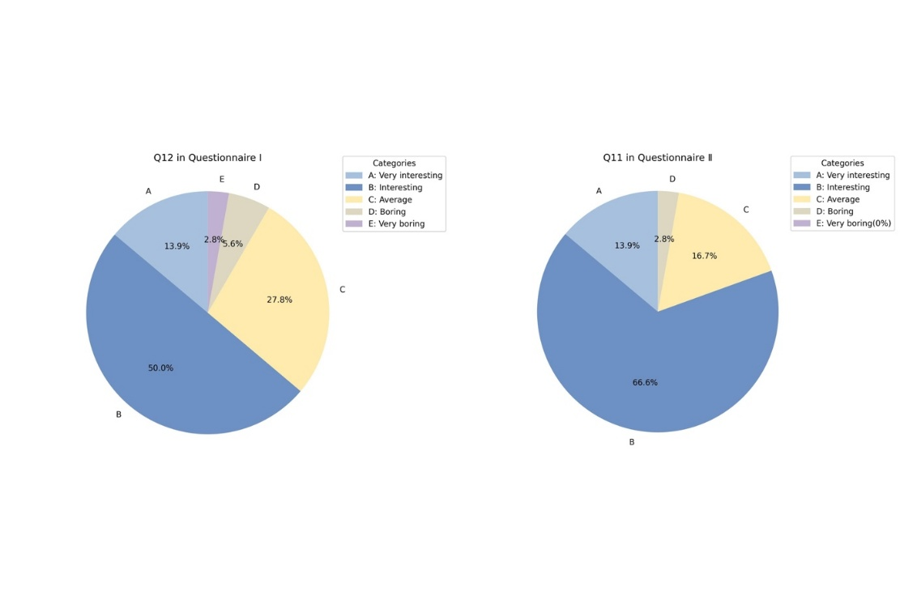
Figure 6. Comparison between students’ responses to an identical question before and after a VRTE session: Did you find the above thought experiment interesting?

Students’ responses to another question that appears both in Questionnaire I and Questionnaire Ⅱ – ‘Would you be interested in experiencing more thought experiments in philosophy?’ – slightly indicate their increased interest. 80.6% of the students in Ⅱ felt like to experiencing more thought experiments, compared with only 77.8% in I. Although the numeric value only marginally increases, notably no students in Ⅱ expressed unwillingness to try thought experiments anymore, in contrast with 2.778% in I (see Figure 7 below):
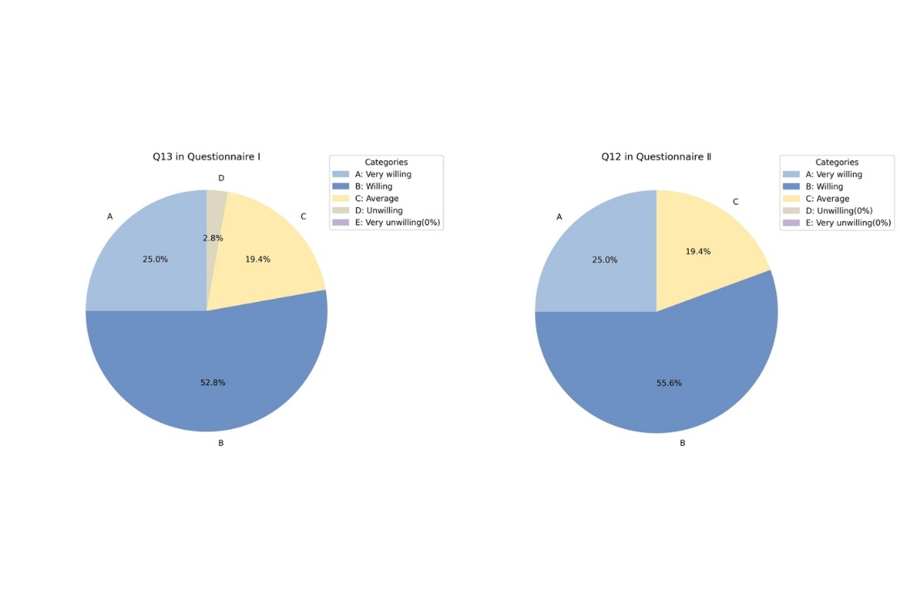
Figure 7. Comparison between students’ responses to an identical question before and after a VRTE session: Would you be interested in experiencing more philosophical thought experiments?

However, their feedback also highlights ways to enhance our VRTEs. Besides the frequently mentioned lack of realism, many students complained that the interactive system of our current VRTEs was inconvenient, significantly compromising their interest.
In summary, we find that VRTEs have certain potential to mitigate the difficulties students encounter. Students’ feedback clearly points to VRTEs’ value in addressing imagination deficiency, which is indeed intuitive. While VRTEs seem capable of preventing the addition of extraneous details and deterring the application of pre-endorsed moral theories, their potential is limited by our previous course structure that placed paper-based instruction before the VRTE session. The usefulness of VRTEs in enhancing seriousness and interest is not clear-cut, with interviews suggesting this is due to our VRTEs’ lack of realism, immersion, and operability. Since developing high-quality VRTEs requires more time for programme development, we have further reason to adjust our course structure. Therefore, in the next section, we propose a course structure for applied ethics that may fully utilises the potential of VRTEs to enhance teaching quality.

4. A Course Structure Proposal
Before discussing how to incorporate VRTEs into teaching, we strongly recommend that an applied ethics course instruct students on the method of cases before teaching classic works that employ thought experiments. In other words, at the very beginning, a teacher should explain that philosophers use thought experiments to elicit readers’ intuitions as evidence for theory selection. Without understanding the argumentative value of thought experiments, students might regard VRTEs as mere games, thus diminishing their pedagogical significance. As mentioned, the method of cases faces several well-founded objections for which VRTEs offer no solution. Therefore, during the methodological instruction, teachers should present both the objections to and defences of the method of cases. Engaging in this methodological reflection can help students refine their approach to applied ethics in future research.
In our previous practice, we began developing VRTEs only after noticing students’ difficulties midway through the semester. This lack of preparation significantly compressed the development time, compromising the realism, immersion, and operability of the final products. To better enhance students’ seriousness and interest, future applied ethics courses should allow sufficient time for programme development. An ideal approach would be to survey students who registered for an applied ethics course in a previous semester, investigating which thought experiments posed significant difficulties for them. Based on the survey results, a teacher can then decide which thought experiments need VRTEs.
Having more time to develop VRTEs allows them to be more vivid, immersive, and realistic. However, as noted, VRTEs that are too lifelike, such as depicting bloody deaths, may cause negative emotions like fear, anxiety, and distress. Therefore, a teacher must balance realism with avoiding unwanted emotions. The best way to strike this balance is for VRTEs to faithfully model the students’ real environment. For example, a trolley VRTE could accurately depict the type of trams used and the surrounding scenery in targeted students’ city. This enhances immersion and realism without crossing ethical boundaries or distorting moral intuitions. On the other hand, VRTEs should avoid directly presenting deaths, especially with bloody and disturbing scenes. In fact, the thought experiments recorded in classic applied ethics works usually stop at the point where a protagonist must make an action choice. Thus, not depicting the bloody consequences of certain choices does not impede a faithful reconstruction of thought experiments in VRTEs.
In our previous teaching practice, students were instructed on Foot 1967 and Thomson 1976 before experiencing the trolley VRTEs. Feedback indicates that some students, who read the written trolley cases prior to experiencing the VRTEs, could not help introducing extraneous details or pre-endorsed moral theories. This suggests that, in a future course, students should experience VRTEs before reading related papers. This arrangement can elicit pre-theoretic intuitions that are direct reactions to the thought experiments depicted by philosophers, thereby providing students with a foundation to evaluate the philosophers’ arguments. Thus, we propose that a teacher should alternate between VRTE sessions and paper-teaching sessions. Specifically, before teaching each classic paper for which VRTEs has been developed, they should first schedule time for students to experience the VRTE version of the thought experiments presented in the paper.
The following flow chart summarises our course proposal (see Figure 8):

Figure 8. Flow chart representing our course proposal

In the second section, we address the concern that students in less well-resourced institutions may lack access to VRTEs, raising issues of educational equity. To mitigate this, we propose that institutions capable of offering VRTEs allow students from nearby, less well-funded institutions to access them either for free or at a minimal fee. Since philosophy departments generally have a limited number of students, VR equipment is unlikely to be fully utilised once purchased, making a shared VRTE economy a viable solution. Furthermore, philosophy departments in less well-resourced institutions could collaborate with engineering or technology departments, where VR equipment might also be valuable. Lastly, as VRTEs are reproducible digital programmes, well-funded institutions could develop VRTEs and share them with other institutions.
Another concern is that using VR carries certain risks, such as cybersickness, visual fatigue, muscle strain, acute stress, and mental overload. To mitigate these risks, we propose several strategies, some of which have already been implemented in our pioneering practice, that can serve as a reference for other institutions. First and foremost, a detailed course design should be submitted to the Institutional Review Board for approval before the course begins. Prior to VRTE sessions, teachers should assess students to identify any individuals who may be psychologically or physiologically unfit for VRTEs. During the sessions, a team comprising laboratory technicians from relevant disciplines, such as psychology and computer science, should monitor students’ activity. Finally, after the sessions, counselling should be offered, or made readily available upon request, to address any discomfort or adverse symptoms students may experience.

5. Responses to Potential Objections
There may be three main potential objections to our teaching proposal. The first objection is that a VRTE presents a scenario where a user, as a protagonist, needs to make an action choice, rather than observing as a third party who can morally evaluate the different action options available to the protagonist. One reason motivating this objection is that a first-person action choice differs fundamentally from a third-person moral evaluation of the choice: the protagonist is deciding what to do, while a third party is assessing the moral status of an action choice (Tassy et al. 2013). It is possible that all the action choices the protagonist faces have the same moral property, such as moral permissibility, but the protagonist might be more motivated or feel a greater obligation to choose one option over the others. For instance, Thomson 1976 describes the following trolley scenario:

Frank is a passenger on a trolley whose driver has just shouted that the trolley’s brakes have failed, and who then died of the shock. On the track ahead are five people; the banks are so steep that they will not be able to get off the track in time. The track has a spur leading off to the right, and Frank can turn the trolley onto it. Unfortunately there is one person on the right hand track. Frank can turn the trolley, killing the one; or he can refrain from turning the trolley, letting the five die (Thomson 1976, 207).

For this scenario, our moral intuitions indicate that it is morally permissible for Frank either to turn the trolley or not. However, as a protagonist in its VRTE counterpart, one has to choose one of the action choices, which does not demonstrate their intuition about moral permissibility.
However, our teaching proposal does not expect students to use the action choices they make in VRTEs as the basis for critically assessing applied ethics works. Instead, it suggests that after experiencing a set of VRTEs, students read the papers where their written counterparts appear. The written scenarios provide students with the role of observers, while the VRTEs help them visualise the scenarios, raise their interest, and encourage them to treat the experiments more seriously. In some cases, the intuitions students develop as protagonists in VRTEs can even guide their moral intuitions as third-party observers. For example, our post-VRTE interviews revealed that many students expected to align their responses to written trolley scenarios with the choices they made in the VRTEs. Foot’s and Thomson’s trolley scenarios are designed to elicit moral intuitions about whether it is morally permissible to turn the trolley onto one person, while in the VRTEs, students had to decide whether to turn the trolley. If students felt obligated to turn the trolley in the VRTEs, they would also believe that this action is morally permissible.
Another reason motivating the objection from the distinction between a protagonist and a third-party observer lies in the possible distortion of moral intuitions caused by a first-personal perspective. A student as a protagonist in a VRTE, the objectors may argue, may choose the action choice that best satisfies their self-interest, rather than the choice that reflects their moral intuition. For example, in a Thomson trolley VRTE a student engaging with the perspective of the passenger may choose inaction to avoid being involved in the moral dilemma and undertaking any moral responsibility. And this self-interested choice may have a lasting effect on their response to the VRTE’s written counterpart, making their response no longer a moral intuition at all.
Our first response is that by strictly controlling users’ reaction time, VRTEs can effectively preclude considerations of self-interest. Feedback from our previous practice indicates that most students did not have the time to add extraneous details or apply pre-endorsed moral theories to the trolley VRTEs. Given their limited time, it seems unlikely that they could consider which action choice better satisfies their self-interest. Furthermore, we can explicitly instruct students not to consider self-interest when experiencing VRTEs.
The second objection concerns the negative emotions that might be caused by VRTEs. This objection claims that only moral judgments formed under cool time – e.g., not being upset or frightened – can serve as evidence for or against moral theories (Rawls 2005, 42). Experiencing VRTEs, the objection follows, may result in students feeling negative emotions, such as being upset, frustrated, or frightened. Therefore, the moral judgments elicited by VRTEs cannot be evidence for theory selection.
We agree that the moral judgments invoked by VRTEs cannot serve as evidence for theory selection. This is why our course proposal suggests teaching students related philosophical works after experiencing VRTEs. It is the moral intuitions they have while reading written thought experiments, rather than those elicited by VRTEs, that serve as the basis for critically evaluating works of applied ethics. Moreover, our course proposal suggests that VRTEs avoid directly presenting deaths, which can significantly reduce the likelihood of students experiencing negative emotions. In our interviews, only students B, H, J, and M reported that the VRTEs caused them some negative emotions. However, three of them (except B) mentioned that by the time they filled out Questionnaire Ⅱ, they had recovered from these emotions. Since our course proposal suggests alternating VRTE sessions and paper-teaching sessions, it is expected that when students read philosophical works, they would not still be experiencing negative emotions caused by VRTEs.
The third objection questions the ability of our course proposal to prevent the addition of extraneous details and elicit pre-theoretic intuitions. Our course proposal suggests alternating between VRTE sessions and paper-based teaching. The objectors concede that VRTEs can deter students from adding extraneous details and applying pre-endorsed theories by strictly controlling reaction time. But they argue that when students read papers, they still have ample time to imagine undescribed details or consider moral theories. Therefore, they believe our course design may nullify the value of VRTEs.
However, as we have reiterated, many students in our interviews claimed that they would stick to the choices they made in VRTEs when facing written thought experiments. Students’ self-reports indicate that their intuitions evoked by VRTEs have a lasting and strong effect, potentially preventing them from applying pre-endorsed theories. Moreover, VRTEs visualise thought experiments in a way that faithfully adheres to philosophers’ original descriptions. Experiencing VRTEs can imprint these visualisations on students’ minds, thereby reducing the likelihood of them adding extraneous details. Admittedly, the issues of extraneous details and pre-endorsed theories will still exist in our teaching proposal, but our approach is designed to merely reduce these difficulties, not to completely resolve them.

Conclusion
A key method in applied ethics is using thought experiments to evoke intuitions as evidence for or against a theory or moral principle. However, undergraduates reading classic applied ethics works often struggle with imagination deficiencies, introduce extraneous details, apply pre-endorsed theories or principles, treat the experiments unseriously, or even lack interest. Our pilot teaching practice, which incorporated a VRTE session, demonstrates that VRTEs can mitigate these challenges. However, our previous practice suggests the need to use surveys to identify which thought experiments should have VRTE counterparts developed in advance, ensuring these VRTEs are sufficiently realistic, immersive, and user-friendly. Moreover, teachers should alternate between VRTE sessions and paper-teaching sessions to improve the efficacy of VRTEs.
The primary limitation of our study is the small sample size. Like many universities, we have a limited number of philosophy undergraduates. Our pilot teaching practice included only 43 registered students, with 36 participating in the VRTE session. A small-N study cannot quantitatively establish the effectiveness of VR-presented thought experiments in improving applied ethics courses. Hence, our current research is a humanistic investigation that heavily relies on interview results. We hope our pioneering work will serve as an initial step, encouraging other institutions to adopt VRTE-based applied ethics courses. Through inter-institutional cooperation, we can gather a larger sample in the future and assess the value of VRTEs in a statistically significant manner.

Bibliography
Allman, John, and Jim Woodward. 2008. ‘What Are Moral Intuitions and Why Should We Care about Them? A Neurobiological Perspective’. Philosophical Issues 18:164–85.
Aoudjit, Abdelkader. 2012. ‘Teaching Moral Philosophy Using Novels: Issues and Strategies’. Journal of Thought 47 (3): 49–66. https://doi.org/10.2307/jthought.47.3.49.
Bromberger, Sylvain. 1966. ‘Why-Questions’. In Mind and Cosmos – Essays in Contemporary Science and Philosophy, edited by Robert G. Colodny, 86–111. University of Pittsburgh Press.
Brown, James Robert. 2010. The Laboratory of the Mind. 2nd edition. New York: Routledge.
Buckwalter, Wesley, and Stephen Stich. 2010. ‘Gender and Philosophical Intuition’. SSRN Scholarly Paper. Rochester, NY: Social Science Research Network. https://doi.org/10.2139/ssrn.1683066.
Bunzl, Martin. 1996. ‘The Logic of Thought Experiments’. Synthese 106 (2): 227–40.
Campos, Esmeralda, Irving Hidrogo, and Genaro Zavala. 2022. ‘Impact of Virtual Reality Use on the Teaching and Learning of Vectors’. Frontiers in Education 7 (September). https://doi.org/10.3389/feduc.2022.965640.
Clarke-Doane, Justin. 2006. ‘Justification and Explanation in Mathematics and Morality’. Oxford Studies in Metaethics 10. https://doi.org/10.1093/acprof:oso/9780198738695.003.0004.
Cummins, Robert C. 1998. ‘Reflection on Reflective Equilibrium’. In Rethinking Intuition: The Psychology of Intuition and Its Role in Philosophical Inquiry, edited by Michael Raymond DePaul and William M. Ramsey, 113–28. Rowman & Littlefield Publishers.
Dancy, Jonathan. 1985. ‘The Role of Imaginary Cases in Ethics’. Pacific Philosophical Quarterly 66 (1–2): 141–53. https://doi.org/10.1111/j.1468-0114.1985.tb00246.x.
Davis, Wayne A. 2007. ‘Knowledge Claims and Context: Loose Use’. Philosophical Studies: An International Journal for Philosophy in the Analytic Tradition 132 (3): 395–438.
Dechering, Anna, and Sander Bakkes. 2018. ‘Moral Engagement in Interactive Narrative Games: An Exploratory Study on Ethical Agency in the Walking Dead and Life Is Strange’. In Proceedings of the 13th International Conference on the Foundations of Digital Games, 1–10. FDG ’18. New York, NY, USA: Association for Computing Machinery. https://doi.org/10.1145/3235765.3235779.
Diemer, Julia, Georg W. Alpers, Henrik M. Peperkorn, Youssef Shiban, and Andreas Mühlberger. 2015. ‘The Impact of Perception and Presence on Emotional Reactions: A Review of Research in Virtual Reality’. Frontiers in Psychology 6 (January). https://doi.org/10.3389/fpsyg.2015.00026.
Esrock, Professor Ellen J. 1994. The Reader’s Eye: Visual Imaging as Reader Response. Baltimore: The Johns Hopkins University Press.
Foot, Philippa. 1967. ‘The Problem of Abortion and the Doctrine of the Double Effect’. Oxford Review 5:5–15.
Gendler, Tamar Szabó. 2010. ‘Philosophical Thought Experiments, Intuitions, and Cognitive Equilibrium’. In Intuition, Imagination, and Philosophical Methodology, edited by Tamar Szabó Gendler, 0. Oxford University Press. https://doi.org/10.1093/acprof:oso/9780199589760.003.0007.
Gettier, Edmund L. 1963. ‘Is Justified True Belief Knowledge?’ Analysis 23 (6): 121–23. https://doi.org/10.1093/analys/23.6.121.
Haidt, Jonathan. 2001. ‘The Emotional Dog and Its Rational Tail: A Social Intuitionist Approach to Moral Judgment’. Psychological Review 108 (4): 814–34. https://doi.org/10.1037/0033-295X.108.4.814.
Haidt, Jonathan, and Fredrik Bjorklund. 2008. ‘Social Intuitionists Answer Six Questions about Moral Psychology’. In Moral Psychology, Vol 2: The Cognitive Science of Morality: Intuition and Diversity, edited by Walter Sinnott-Armstrong, 181–217. Cambridge, MA, US: Boston Review.
Haidt, Jonathan, and Matthew A. Hersh. 2001. ‘Sexual Morality: The Cultures and Emotions of Conservatives and Liberals’. Journal of Applied Social Psychology 31 (1): 191–221. https://doi.org/10.1111/j.1559-1816.2001.tb02489.x.
Harman, Gilbert. 1977. The Nature of Morality: An Introduction to Ethics. New York: Oxford University Press.
Huebner, Bryce, and Marc D. Hauser. 2011. ‘Moral Judgments about Altruistic Self-Sacrifice: When Philosophical and Folk Intuitions Clash’. Philosophical Psychology, February. https://www.tandfonline.com/doi/abs/10.1080/09515089.2010.534447.
Huemer, M. 2007. Ethical Intuitionism. 2005th edition. Basingstoke: Palgrave Macmillan.
Inwagen, Peter van. 1997. ‘Materialism and the Psychological-Continuity Account of Personal Identity’. Philosophical Perspectives 11:305–19.
Irshad, Shafaq, Andrew Perkis, and Waleed Azam. 2021. ‘Wayfinding in Virtual Reality Serious Game: An Exploratory Study in the Context of User Perceived Experiences’. Applied Sciences 11 (17): 7822. https://doi.org/10.3390/app11177822.
Johnson, A., T. Moher, Y.J. Cho, Y.J. Lin, D. Haas, and J. Kim. 2002. ‘Augmenting Elementary School Education with VR’. IEEE Computer Graphics and Applications 22 (2): 6–9. https://doi.org/10.1109/38.988740.
Kitcher. 2012. ‘The Lure of the Peak’. The New Republic, 2012. https://newrepublic.com/article/99529/on-what-matters-derek-parfit.
Kokkinara, Elena, Konstantina Kilteni, Kristopher J. Blom, and Mel Slater. 2016. ‘First Person Perspective of Seated Participants Over a Walking Virtual Body Leads to Illusory Agency Over the Walking’. Scientific Reports 6 (1): 28879. https://doi.org/10.1038/srep28879.
Lavoie, Raymond, Kelley Main, Corey King, and Danielle King. 2021. ‘Virtual Experience, Real Consequences: The Potential Negative Emotional Consequences of Virtual Reality Gameplay’. Virtual Reality 25 (1): 69–81. https://doi.org/10.1007/s10055-020-00440-y.
Lewis, David. 1978. ‘Truth in Fiction’. American Philosophical Quarterly 15 (1): 37–46.
Machery, Edouard. 2011. ‘Thought Experiments and Philosophical Knowledge’. Metaphilosophy 42 (3): 191–214.
Meynell, Letitia. 2014. ‘Imagination and Insight: A New Acount of the Content of Thought Experiments’. Synthese 191 (17): 4149–68. https://doi.org/10.1007/s11229-014-0519-x.
Moghimi, Mohammadhossein, Robert Stone, Pia Rotshtein, and Neil Cooke. 2016. ‘Influencing Human Affective Responses to Dynamic Virtual Environments’. Presence: Teleoperators and Virtual Environments 25 (2): 81–107. https://doi.org/10.1162/PRES_a_00249.
Mujber, T. S., T. Szecsi, and M. S. J. Hashmi. 2004. ‘Virtual Reality Applications in Manufacturing Process Simulation’. Journal of Materials Processing Technology, Proceedings of the International Conference on Advances in Materials and Processing Technologies: Part 2, 155–156 (November):1834–38. https://doi.org/10.1016/j.jmatprotec.2004.04.401.
Nagel, Thomas. 1989. The View From Nowhere. Revised ed. edition. New York London: Oxford University Press.
Nichols, Shaun, and Joshua Knobe. 2007. ‘Moral Responsibility and Determinism: The Cognitive Science of Folk Intuitions’. Noûs 41 (4): 663–85. https://doi.org/10.1111/j.1468-0068.2007.00666.x.
Norton, John. 2004. ‘Why Thought Experiments Do Not Transcend Empiricism’. In Contemporary Debates in the Philosophy of Science, edited by Christopher Hitchcock, 44–46. Oxford, UK: ‎Wiley-Blackwell.
Nozick, Robert. 1990. The Examined Life: Philosophical Meditations. New York, NY: Simon & Schuster.
Parfit, Derek. 1986. Reasons and Persons. Reprint edition. New York: Oxford University Press.
———. 2011. On What Matters: Volume Two. New York: Oxford University Press.
Pastötter, Bernhard, Sabine Gleixner, Theresa Neuhauser, and Karl-Heinz T. Bäuml. 2013. ‘To Push or Not to Push? Affective Influences on Moral Judgment Depend on Decision Frame’. Cognition 126 (3): 373–77. https://doi.org/10.1016/j.cognition.2012.11.003.
Pust, Joel. 2019. ‘Intuition’. In The Stanford Encyclopedia of Philosophy, edited by Edward N. Zalta, Summer 2019. Metaphysics Research Lab, Stanford University. https://plato.stanford.edu/archives/sum2019/entries/intuition/.
Ramirez, Erick Jose. 2024. The Ethics of Virtual and Augmented Reality: Building Worlds. 1st edition. New York London: Routledge.
Rawls, John. 1951. ‘Outline of a Decision Procedure for Ethics’. The Philosophical Review 60 (2): 177–97. https://doi.org/10.2307/2181696.
———. 2005. A Theory of Justice: Original Edition. Cambridge, Mass.: Belknap Press: An Imprint of Harvard University Press.
Rueda, Jon, and Francisco Lara. 2020. ‘Virtual Reality and Empathy Enhancement: Ethical Aspects’. Frontiers in Robotics and AI 7. https://www.frontiersin.org/articles/10.3389/frobt.2020.506984.
Sastry, L., and D. R. S. Boyd. 1998. ‘Virtual Environments for Engineering Applications’. Virtual Reality 3 (4): 235–44. https://doi.org/10.1007/BF01408704.
Saul, Jennifer M. 2007. Simple Sentences, Substitution, and Intuitions. Oxford: Oxford University Press.
Shafer-Landau, Russ. 2003. Moral Realism: A Defence. 1st edition. Oxford: Clarendon Press.
Singer, Peter. 1972. ‘Famine, Affluence, and Morality’. Philosophy and Public Affairs 1 (3): 229–43.
———. 2011. Practical Ethics. 3rd edition. New York: Cambridge University Press.
Slater, Mel. 2018. ‘Immersion and the Illusion of Presence in Virtual Reality’. British Journal of Psychology 109 (3): 431–33. https://doi.org/10.1111/bjop.12305.
Slater, Mel, Bernhard Spanlang, Maria V. Sanchez-Vives, and Olaf Blanke. 2010. ‘First Person Experience of Body Transfer in Virtual Reality’. PLOS ONE 5 (5): e10564. https://doi.org/10.1371/journal.pone.0010564.
Smyth, Nicholas. 2023. ‘When Does Self-Interest Distort Moral Belief?’ Analytic Philosophy 64 (4): 392–408. https://doi.org/10.1111/phib.12261.
Souchet, Alexis D., Domitile Lourdeaux, Alain Pagani, and Lisa Rebenitsch. 2023. ‘A Narrative Review of Immersive Virtual Reality’s Ergonomics and Risks at the Workplace: Cybersickness, Visual Fatigue, Muscular Fatigue, Acute Stress, and Mental Overload’. Virtual Reality 27 (1): 19–50. https://doi.org/10.1007/s10055-022-00672-0.
Street, Sharon. 2006. ‘A Darwinian Dilemma for Realist Theories of Value’. Philosophical Studies: An International Journal for Philosophy in the Analytic Tradition 127 (1): 109–66.
Sturgeon, Nicholas. 1988. ‘Moral Explanations’. In Essays on Moral Realism, edited by Geoffrey Sayre-McCord, 229–55. Ithaca, NY: Cornell University Press.
Tassy, Sébastien, Olivier Oullier, Julien Mancini, and Bruno Wicker. 2013. ‘Discrepancies between Judgment and Choice of Action in Moral Dilemmas’. Frontiers in Psychology 4 (May). https://doi.org/10.3389/fpsyg.2013.00250.
Thomson, Judith Jarvis. 1971. ‘A Defense of Abortion’. Philosophy and Public Affairs 1 (1): 47–66.
———. 1976. ‘Killing, Letting Die, and the Trolley Problem’. The Monist 59 (2): 204–17.
Tversky, Amos, and Daniel Kahneman. 1981. ‘The Framing of Decisions and the Psychology of Choice’. Science 211 (4481): 453–58.
Walsh, Adrian. 2011. ‘A Moderate Defence of the Use of Thought Experiments in Applied Ethics’. Ethical Theory and Moral Practice 14 (4): 467–81. https://doi.org/10.1007/s10677-010-9254-7.
Weatherson, Brian. 2003. ‘What Good Are Counterexamples?’ Philosophical Studies 115 (1): 1–31. https://doi.org/10.1023/a:1024961917413.
Wicken, Marcus, Rebecca Keogh, and Joel Pearson. 2021. ‘The Critical Role of Mental Imagery in Human Emotion: Insights from Fear-Based Imagery and Aphantasia’. Proceedings of the Royal Society B: Biological Sciences 288 (1946): 20210267. https://doi.org/10.1098/rspb.2021.0267.
Williamson, Timothy. 2004. ‘Philosphical “Intuitions” and Scepticism about Judgement’. Dialectica 58 (1): 109–53. https://doi.org/10.1111/j.1746-8361.2004.tb00294.x.
Wilson, James. 2016. ‘VII—Internal and External Validity in Thought Experiments’. Proceedings of the Aristotelian Society 116 (2): 127–52. https://doi.org/10.1093/arisoc/aow008.
Wood, Allen. 2011. ‘Humanity as End in Itself’. In On What Matters, by Derek Parfit, 1st ed., 58–82. Oxford University PressOxford. https://doi.org/10.1093/acprof:osobl/9780199572816.003.0003.
Zahiu, Anda, Emilian Mihailov, Brian D. Earp, Kathryn B. Francis, and Julian Savulescu. 2023. ‘Empathy Training through Virtual Reality: Moral Enhancement with the Freedom to Fall?’ Ethics and Information Technology 25 (4): 50. https://doi.org/10.1007/s10676-023-09723-9.
Zhang, Lei, Doug A. Bowman, and Caroline N. Jones. 2019. ‘Exploring Effects of Interactivity on Learning with Interactive Storytelling in Immersive Virtual Reality’. In 2019 11th International Conference on Virtual Worlds and Games for Serious Applications (VS-Games), 1–8. https://doi.org/10.1109/VS-Games.2019.8864531.

Jinglin Zhou is a postdoctoral researcher at the School of Philosophy, Fudan University, and a recipient of the National Overseas Postdoctoral Talent Introduction Program. His research focuses primarily on moral progress and moral enhancement, with a particular emphasis on philosophical methodology in the ethics of technology; jinglin_zhou@fudan.edu.cn.
Yiran Cao (co-first author) is a PhD candidate at the School of International Relations and Public Affairs, Fudan University. Her primary research interests lie in comparative politics and social governance, with her current work focusing on the ethics of technology; 20110170001@fudan.edu.cn.
Jiacheng Ji is a third-year master’s student in philosophy at Fudan University. He examines ethical implications in emerging technologies. His academic focus spans neuroethics, the moral competence of burgeoning medical large language models, and the topic of epistemic injustice in feminist theory; 22210160031@m.fudan.edu.cn.
Wang Guoyu (corresponding author) is a Professor and Doctoral Advisor at the School of Philosophy, Fudan University, and holds the distinguished title of Changjiang Scholar Professor, awarded by the Chinese Ministry of Education. She also serves as the Director of the CAST-Fudan Institute of Science and Technology Ethics for the Human Future and a member of the Medical Ethics Subcommittee under the National Ethics Committee; wguoyu@fudan.edu.cn.

Philosophical discussions on thought experiments often focus on their content and the judgments they produce. Are we learning something a priori, or are these experiments just vivid ways of making common arguments (Brown 2010; Norton 2004)? Some philosophers see thought experiments as mental models, akin to scientific ones, used to test intuitions (Gendler 2010; Meynell 2014). Others question what kind of evidence, if any, they provide (Allman and Woodward 2008; Bunzl 1996; Machery 2011). These experiments are considered by some to contribute to philosophical debates and offer insights into our moral psychological mechanisms (Haidt and Bjorklund 2008; Pastötter et al. 2013). In this paper, we sidestep these debates and focus on reducing the difficulties students face when reading written thought experiments.
There are different philosophical positions on the nature of intuitions. Some philosophers equate intuitions with beliefs or some kind of belief (Lewis 1978, x), some regard them as dispositions to believe (van Inwagen 1997, 309), and others see them as sui generis occurrent propositional attitudes (Huemer 2007), variously characterised as one in which a proposition occurrently seems true. In this paper, it will be assumed that intuitions are some sort of sui generis state. However, such an assumption does not matter for our argument.
There are many scepticisms about the probative role of intuitions in philosophy (e.g., Clarke-Doane 2006; Cummins 1998; Harman 1977; Street 2006). However, whether the method of cases is a justified approach to study applied ethics and other branches of philosophy is not the concern of this paper on philosophical pedagogy. Regardless, teaching students classic works in applied ethics necessitates helping them grasp the method of cases and various thought experiments.
In this paper, we focus exclusively on the pedagogy of applied ethics. Nonetheless, whether VRTEs can mitigate the difficulties students encounter in other branches of philosophy, such as epistemology, also deserves exploration.
We have also conducted an informal survey on the reactions of part-time postgraduates in applied ethics, most of whom did not study philosophy at the undergraduate level, to written thought experiments. We found that they experienced even greater difficulties than undergraduates. For example, more than half of the part-time postgraduates did not take the trolley scenarios seriously.
Three of them are variations we developed from the thought experiments of Foot 1967 and Thomson 1976.
An anonymous reviewer reasonably expected the percentage of students who did not take thought experiments seriously to be much higher than 13%, an expectation we ourselves shared before conducting the survey. However, there seems to be a good explanation for the relatively low proportion: our survey participants were philosophy undergraduates, who tend to engage seriously with philosophical texts. On the contrary, when we surveyed part-time postgraduates in applied ethics, most of whom had not studied philosophy at the undergraduate level, we found that a larger proportion of students were unserious. Furthermore, as mentioned, only 36 out of 43 registered students submitted valid responses. It is likely that those who did not submit responses, or submitted invalid ones, were among the least serious students. Including them could significantly increase the proportion of students who did not take the thought experiments seriously.
See (Williamson 2004; Saul 2007) for arguments against treating the strength of intuitions as indicators of their trustworthiness.
For instance, John Rawls claims that ‘once we regard the sense of justice as a mental capacity, as involving the exercise of thought, the relevant judgments are those given under conditions favorable for deliberation and judgment in general’ (Rawls 2005, 42).
Apart from mitigating students’ difficulties with thought experiments, we believe VRTEs can provide significant value in moral education. Written thought experiments are monologic descriptions, where our role is simply to follow philosophers’ indications to form certain intuitions. However, our intricate moral life requires us to cultivate moral emotions, dispositions, and moral-epistemic capacities to navigate it effectively – something written thought experiments alone cannot achieve. A VRTE, on the other hand, can present a complex narrative in which a user, playing the role of a protagonist, must form a series of moral emotions, judgments, and dispositions in various episodes. Given the immersive and embodied nature of VRTEs, the user may empathise with the protagonist and treat these episodes seriously. This can help improve their moral capacities, which they can rely on in real-life moral situations. For example, a VRTE version of the game This War of Mine can train a user on how to morally navigate a world filled with relics and violence during a catastrophe. Although the value and application of VRTEs for moral education are not our main focus here, they are important topics worthy of future exploration.
We thank the anonymous reviewer for thoughtfully raising the second and third objections to incorporating VRTEs into applied ethics classrooms.
Before the VRTE session, we submitted our course design to the Institutional Review Board for review and obtained approval. Additionally, students participated voluntarily by signing a consent form, in which we explicitly informed them of potential risks. Lastly, our VR lab is staffed with a laboratory technician who holds a PhD in computer science and has expertise in managing the potential risks associated with VR.
Those students who did not submit responses or submitted invalid ones expressed their unwillingness to participate in our VRTE session. Due to teaching requirements, we could not force them to join. However, these students were the ones most uninterested in thought experiments and the least serious when making choices. Their participation would likely have improved our statistical results.
To prevent others’ observations from influencing students’ choices in the VRTEs, we did not allow spectators during the session.
In the future, we may also develop a VRTE that faithfully presents Thomson’s trolley scenario. However, we are unsure whether the institutional review board at our university, and those at other institutions, would approve the use of such a VRTE for educational purposes.
When students mentioned they would have stuck to their choice in the VRTE in their responses to the written version of Foot’s trolley case, they probably meant that the protagonist should turn the trolley to avoid killing five people.
40% of the responses to Q19 in Questionnaire III (‘Compared to presenting the trolley scenarios in text form, did experiencing the trolley scenarios in VR make you more serious in making moral judgments?’) also indicate that VRTEs can increase seriousness.
This is supported by our survey observation: 78% of respondents identified ‘The VR scenarios are not realistic’ as a factor that might reduce their seriousness in making moral judgments.
Q11 in Questionnaire III also asked the participants in our VRTE session, ‘To what extent has experiencing classic thought experiments in VR increased your interest in philosophy?’ 86% of participants claimed that their interest had been greatly or slightly increased.
Students’ responses to Q12 in Questionnaire III (‘What factors might make VR-presented thought experiments less likely to increase your interest in philosophy?’) indicate that a lack of realism (70%) and a poor interactive system (57%) are the two main obstacles preventing our current VRTEs from sparking significant interest in philosophy.
For works on the potential of VR to cause negative emotions, please see (Diemer et al. 2015; Lavoie et al. 2021; Moghimi et al. 2016)
See also footnote 11.
Our lab is staffed by such technicians. However, we understand that not all institutions have the budget to fund these positions, which poses an equity issue. Nevertheless, in addition to allowing students from less well-funded institutions to share a VR lab, philosophy departments could collaborate with psychology and computer science departments to access the necessary human resources.
Erick Jose Ramirez argues that thought experiments used in philosophy to elicit intuitions for theory-selection, such as Foot’s trolley scenario, are instances of perspectival thought experiments (Ramirez 2024, 18). For Ramirez, these thought experiments require us to recreate the situation in our imaginations. We must mentally put ourselves into the trolley problem and imagine what it would be like to actually confront the dilemma in the first person. We need to realistically face the time-sensitive decision to save five by killing one and then, from that position, determine what we would do, how we would feel, or what we would believe is morally justifiable. If Ramirez is correct, the argument against our teaching approach based on the distinction between a protagonist’s perspective and a third-party observer’s perspective necessarily fails. This is because VRTEs just provide a first-person perspective that is difficult to achieve without the aid of VR. Nonetheless, we disagree with Ramirez in that we maintain only some thought experiments in ethics require a first-person perspective, such as Huebner and Hauser’s trolley scenario (Huebner and Hauser 2011, 83), while others expect us to evaluate the protagonists’ available options from a third-person perspective. Even so, our teaching proposal can still help students alleviate their difficulties with the latter kind of thought experiments.
Please refer to the paragraphs in the second section where we argue that VRTEs can prevent the addition of extraneous details.
Although we take no stand on whether an action’s being morally obligated implies its also being morally permissible, we expect that in most cases when people feel it is their moral duty to do something, they would also hold that it is permissible to do so.
Many philosophers hold the view that self-interest, when in play, always distorts moral belief formation (e.g., Rawls 1951, 179–80; Nagel 1989, 148; Sturgeon 1988, 229–30; Shafer-Landau 2003, 219; Parfit 2011, 553). Nicolas Smyth offers a rebuttal, arguing that self-interest only sometimes distorts moral belief formation (Smyth 2023).
Some students in our interviews indicated that they preferred inaction in the second VRTE, where they played the role of a passerby.

