Supp. Figure S1. The number of heteroplasmies per Kb for different genes.
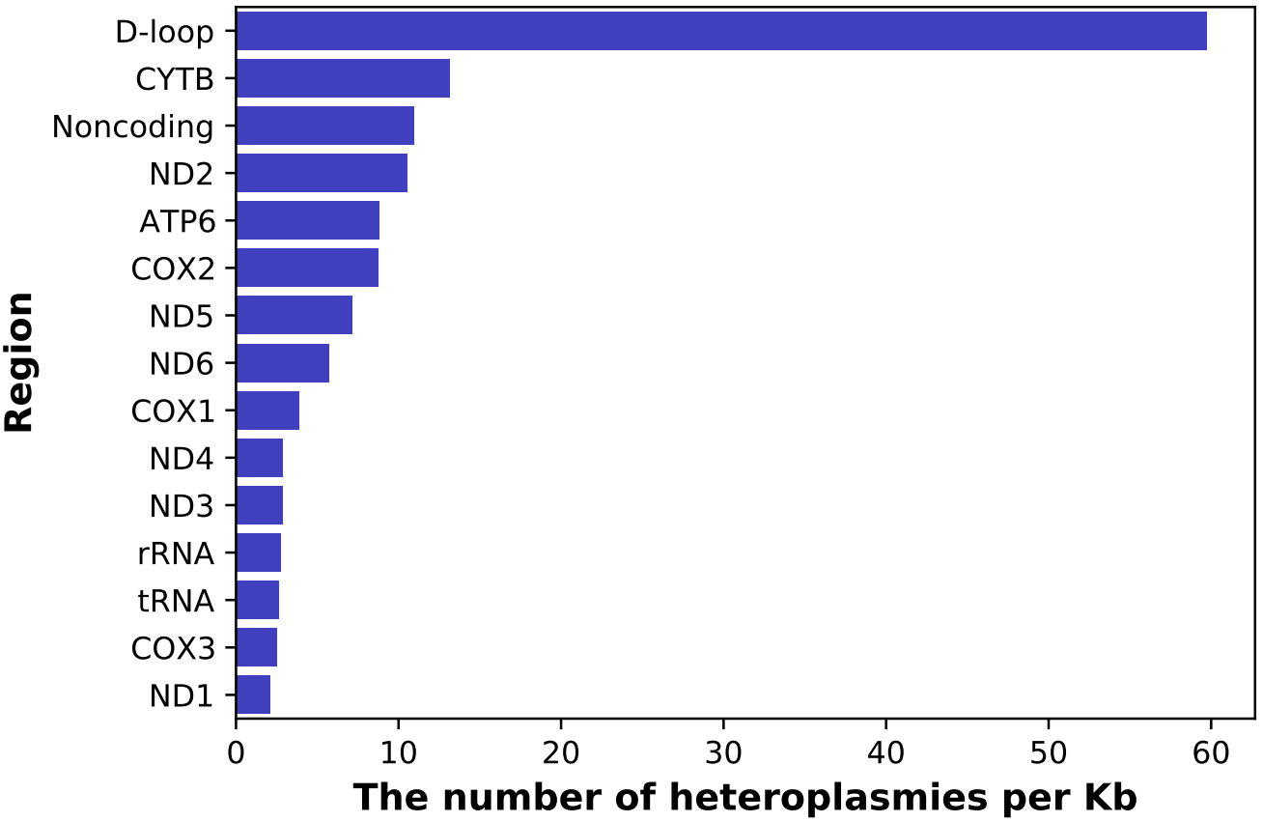

Supp. Figure S2. The distribution of the number of heteroplasmies per sample. The blue dot denotes the observed number of samples with a specific number of heteroplasmies. The bar plot denotes the expected number following a Poisson distribution.

Supp. Figure S3. The correlation between the allele frequency of mutations in mothers and their offspring in three successive transmissions.
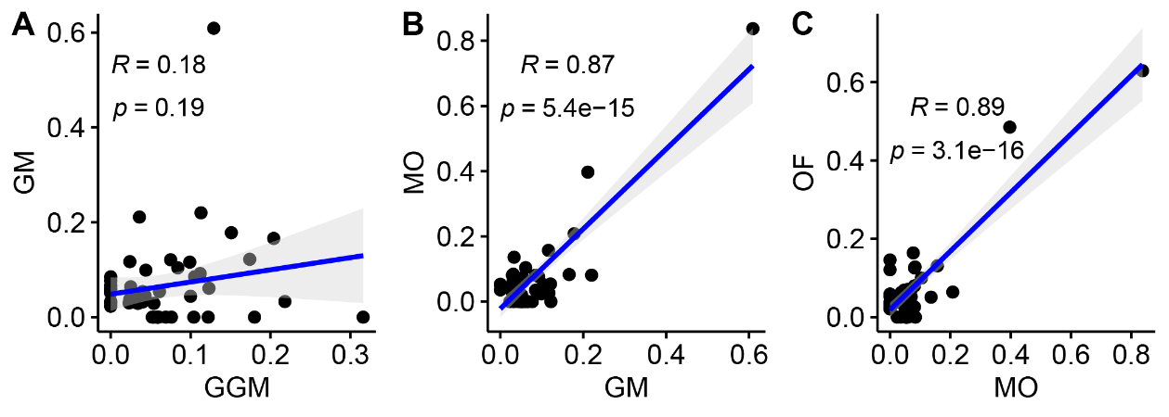

Supp. Figure S4. The bottleneck size (Nb) estimated from the frequency change in three transmissions. A: GGM-GM; B: GM-MO; C: MO-OF. The optimal Nb is marked in red, which was 38, 53, and 71 respectively.
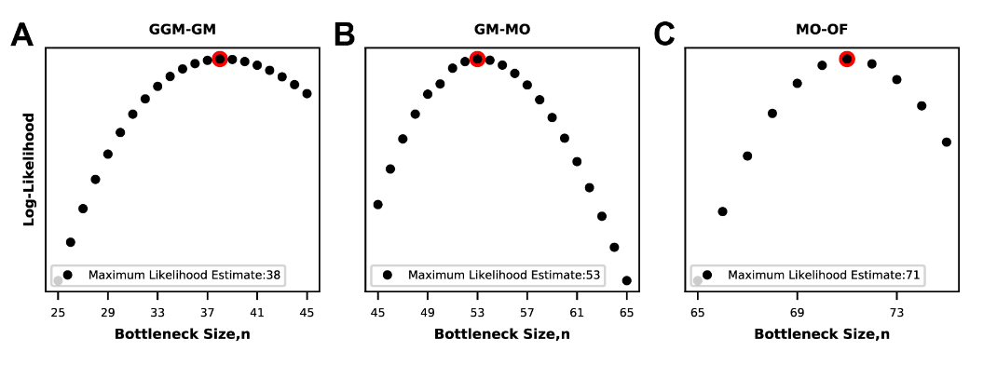

Supp. Figure S5. The frequency change of two transmitted heteroplasmies in the same individual and that of two transmitted heteroplasmies in different individuals.
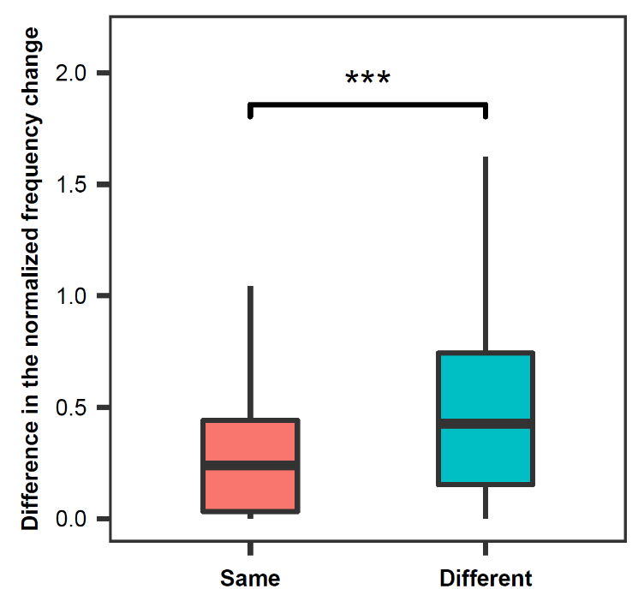

Supp. Figure S6. Distribution of the estimated bottleneck sizes when using only one heteroplasmy from each sample. (A) Distribution of the Nb estimated from the frequency change in the transmission of GGM-GM. (B) Distribution of the Nb estimated from the frequency change in the transmission of GM-MO. (C) Distribution of the Nb estimated from the frequency change in the transmission of MO-OF. A heteroplasmy was randomly selected when there was more than one heteroplasmy in the sample, and the process was repeated 1000 times. The red line represents the best fitting curve

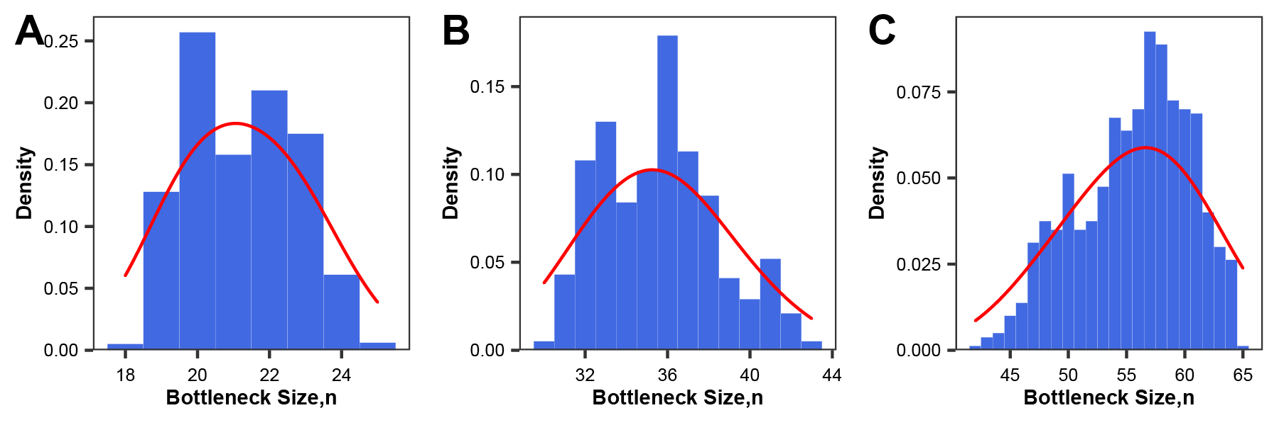

Supp. Figure S7. The number and minor allele frequency of heteroplasmies in two different tissues. (A) The number of heteroplasmies in the blood (BL) and buccal swab (BS) tissues. (B) The minor allele frequency of heteroplasmies in the BL and BS tissues.
