Supplementary materials
Supp Table 1.The correlation between serum SCFAs and UPDRS part III score
 | Correlation coefficient | P value
Acetic acid | -0.232 | 0.105
Propionic acid | -0.365** | 0.009
Butyric acid | -0.246 | 0.084
Isobutyric acid | -0.095 | 0.512
Isovaleric acid | -0.089 | 0.539
Pentanoic acid | -0.015 | 0.917
Isocaproic acid | -0.200 | 0.163
Caproic acid | -0.183 | 0.203
Heptanoic acid | -0.145 | 0.314
P values was obtained from Spearman nonparametric correlation analysis method. **, P<0.01.

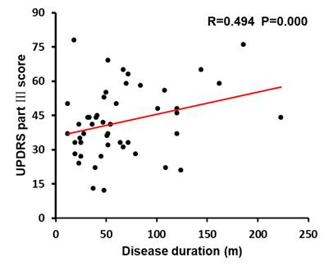
Supplementary Fig. 1. UPDRS part III score was significantly positively correlated with disease duration in PD patients (n=50), R=0.494, P=0.000. Investigated by Spearman nonparametric correlation analysis method. UPDRS, Unified Parkinson’s Disease Rating Scale.
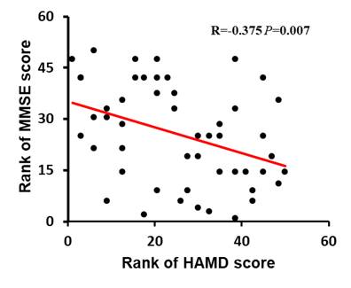
Supplementary Fig. 2. MMSE score was significantly negatively correlated with HAMD score in PD patients, R=-0.375, P=0.007. Investigated by Spearman nonparametric correlation analysis method. MMSE, Mini-mental State Examination. HAMD, Hamilton Depression Scale.

